PRIVACY-PRESERVING MACHINE UNLEARNING IN FEDERATED LLMS: A CERTIFIED RIGHT-TO-BE-FORGOTTEN FRAMEWORK
(ForgetSafe)
A project report submitted in partial fulfilment of the requirements for the award of the degree of
BACHELOR OF TECHNOLOGY
in
COMPUTER SCIENCE AND ENGINEERING (DATA SCIENCE)
Submitted by
G.SHASHANK | 23K91A6761
B.SATHISH | 23K91A6719
G.RAKESH | 23K91A6759
B.AKHIL | 23K91A6721
Batch A9 (CSE - Data Science, Section A)
Under the esteemed guidance of
[GUIDE NAME]
[DESIGNATION]
[COLLEGE LOGO]
DEPARTMENT OF COMPUTER SCIENCE AND ENGINEERING (DATA SCIENCE)
[COLLEGE NAME]
[COLLEGE ADDRESS / AFFILIATING UNIVERSITY]
[ACADEMIC YEAR]

[COLLEGE LOGO]
[COLLEGE NAME]
DEPARTMENT OF COMPUTER SCIENCE AND ENGINEERING (DATA SCIENCE)
CERTIFICATE
This is to certify that the project report entitled "Privacy-Preserving Machine Unlearning in Federated LLMs: A Certified Right-to-Be-Forgotten Framework (ForgetSafe)" is a bonafide record of the work carried out by G.SHASHANK (23K91A6761), B.SATHISH (23K91A6719), G.RAKESH (23K91A6759), B.AKHIL (23K91A6721), in partial fulfilment of the requirements for the award of the degree of Bachelor of Technology in Computer Science and Engineering (Data Science), during the academic year [ACADEMIC YEAR], under my supervision.

Project Guide  [GUIDE NAME]  [DESIGNATION] | Head of the Department  [HOD NAME]  Department of Computer Science and Engineering (Data Science) | External Examiner  [NAME AND SIGNATURE]
DECLARATION
We hereby declare that the project report entitled "Privacy-Preserving Machine Unlearning in Federated LLMs: A Certified Right-to-Be-Forgotten Framework (ForgetSafe)", submitted to the Department of Computer Science and Engineering (Data Science), [COLLEGE NAME], in partial fulfilment of the requirements for the award of the degree of Bachelor of Technology in Computer Science and Engineering (Data Science), is a record of original work carried out by us under the guidance of [GUIDE NAME], [DESIGNATION]. The results embodied in this report have not been submitted to any other university or institution for the award of any degree or diploma.

G.SHASHANK | 23K91A6761
B.SATHISH | 23K91A6719
G.RAKESH | 23K91A6759
B.AKHIL | 23K91A6721
Place: [PLACE]
Date: [DATE]
ACKNOWLEDGEMENT
We express our sincere gratitude to our project guide, [GUIDE NAME], [DESIGNATION], for valuable guidance, encouragement and constructive suggestions throughout this project.
We thank [HOD NAME], Head of the Department of Computer Science and Engineering (Data Science), for providing the facilities and support needed to complete this work, and [PRINCIPAL NAME], Principal, [COLLEGE NAME], for the encouragement given to us.
We thank the project coordinators and all faculty and staff members of the department for their help, and our families and friends for their constant support.
We also acknowledge the authors of the papers on which this work builds, in particular the authors of the recorded base paper, Asma Khan, Seyong Jin and their co-authors, and of the federated-unlearning studies by Wei et al., Zhang et al. (Oblivionis) and Jiang et al., whose problem statements and evaluation practice shaped our own measurements, and the authors and maintainers of the open-source software used for the user interface and the documentation tooling, in particular React, Vite, Recharts, Playwright, python-docx and matplotlib.

G.SHASHANK
B.SATHISH
G.RAKESH
B.AKHIL
ABSTRACT
Federated learning keeps raw data on client devices, yet each client's influence stays in the shared model parameters. Regulations such as the General Data Protection Regulation grant users a right to erasure, and retraining a large federated language model for every request is impractical. Existing federated unlearning methods mostly remove influence heuristically, and few can show a regulator that forgetting actually happened. The base paper recorded for this batch (Khan et al., IEEE Access, 2025) is a review in an unrelated field; only its review method, a taxonomy with strengths, limitations and an explicit research gap, is adopted here to frame federated unlearning.
This project builds ForgetSafe, a certified federated-unlearning demonstrator. Five simulated clients contribute L2-clipped parameter updates of a character-bigram language model, which stands in for a large-language-model adapter; the coordinator releases a Gaussian-noised aggregate and reports its one-shot (epsilon, delta) bound. To honour a deletion request, the stored update of the chosen client is subtracted and the aggregate is renormalised over the remaining clients, without retraining. The result is checked against a retained-only recomputation, a loss-based membership-inference attack and a utility measure, and a certificate is issued and written to a SHA-256 hash-chained audit ledger. The backend uses only the Python standard library; a React application exposes training, unlearning, a model explorer and the audit ledger.
The report measures the system honestly. At the default noise the released model is dominated by noise (perplexity 142 +/- 28 over 50 seeds, worse than a uniform model at 32), the membership attack is at chance (AUC 0.52 before removal), and the reported epsilon of 1.61 lies outside the range in which the classical Gaussian bound is valid. The certificate check is an algebraic identity (distance about 1e-14) because the reference reuses the stored noise; an independent retraining with fresh noise is as far from the unlearned model as two independent retrainings are from each other (875 against 881). With no noise the attack falls from AUC 0.99 to 0.54 after removal, so the removal itself is real. The hash chain detects edits, deletions and re-ordering but not tail truncation or a fully re-hashed forgery. Five unit tests and fourteen smoke-test checks pass. The report lists the work needed to move from this demonstrator to a real federated LLM.
Keywords: machine unlearning, federated learning, differential privacy, right to be forgotten, membership inference, audit ledger.
TABLE OF CONTENTS
CHAPTER 1 INTRODUCTION 1
1.1 Domain and Background 1
1.2 Motivation 1
1.3 Problem Statement 2
1.4 Need for the Project 2
1.5 Objectives 3
1.6 Scope of the Project 3
1.7 Contributions 4
1.8 Limitations and Assumptions 5
1.9 Organisation of the Report 5
CHAPTER 2 LITERATURE SURVEY 7
2.1 Overview of the Survey 7
2.2 Analysis of the Base Paper 7
2.3 Related Work 8
2.4 Datasets and Algorithms in the Literature and in This Project 10
2.5 Strengths and Limitations of Existing Approaches 11
2.6 Research Gap 12
CHAPTER 3 FEASIBILITY STUDY 13
3.1 Technical Feasibility 13
3.2 Economic Feasibility 13
3.3 Operational Feasibility 14
3.4 Schedule Feasibility 14
3.5 Advantages and Constraints Summary 15
CHAPTER 4 SYSTEM REQUIREMENTS AND ANALYSIS 16
4.1 Existing System and Its Limitations 16
4.2 Proposed System and Its Advantages 16
4.3 Functional Requirements 17
4.4 Non-Functional Requirements 17
4.5 Hardware and Software Requirements 18
4.6 User Roles and Constraints 18
CHAPTER 5 SYSTEM DESIGN 20
5.1 System Architecture 20
5.2 High-Level Workflow 22
5.3 Data-Flow Diagrams 23
5.4 UML Diagrams 25
5.5 Data Design 29
5.6 Module Design 32
5.7 User Interface Design 33
CHAPTER 6 METHODOLOGY AND SOFTWARE IMPLEMENTATION 35
6.1 Overall Methodology 35
6.2 Dataset 36
6.3 Preprocessing 37
6.4 Algorithm Choice and Justification 38
6.5 Mathematical Formulation 39
6.6 Model Architecture and Training 41
6.7 Application Architecture 42
6.8 Key Code Walkthroughs 42
6.9 Implementation Decisions and Their Reasoning 44
6.10 API Design 45
6.11 Security and Error Handling 47
6.12 Installation and Execution 48
CHAPTER 7 SYSTEM TESTING 49
7.1 Testing Strategy 49
7.2 Unit Testing 49
7.3 Integration Testing 50
7.4 Functional Testing 51
7.5 Security Testing 51
7.6 Validation and Edge Cases 53
7.7 Performance Testing 54
7.8 User Acceptance Testing 56
7.9 Limits of the Testing Done 57
CHAPTER 8 RESULTS AND OUTPUT SCREENS 58
8.1 Output Screens 58
8.2 Model and Verification Results 60
8.3 Certificate, Ledger and API Results 65
8.4 Comparison with the Base Paper and Related Work 66
8.5 Sample Inputs and Outputs 67
8.6 Success and Failure Analysis 68
8.7 Limitations of the Results 69
8.8 Objectives Against Outcomes 69
CHAPTER 9 CONCLUSION 71
9.1 Summary of the Work 71
9.2 Objectives Achieved 71
9.3 Key Findings 71
9.4 Practical Applications 72
9.5 Known Limitations 72
CHAPTER 10 FUTURE SCOPE 73
10.1 Improvements to the Existing System 73
10.2 Additional Features 73
10.3 Scalability and Deployment 73
10.4 Further Research 74
REFERENCES 75
APPENDIX A IMPORTANT CODE 77
A.1 Federated Training and Unlearning (engine.py) 77
A.2 Hash-Chained Audit Ledger (audit.py) 78
A.3 Clipping and Membership Attack (model.py) 78
APPENDIX B INSTALLATION AND USER GUIDE 79
B.1 Installation Guide 79
B.2 User Guide 79
B.3 Troubleshooting 80
APPENDIX C ADDITIONAL SCREENS 81

LIST OF FIGURES
Fig. 5.1: System architecture of ForgetSafe 20
Fig. 5.2: High-level workflow of a training and an unlearning request 22
Fig. 5.3: Data-flow diagram, level 0 (context) 23
Fig. 5.4: Data-flow diagram, level 1 24
Fig. 5.5: Data-flow diagram, level 2 (unlearning and verification) 25
Fig. 5.6: Use-case diagram 26
Fig. 5.7: UML class diagram 27
Fig. 5.8: Sequence diagram of training, unlearning and audit verification 28
Fig. 5.9: Flowchart of the unlearning algorithm (`FederatedUnlearningEngine.unlearn`) 29
Fig. 5.10: Entity-relationship view of the data model (no SQL database) 30
Fig. 5.11: Dashboard: workflow stepper, four metric tiles, client norms and certificate slot 34
Fig. 5.12: Certified unlearning: confirmation result, certificate and before-and-after chart 34
Fig. 7.1: Seven manipulations of the audit ledger: four are detected, three are not 52
Fig. 7.2: Median and 95th-percentile response time per endpoint 54
Fig. 7.3: Median wall time of unlearning and of retraining the proxy against the number of clients 55
Fig. 7.4: Time to append one record against the number of records already in the ledger 56
Fig. 8.1: Landing page with the live lab status 58
Fig. 8.2: Federated training screen after training 58
Fig. 8.3: Dashboard after training 59
Fig. 8.4: Model explorer before any removal 59
Fig. 8.5: Certified unlearning screen before a request 59
Fig. 8.6: Verification certificate after removing Client 01 59
Fig. 8.7: Model explorer after removing Client 01 60
Fig. 8.8: Compliance audit screen with a verified hash chain 60
Fig. 8.9: Perplexity and next-character accuracy against the noise multiplier (dotted lines: default σ = 3 and the ε < 1 boundary at σ = 4.85) 62
Fig. 8.10: Membership AUC before and after removal against the noise multiplier (error bars: standard error) 62
Fig. 8.11: Reported ε against perplexity: the classical bound is valid only to the left of ε = 1 63
Fig. 8.12: Membership AUC before and after removal with almost no noise 63
Fig. 8.13: Distance between the unlearned model and a fresh retrain, compared with the distance between two fresh retrains 64
Fig. 8.14: Perplexity and accuracy as clients are removed one after another 65
Fig. 9.1: Without noise the removal is clearly visible to the membership attack 72
Fig. B.1: Training screen after the first run 80
Fig. B.2: Certificate after a removal 80
Fig. C.1: Federated training screen before the first training run 81
Fig. C.2: Confirmation dialog before a removal 81
Fig. C.3: Verification certificate, full page 81
Fig. C.4: Certificate for the second removal (Client 02) 82
Fig. C.5: Dashboard after two removals 82
Fig. C.6: Training screen after two removals 82
Fig. C.7: Dashboard in dark mode 82
Fig. C.8: Original single-page interface served by the API 83
Fig. C.9: Certified unlearning screen on a 390-pixel-wide viewport 83
Fig. C.10: Landing page, how-it-works section 83

LIST OF TABLES
Table 1.1: Needs and how the project addresses them 2
Table 1.2: Organisation of the report 5
Table 2.1: Literature items and how they were used 7
Table 2.2: Approaches reported in the literature and the choice made in this project 10
Table 2.3: Comparison of classes of approach 11
Table 3.1: Cost elements of the demonstrator and of a production extension 13
Table 3.2: Phases of the work in order 14
Table 3.3: Feasibility summary 15
Table 4.1: Limitations of existing practice 16
Table 4.2: Advantages of the proposed system and their qualifications 16
Table 4.3: Functional requirements and traceability 17
Table 4.4: Non-functional requirements and their status 17
Table 4.5: Hardware 18
Table 4.6: Software 18
Table 4.7: Roles of use 18
Table 5.1: Layers of the architecture 21
Table 5.2: Workflow steps and the code that runs them 22
Table 5.3: Processes and data stores of the level-1 diagram 24
Table 5.4: Classes of the back end 27
Table 5.5: Engine state 30
Table 5.6: Ledger record schema 31
Table 5.7: The 25 fields of an unlearning certificate 31
Table 5.8: Back-end and test modules 32
Table 5.9: Front-end modules 33
Table 6.1: Approach classes and the resulting design decisions 35
Table 6.2: The five client corpora and their update vectors 36
Table 6.3: Roles of the three fixed sets 36
Listing: alphabet, index and `normalize_text()` (model.py) 37
Listing: `_offset()` and `raw_update()` (model.py) 37
Listing: `clipped_update()` (model.py) 38
Table 6.4: Alternatives considered 38
Listing: training 39
Table 6.5: Reported and exact epsilon for the Gaussian mechanism (delta = 1e-5) 39
Listing: unlearning and certification 40
Listing: model and metrics 40
Table 6.6: Configuration of the demonstrator 41
Table 6.7: Technology stack 42
Listing: `FederatedUnlearningEngine.train()` (engine.py) 42
Listing: core of `unlearn()` (engine.py) 43
Table 6.8: Main implementation decisions 44
Table 6.9: API endpoints 45
Listing: request and (abbreviated) response 46
Table 6.10: Measured API behaviour at the edges 46
Table 6.11: Security gaps of the demonstrator 47
Listing: starts both servers and opens the browser 48
Listing: manual start 48
Table 6.12: Ways to run the application 48
Listing: verification commands 48
Table 7.1: Test layers and instruments 49
Table 7.2: The five unit tests 49
Table 7.3: The fourteen smoke checks 50
Table 7.4: Functional test results 51
Table 7.5: Input-handling probes against the live API 52
Table 7.6: Tamper experiments on the hash-chained ledger 52
Table 7.7: API edge-case probes (experiments/api) 53
Table 7.8: API response times on 127.0.0.1 54
Table 7.9: Cost of `unlearn()` against re-running the proxy training (median of 5 runs, synthetic clients) 55
Table 8.1: Removing each client from the default model (seed 2026) 61
Table 8.2: Fifty-seed study with the default configuration 61
Table 8.3: Noise sweep (mean over 100 requests per row) 61
Table 8.4: Removal with σ = 1e-6 (essentially no noise) 63
Table 8.5: Unlearned model against retraining with independent noise (200 pairs per σ) 64
Table 8.6: Removing four of the five clients in turn (seed 2026) 64
Table 8.7: Fields of the unlearning certificate 65
Table 8.8: What the closest works evaluate, and why the numbers are not comparable 66
Listing: Training request and response 67
Listing: Text generated before the removal 67
Listing: Unlearning request and the certificate it returns 67
Listing: Text generated after the removal 67
Listing: Audit verification and a repeated request 67
Table 8.9: The two ledger records written by this sequence of requests 68
Table 8.10: Cases in which the system succeeds 68
Table 8.11: Cases in which the system fails or the evidence is weak 68
Table 8.12: Objectives measured against outcomes 69
Table 9.1: Objectives and verdicts 71
Listing: FederatedUnlearningEngine.train() in certified_unlearning/engine.py 77
Listing: FederatedUnlearningEngine.unlearn() in certified_unlearning/engine.py 77
Listing: AuditLedger.append() and AuditLedger.verify() in certified_unlearning/audit.py 78
Listing: clipped_update() and membership_auc() in certified_unlearning/model.py 78

LIST OF ABBREVIATIONS
Abbreviation | Expansion
AI | Artificial Intelligence
API | Application Programming Interface
AUC | Area Under the ROC Curve
CLI | Command-Line Interface
CPU | Central Processing Unit
CSS | Cascading Style Sheets
DFD | Data-Flow Diagram
DP | Differential Privacy
ER | Entity-Relationship
FedAvg | Federated Averaging
FL | Federated Learning
FR | Functional Requirement
GDPR | General Data Protection Regulation
GUI | Graphical User Interface
HTTP | Hypertext Transfer Protocol
JSON | JavaScript Object Notation
JSONL | JSON Lines
LLM | Large Language Model
LoRA | Low-Rank Adaptation
MIA | Membership-Inference Attack
NFR | Non-Functional Requirement
NLL | Negative Log-Likelihood
RAM | Random-Access Memory
REST | Representational State Transfer
ROC | Receiver Operating Characteristic
RTBF | Right To Be Forgotten
SHA | Secure Hash Algorithm
SISA | Sharded, Isolated, Sliced, Aggregated (training)
UI | User Interface
UML | Unified Modeling Language
URL | Uniform Resource Locator

CHAPTER 1
INTRODUCTION

1.1 Domain and Background
Machine learning has moved from models trained on one organisation's data to models trained collaboratively across many organisations. Federated learning is the best-known form of this arrangement: a coordinating server sends a global model to the participating clients, each client improves it on data that never leaves its own device or premises, and the server aggregates the returned updates into a new global model [9]. The promise is that raw records stay where they were created, which matters most where the data is regulated or commercially sensitive, such as banking, healthcare, education and retail records.
Large language models (LLMs) are now trained and adapted in the same way. Full pre-training is out of reach for most organisations, but parameter-efficient adapters such as low-rank adaptation (LoRA) [22] make it practical for each client to fine-tune only a small set of added weights on private text and to share only those weights. A federated LLM pipeline therefore combines three ideas: a shared base model, client-side fine-tuning on private text, and server-side aggregation of adapter updates. The framework surveyed in the literature for this setting, Oblivionis [3], explicitly pairs federated fine-tuning of LLMs with several federated and unlearning algorithms.
Keeping raw data local does not mean that a client's data has no effect on the shared model. Every aggregated update carries a trace of the data that produced it, and language models are known to memorise parts of their training text: Carlini et al. extracted verbatim training sequences from a deployed language model [21]. In a federated pipeline the trace of one client is spread across the global parameters and cannot simply be deleted by deleting the client's files. Machine unlearning is the field that asks how to remove the influence of specific training data from a trained model without paying the full price of training again [18], [12], and federated unlearning is its form for the client-server setting [17], [7].
The legal background is the right to erasure, commonly called the Right to Be Forgotten, in Article 17 of the General Data Protection Regulation [20]. A person may ask a controller to erase personal data, and the controller must act without undue delay. Whether the obligation extends to a model trained on the data is still debated, but a system that can show it has removed a contributor's influence is better placed than one that cannot. This project concerns that second kind of system: not only removing a client's contribution, but producing evidence that the removal happened.

1.2 Motivation
Three observations motivate the project, each taken from the batch's abstract and literature survey and checked against the papers that were available.
1. Deleting a client from a federated model is expensive if done honestly. The reference method is retraining the model without the client's data. For an LLM that is a repeat of the whole fine-tuning, and every deletion request triggers one. Sharded training (SISA) reduces the cost by retraining only the shard that held the data [12], but it changes how the model is trained from the start.
2. Cheap alternatives usually come without proof. Approximate methods such as gradient ascent on the data to be forgotten, or heuristic changes to weights, are fast, but the literature reviewed in this project reports that they give no formal statement that the data was forgotten, and that aggressive unlearning can damage the model's usefulness on the remaining data.
3. A regulator or a user needs something they can check. Even a correct removal is of little use in a compliance setting if the only evidence is the operator's word. The need is for a record of each request that can be inspected and that exposes later alteration.
Differential privacy [10] offers a vocabulary for the second observation: a mechanism that adds calibrated noise bounds how much any single client can change what is released. The literature on certified removal [13], [14] shows that this vocabulary can be turned into removal guarantees for well-behaved models. What is missing, and what the batch's research gap names, is a complete and inspectable pipeline in which training, removal, verification and record-keeping fit together for federated language-model workloads. ForgetSafe is a small, fully runnable version of such a pipeline, built so that each step can be executed, measured and criticised.
A further motivation is methodological. A demonstrator that prints "CERTIFIED" is easy to build and easy to misread. The project therefore treats its own certificate as something to be tested: the measurement study in Chapter 8 asks what the certificate really establishes, under which noise settings the membership-inference check is informative, and where the audit record can be defeated. These findings are part of the contribution.

1.3 Problem Statement
The problem statement of the batch (6.OBJECTIVES&PROBLEM STATEMENT.docx) has four parts, which the project adopts without change:
- Client data influence remains embedded in federated LLM parameters after training.
- Retraining large models for every deletion request is impractical.
- Heuristic unlearning gives no formal proof that data was forgotten.
- Without verifiable unlearning, models cannot demonstrate compliance with the Right to Be Forgotten.
Stated as a design problem: given a set of clients that each contributed an update to a federated model, produce a procedure that (a) removes one client's contribution from the model without retraining from scratch, (b) states a privacy bound for what the model release reveals, (c) checks the result against a trusted reference and against an adversary that tries to tell whether the client's data was used, (d) reports how much usefulness remains, and (e) stores a record of the whole request that cannot be quietly changed. The project solves this design problem on a deliberately small model so that every claim can be re-run, and states in Chapter 8 where the small model stops being a fair stand-in for a real LLM.

1.4 Need for the Project
The need is stated in the batch as a certified unlearning framework that removes a client's influence efficiently and proves it to regulators and users. Four needs follow from that sentence.
Table 1.1: Needs and how the project addresses them
Need | What it requires | How ForgetSafe addresses it
Efficiency | Removal cost should not repeat the cost of training | Stored clipped updates are subtracted from the aggregate; no client data is touched and no training round is repeated
Evidence | A statement that can be checked, not only asserted | A certificate with reference-distance, membership-inference, utility and hash fields for every request
Bounded release | A formal statement of what the released model can reveal | L2 clipping, Gaussian noise and a reported (epsilon, delta) bound, with its limits stated
Accountability | A record that outlives the session and exposes edits | Append-only JSONL ledger with a SHA-256 chain, verified on demand

The need is real but the project's answer is partial, and the report says where. The efficiency need is met only for a model whose aggregate is a sum of per-client updates; the evidence need is met by checks whose strength depends on the noise setting; and the accountability need is met for casual tampering but not for an adversary who can rewrite the whole file. These qualifications are developed in Chapters 5 to 9.

1.5 Objectives
The six objectives are those of the batch document 6.OBJECTIVES&PROBLEM STATEMENT.docx. Chapter 8 measures each of them against the outcome.
1. Set up federated fine-tuning of an LLM across multiple clients.
2. Remove a client's data influence through parameter-level unlearning without full retraining.
3. Certify forgetting with differential-privacy based guarantees.
4. Verify unlearning using membership-inference tests and comparison with retraining.
5. Preserve model utility on the remaining data.
6. Provide auditable compliance records for each unlearning request.
Two clarifications bind the reading of these objectives. First, objective 1 is interpreted at the scale the project could run offline on a classroom computer: five simulated clients fine-tuning a character-level language model whose parameter vector stands in for an LLM adapter update, not a pre-trained transformer. Second, objective 3 is interpreted as reporting a one-shot Gaussian-mechanism bound for the noisy aggregate and checking the removal against a recomputation, not as a proven end-to-end differential-privacy theorem for LLM training.

1.6 Scope of the Project
In scope. The project delivers the following, all present in 8.ProjectCode and exercised by the tests and the measurement scripts:
- A federated training procedure over five simulated clients (Finance, Healthcare, Education, Retail, Travel), each holding five text records, with per-client L2 clipping and Gaussian noise on the aggregate (certified_unlearning/engine.py, model.py, dataset.py).
- Client-level unlearning by subtraction of the tracked clipped update, with renormalisation over the retained clients and a status of CERTIFIED or REVIEW_REQUIRED.
- A verification stack: reference recomputation, loss-based membership-inference AUC before and after, public-set perplexity and next-character accuracy, and a utility-retention percentage.
- A hash-chained, append-only audit ledger with an on-demand verifier, and a downloadable JSON certificate.
- A localhost JSON API (nine routes) in certified_unlearning/web.py, a React web interface with a landing page and five screens, the original single-page interface, a Tkinter desktop interface and a command-line demonstration.
- An automated test suite (5 unit tests, 14 end-to-end smoke checks) and a measurement suite that produces every number reported here.
Out of scope. The following are deliberately not attempted, and the report does not claim them:
- Fine-tuning or unlearning in a real pre-trained LLM, in a deep-learning framework, on a GPU, or with a federated-learning library.
- Sample-level or class-level unlearning (only whole-client removal is implemented).
- Multi-round federated averaging in which later updates depend on earlier global models; the demonstrator aggregates once.
- A privacy accountant for repeated releases, secure aggregation, authenticated or encrypted storage of the tracked updates, and signed audit records.
- User authentication, authorisation and multi-tenant operation; the interface has no login.
- Any legal determination of compliance. The software demonstrates a mechanism; it is not a compliance product.

1.7 Contributions
The contributions of the project are listed below as they will be defended in the later chapters. None is claimed as new to the field; the novelty statement is in the novelty section of the methodology document and in Chapter 2.
1. An end-to-end workflow that joins federated training, parameter-level client removal, verification and compliance record-keeping in one runnable program, with the model isolated behind a small interface so that a LoRA adapter tensor could replace the bigram proxy.
2. Tracked-update unlearning with a certificate. Each client's clipped update is stored; removing the client subtracts that update from the noisy aggregate and renormalises, in time independent of the amount of client data, and issues a certificate carrying the privacy parameters, the reference distance, the attack and utility measurements and the model hashes before and after.
3. A verification stack of a reference recomputation, a loss-based membership-inference AUC, public-set perplexity and accuracy, and a utility-retention floor, applied to every request.
4. A hash-chained audit ledger with a verifier and a tamper study that separates the edits it detects (field edits, deletions, re-ordering) from those it cannot (tail truncation, full re-hashing, forged appends).
5. A React demonstrator and a JSON API that let an operator train, remove a client, read the certificate, sample the model and verify the ledger, with documented error handling for the invalid requests (untrained, unknown client, repeated removal, removal of the last client).
6. An honest measurement study over 50 seeds, a noise sweep, a fresh-noise retraining comparison, a noise-free attack, sequential removal, scaling and API latency. It shows that at the default setting the model is dominated by noise (perplexity 142 against 32 for a uniform model), that the reference check is an algebraic identity, and that the reported epsilon of 1.61 lies outside the range in which the classical bound is valid.

1.8 Limitations and Assumptions
The limitations are summarised here and treated in detail in Chapters 7 and 8 and in the scope-and-limitations document.
- Proxy model. The model is a character-bigram language model with 1,089 parameters. Its parameter vector plays the role of an adapter update; conclusions about exact subtraction do not carry over to multi-round, non-linear LLM training.
- Tiny synthetic corpus. Twenty-five hand-written training sentences, five public evaluation sentences and five non-member sentences. The membership-inference AUC resolves differences of 0.04 only, and no train/test split of an external dataset exists.
- Noise dominance at the default setting. With noise multiplier 3 the model reaches perplexity 130 on the baseline seed (142 +/- 28 over 50 seeds) and about 4 % next-character accuracy; the membership attack is at chance before unlearning (AUC 0.52 +/- 0.22).
- Epsilon range. The reported epsilon of 1.61 follows the classical Gaussian-mechanism formula, which is formally valid only for epsilon below 1, that is for a noise multiplier above 4.84.
- Noise reuse and accounting. The same noise vector is kept after unlearning, and there is no privacy accountant; the certificate repeats the training-time epsilon.
- Identity-style certificate. The reference model is rebuilt from the same stored updates and noise, so a distance near 1e-14 is expected by construction.
- Tamper evidence, not tamper-proofing. The ledger carries no signature or external anchor.
- Single shared engine, no authentication. Every caller of the API acts on one global session.
The assumptions are equally explicit: the coordinator is trusted to store the clipped updates and the noise honestly; clients are honest-but-curious rather than malicious; the aggregate is a one-shot sum rather than a multi-round average; and the evaluation texts are fixed and public.

1.9 Organisation of the Report
Table 1.2: Organisation of the report
Chapter | Title | Content
1 | Introduction | Domain, motivation, problem, need, objectives, scope, contributions, limitations
2 | Literature Survey | Base-paper analysis, related work by theme, algorithms and datasets, strengths and limits, research gap, novelty
3 | Feasibility Study | Technical, economic, operational and schedule feasibility
4 | System Requirements and Analysis | Existing and proposed system, functional and non-functional requirements, platform, roles
5 | System Design | Architecture, workflow, data-flow diagrams, UML, data model, modules, user interface
6 | Methodology and Software Implementation | Pipeline, data, algorithm and its justification, mathematics, application, API, security, installation
7 | System Testing | Strategy and results of unit, integration, functional, security, validation and performance tests; limits of testing
8 | Results and Output Screens | Output screens, measurements, comparison with the literature, success and failure analysis, objectives against outcomes
9 | Conclusion | Summary, objectives achieved, findings, applications, limitations
10 | Future Scope | Improvements, features, deployment, research directions
- | References, Appendices A-C | Numbered IEEE reference list; important code; installation and user guide; additional screens

CHAPTER 2
LITERATURE SURVEY

2.1 Overview of the Survey
The survey has three layers. The first is the batch's own literature table (5.LITERATURE SURVEY.docx), which lists five papers; the second is the three papers kept in the batch's archive of base papers, which were read in full for this report; the third is a set of standard method references on federated learning, differential privacy, unlearning, membership inference, the regulation and LLM adapters, whose bibliographic details are well established. The table below records what each batch item is and how much of it could be checked.
Table 2.1: Literature items and how they were used
Ref. | Work | Year / venue | Status in this report
[1] | Deep learning approaches for continuous sign language recognition: a comprehensive review | 2025, IEEE Access | Read; base paper recorded in the batch; its review method is adopted
[5] | Federated illusion: multi-level geometric privacy audit for federated graph unlearning | 2026, Information | Listed in the batch survey; not independently verified
[6] | Computationally efficient federated unlearning | 2025, 26th Int. Middleware Conf. | Listed in the batch survey; not independently verified
[7] | A comprehensive investigation of federated unlearning | 2024, 2nd Int. Conf. DAML | Verified through its published abstract
[8] | Unlearning under siege: robustness risks of certified machine unlearning | 2026, Neurocomputing | Listed in the batch survey; not independently verified
[2] | Rethinking federated unlearning via the lens of memorization | 2026, KDD | Read in full (archived base paper)
[3] | Oblivionis: lightweight learning and unlearning for federated LLMs | 2025, arXiv | Read in full (companion reference paper)
[4] | Certifying the right to be forgotten: primal-dual optimisation (FedORA) | 2025, arXiv | Read in full (archived paper)

Three of the batch items, [5], [6] and [8], could not be located by searching their titles, so nothing is said here about their methods or results beyond what their titles state: [5] concerns auditing privacy in federated graph unlearning, [6] concerns the computational efficiency of federated unlearning, and [8] concerns the robustness of certified machine unlearning. They are kept in the reference list because the batch lists them, and they are not used as evidence anywhere in this report.

2.2 Analysis of the Base Paper
The base paper recorded in the batch files is Khan et al., "Deep learning approaches for continuous sign language recognition: a comprehensive review" (IEEE Access, volume 13, 2025) [1]. It is a survey of continuous sign language recognition (CSLR), the task of identifying consecutive signs in video streams without prior knowledge of their temporal boundaries. Its subject is therefore unrelated to federated learning, language models or unlearning, and the batch's own base-paper document says so: what the project adopts is the paper's review method, not its technology.

2.2.1 What the paper does
Reading its abstract and section structure shows the method clearly. The authors argue that earlier CSLR research lacked a unified framework joining spatial, temporal and alignment approaches, and respond by organising the literature into a taxonomy. The taxonomy covers the sign language studied, data collection, input method, gesture signals, identification methods, the datasets applied and overall efficiency. The paper's sections move from the task and its input modalities, through acquisition devices (sensor-based, vision-based and hybrid), to the methods and materials, including the datasets used. The deep-learning models are then grouped by spatial, temporal and alignment approach, and for each group the paper describes the benefits and the drawbacks. It closes with the open challenges, which it lists as the need for diverse and naturalistic datasets, signer diversity and real-time systems.

2.2.2 The method adopted here
Three steps of that method are reused. First, organise existing work into classes rather than listing papers one by one; for this project the classes are the approaches to removing a client from a federated model (the table of approaches below). Second, compare each class on strengths and limitations against the same criteria; here the criteria are cost, strength of evidence, utility impact, applicability to federated LLM pipelines and auditability (the comparison of classes). Third, name the gap that the comparison leaves open (the research-gap section), and let the gap define the objectives.

2.2.3 What is not drawn from the paper
No algorithm, dataset, metric or result of the sign-language paper is used in ForgetSafe, and no numerical comparison between the two is possible or made: they address different tasks, data and measures. Where the report compares the project with published work numerically or in kind, the comparison is with the technically closest papers, [2], [3] and [4], and even there it is qualitative, because their datasets (image classification benchmarks, LLM unlearning benchmarks) and models differ from the character-level proxy used here.

2.3 Related Work
The related work is grouped by theme. The first group is the closest technically; the later groups supply the methods that ForgetSafe relies on.

2.3.1 Federated unlearning
Wei et al. [2] revisit federated unlearning through memorisation. Their argument is that existing federated unlearning methods may overlook the information shared between the data to be forgotten and the remaining data, which leads to ineffective unlearning and unfairness between clients. Unlearning, they argue, should remove the unique memorised information of the forgotten data and keep overlapping patterns that the remaining data also supports. They propose Grouped Memorization Evaluation, an example-level metric separating memorised from overlapping knowledge, and Federated Memorization Pruning (FedMemPrune), which resets the parameters responsible for memorisation. They evaluate on CIFAR-10, CIFAR-100 and EMNIST with ResNet-18, ResNet-34 and VGG-9 models, including a non-IID partition with a Dirichlet concentration of 0.5, and report that the method closely matches retraining-based baselines while removing memorisation more effectively than the other federated unlearning algorithms they compare.
Zhang et al. (Oblivionis) [3] address the federated LLM setting directly. They present a lightweight framework that unifies federated learning and unlearning as a dual optimisation objective and incorporates six federated-learning algorithms (FedAvg, FedAvgM, FedAdagrad, FedAdam, FedYogi and FedProx) and five unlearning algorithms (gradient ascent, gradient difference, NPO, SimNPO and retraining) for comparison. Their setting is LoRA fine-tuning of Llama-family models, evaluated on the TOFU and MUSE unlearning benchmarks, motivated by the Right to Be Forgotten, and they report a balance between forgetting efficacy and model utility. It is the nearest published match to the batch's title, and it is the reason the project keeps a LoRA-style adapter as the model it stands in for.
Jiang et al. (FedORA) [4] treat vertical federated learning, where parties hold different features of the same samples. They formulate removal of samples or labels as a constrained optimisation solved with a primal-dual method, with an unlearning loss that promotes classification uncertainty rather than misclassification, an adaptive step size, and an asymmetric batch design. Their theoretical analysis bounds the model difference between FedORA and training from scratch, and they evaluate on a tabular dataset (Income) and image datasets (MedMNIST, CIFAR-10, CIFAR-100, Tiny-ImageNet), including resilience to membership-inference and backdoor attacks. It is the most explicit among the papers read about tying an unlearning procedure to a bound against the retraining reference.
FedEraser (Liu et al.) [17] is the best-known client-level method and the closest in mechanism to ForgetSafe: the server retains the clients' historical updates and, when a client leaves, calibrates the retained updates of the other clients to reconstruct an unlearned model instead of retraining. Zhang's review [7] surveys this family (it names FedEraser, FedCIO, FedRecovery and F2UL), and concludes that future work should concentrate on standardised evaluation metrics, computational efficiency and non-IID data. The batch lists three further works on auditing, efficiency and robustness of unlearning [5], [6], [8]; they are listed but not analysed, as explained in the overview of the survey.

2.3.2 Exact, sharded and certified removal
Cao and Yang [18] introduced the idea of making a system forget by converting learning into a summation form over transformed data points, so that removing a point means subtracting its term; this is the idea that ForgetSafe's linear aggregate relies on. Bourtoule et al. [12] proposed SISA training, which shards the data, trains an isolated model per shard and slices each shard's training so that a deletion retrains only one shard from a recent checkpoint; the price is a training architecture and an ensemble at inference. Guo et al. [13] defined certified removal in the language of differential privacy: a removal mechanism is (epsilon, delta)-certified if the model after removal is statistically indistinguishable from the model retrained without the point, and they achieved it for linear, convex models with a Newton-style update and added noise. Sekhari et al. [14] studied how many deletions an algorithm can absorb, their "deletion capacity", at a given accuracy and privacy level, and showed that the capacity depends on the dimension of the model and the privacy budget.

2.3.3 Differential privacy and the Gaussian mechanism
Dwork and Roth [10] give the Gaussian mechanism: adding noise of standard deviation sigma times the L2 sensitivity to a query output satisfies (epsilon, delta)-differential privacy when sigma is large enough relative to epsilon and delta, for epsilon in the open interval (0, 1). Their analysis yields the formula that the application evaluates. Abadi et al. [11] extended the idea to deep learning (DP-SGD) with clipping of per-example gradients and a moments accountant that tracks the cumulative privacy loss over many steps, which a one-shot formula cannot. Balle and Wang [19] showed how to calibrate the Gaussian mechanism analytically so that it is valid for all epsilon, not only below 1. McMahan et al. [9] introduced federated averaging, the aggregation rule that federated LLM pipelines build on.
The derivation that matters for this project is short. If each client's contribution is clipped to L2 norm at most C, then adding or removing one client changes the sum of contributions by a vector of norm at most C, so the L2 sensitivity of the sum is C. Noise drawn from a Gaussian with standard deviation sigma times C, with sigma the "noise multiplier", then gives (epsilon, delta)-differential privacy with epsilon = sqrt(2 ln(1.25/delta)) / sigma, provided epsilon is below 1 [10]. Dividing the noisy sum by the number of clients afterwards is post-processing and does not change the guarantee. Two consequences are used later: the guarantee concerns the one noisy release only, and for delta = 1e-5 the formula requires a multiplier above about 4.84 before epsilon drops below 1, a range in which [19] is the remedy.

2.3.4 Membership inference and memorisation
Shokri et al. [15] showed that an adversary with query access can often tell whether a record was in a model's training set, using shadow models trained to imitate the target. Yeom et al. [16] connected this to overfitting and gave a simpler attack that predicts membership when a record's loss is below a threshold; the loss-based attack used in this project is of that family, summarised as an AUC over the member and non-member scores. For language models, Carlini et al. [21] extracted verbatim training sequences, which shows that the influence a client leaves in a text model can be concrete and not only statistical.

2.3.5 Regulation and adapters
Article 17 of the GDPR [20] grants the right to erasure, the legal anchor of the whole field. LoRA [22] fixes the pretrained weights and trains low-rank update matrices, so the object a client contributes in a federated LLM pipeline is a small tensor, which is why the project's per-client vector is a reasonable, if much smaller, stand-in for it.

2.4 Datasets and Algorithms in the Literature and in This Project
The next table lists the removal approaches that appear in the papers read, the model and data used where the paper states them, and the corresponding choice made in ForgetSafe.
Table 2.2: Approaches reported in the literature and the choice made in this project
Approach | Source | Models and data reported | In ForgetSafe
Retraining without the client | reference method in [2]-[4], [12] | Used as the baseline in all three papers read | Used as the reference for comparison, in two forms: recomputation from stored updates, and a retrain with fresh noise (Chapter 8)
Sharded retraining (SISA) | [12] | Shard-and-slice training of isolated models | Not implemented; named as a future backend
Gradient ascent, gradient difference, NPO, SimNPO | reported in [3] | Llama-family LoRA models; TOFU and MUSE benchmarks | Not implemented; the proxy model has no gradient training
Memorisation pruning (FedMemPrune) | [2] | ResNet-18/34, VGG-9; CIFAR-10, CIFAR-100, EMNIST; Dirichlet 0.5 non-IID | Not implemented
Primal-dual constrained optimisation (FedORA) | [4] | Income, MedMNIST, CIFAR-10/100, Tiny-ImageNet; vertical FL | Not implemented
Calibration with stored updates (FedEraser) | [17] | Server keeps clients' historical updates | Related mechanism: updates are stored; removal is exact subtraction rather than calibration
Newton-step certified removal | [13] | Convex, linear models | Not implemented; ForgetSafe's certificate is a different, simpler check
Summation-form unlearning | [18] | Statistical-query learners | Implemented: the aggregate is a sum of per-client terms
Gaussian mechanism on a clipped sum | [10], [11] | Noise standard deviation = multiplier x clipping norm | Implemented with one release and no accountant

Data in this project. ForgetSafe uses no benchmark. Its corpus is the built-in set of 25 training sentences (five clients with five records each), five public evaluation sentences and five non-member sentences in certified_unlearning/dataset.py. The choice follows from the objective of a fully offline, reproducible demonstrator, and it is the main reason that the project's numbers cannot be compared with those of papers evaluated on CIFAR or TOFU. Algorithms in this project are a character-bigram language model, L2 clipping, a Gaussian-noise sum, subtraction-based removal, a loss-based membership attack and a SHA-256 hash chain, each justified in Chapter 6.
Why subtraction is exact here and not in LLM training. Removal by subtraction is exact when the released model is a function of the clients' contributions that is linear in them and when each contribution depends only on that client's data. ForgetSafe's aggregate is of this form: every client's bigram-count vector is computed from its own records alone, the vectors are clipped and summed once, and the sum is divided by a count. Removing a client therefore leaves exactly the sum of the others. In federated LLM training the situation is different. Training runs for many rounds, and each client's update in round t is computed from the global model produced in round t-1, which already contains every other client's earlier contributions; the update is also a non-linear function of the weights. Subtracting the client's recorded updates then removes only the first-order, direct part of its influence. This is why the surveyed methods calibrate stored updates [17], retrain shards [12], prune memorised parameters [2] or optimise an unlearning objective [3], [4], and why the project's claim of exactness is restricted to its one-shot linear aggregate.

2.5 Strengths and Limitations of Existing Approaches
Following the base paper's method, each class is compared on the same criteria. The comparison draws on the batch's list of existing systems and on the papers above.
Table 2.3: Comparison of classes of approach
Class | Strengths | Limitations
Full retraining | Strongest removal reference; no assumption about the model | Cost of the whole training for every request; impractical for large federated LLMs
Approximate unlearning (gradient ascent, heuristic weight edits) | Fast; works on pre-trained models | No formal statement that the data is forgotten; aggressive settings damage utility on retained data; mostly studied on centralised models
Sharded training (SISA) | Limits retraining to one shard; exact in the shard sense | Needs the sharded architecture from the start; ensemble cost; weaker fit for federated LLM adapters
Differentially private training | Formal bound on the influence of one client or example | Privacy-utility trade-off; needs an accountant over many rounds; does not itself remove anything
Certified removal for convex models | A formal (epsilon, delta) statement against retraining | Established for convex, linear models; not for deep, non-convex LLMs
Stored-update methods (FedEraser) | Avoids client data; reuses history | Storage of updates; calibration costs; evidence for the removal is empirical
Memorisation-aware pruning | Targets what was actually memorised; preserves shared knowledge | Evaluated on vision benchmarks; an audit record is not part of the method as described

What a certificate can mean depends on the definition. In the sense of [13], a removal is certified when the output distribution of the removal mechanism is within (epsilon, delta) of the output distribution of retraining without the point; this is a statement about distributions, proved for a model class. A weaker, operational meaning is that a check passed: a reference recomputation agreed, an attack failed, utility stayed above a floor. The first meaning gives a guarantee and the second gives evidence. A certificate should say which it is, and ForgetSafe's does the second.
A theme across the classes is that removal and evidence of removal are treated separately. Methods that remove well rarely produce a record a third party can inspect, and methods that give guarantees are restricted to models far simpler than an LLM. This is the observation that the research gap formalises.

2.6 Research Gap
The batch states the gap in one sentence: federated unlearning methods mostly remove client influence heuristically, and certified, auditable unlearning designed for federated LLM pipelines remains an open problem. The survey supports that statement in four parts.
1. Certification is concentrated in convex or centralised settings [13], [14]; federated LLM unlearning work [3] concentrates on forgetting-quality and utility measures rather than certified bounds.
2. Verification evidence is rarely packaged. FedORA reports membership-inference resilience as an experimental finding [4]; in the parts of [2]-[4] that were read, no per-request certificate that an operator can hand to a user or regulator is described.
3. Auditability is not part of the algorithms. The papers read focus on the removal procedure; a tamper-evident record of each request is not part of the methods as described.
4. Little attention is given to how reliable the evidence is. A certificate or attack score is useful only if its limits are known: the noise level at which the attack is informative, whether the reference comparison is independent, and whether the recorded privacy parameter is valid.
ForgetSafe addresses the first three parts at demonstrator scale and addresses the fourth by measuring its own evidence. It does not close the gap for real LLMs: it shows the shape of the pipeline and where its weak points are on a model small enough to examine completely.

CHAPTER 3
FEASIBILITY STUDY

3.1 Technical Feasibility
Technical feasibility asks whether the required technology exists, whether the team could use it, and whether the result performs acceptably. For ForgetSafe the answer was settled by choosing a deliberately small technology set.
Technology. The back end uses only the Python standard library: http.server for the API, dataclasses, hashlib, json, random and math for the engine, and tkinter for the optional desktop interface. There is no dependency to install for the engine, the API or the tests. The front end uses React 19 with Vite 8, React Router, Recharts and a few presentation libraries, and is optional: the original single-page interface served at / needs no build. All components are mature and freely available.
Skills. The mathematics needed (vector norms, Gaussian noise, the Gaussian mechanism, AUC) is undergraduate level and was implemented directly. The federated-learning and unlearning concepts were learned from the surveyed papers [9], [12], [13], [17]. No GPU programming or deep-learning framework skill was required, which is both the reason the project was feasible on a classroom computer and the reason it remains a demonstrator.
Performance. On the measurement machine, training the five-client proxy takes about 5 ms inside the engine and about 36 ms through the API (median); an unlearning request takes a median of 58 ms through the API (95th percentile 82 ms), including the attack, the metrics and the ledger write. These times are far inside what an interactive demonstration needs. The scaling experiment (Chapter 8) shows that the cost of a request does not grow with the amount of client data in the way retraining does: from 100 to 500 synthetic clients, unlearn() rises from 116 ms to 204 ms while re-running the proxy training rises from 159 ms to 1385 ms. This applies to the proxy only.
Technical risks. Two risks were identified at the start and are both borne out in the results: a real LLM could not be trained or unlearned on the available CPU-only machine, and a formal certificate for a non-linear model is a research problem. The design isolates the model behind CharacterLanguageModel and clipped_update so that a heavier model can be substituted, but that substitution was not attempted. The project is therefore technically feasible as a demonstrator and not as a production system.

3.2 Economic Feasibility
Economic feasibility compares costs with benefits. No monetary figures were recorded for this project, so none are invented here; the analysis is qualitative and uses measured quantities where they exist.
Table 3.1: Cost elements of the demonstrator and of a production extension
Item | Demonstrator (this project) | Production extension (not built)
Software licences | None: Python, Node.js, React, Vite and Recharts are open source | Same, plus any managed services chosen
Compute | One CPU-only workstation (i5-12500, 15.7 GB); runs in milliseconds | GPU compute for LLM fine-tuning and for each retraining baseline
Storage | One tracked vector of 1,089 values per client (about 8.7 kB at 64-bit precision) and a JSONL ledger | One adapter-sized tensor per client (per round if rounds are tracked), encrypted at rest, plus signed ledger storage
Development effort | Student project effort | Engineering effort for secure aggregation, privacy accounting, signing and access control
Operating cost per request | Negligible (tens of milliseconds) | Depends on the model; the aim is to be far below a full retrain

The benefit of the approach, in a real deployment, would be the avoided cost of retraining for each deletion request and the reduced risk of being unable to show compliance. The demonstrator does not measure either benefit at LLM scale; it measures only that the removal step itself is cheap for the proxy. The economic case is therefore plausible but unproven, and the report does not quantify it.

3.3 Operational Feasibility
Operational feasibility asks whether the intended users can work with the system. The intended users are the operator of a federated training service, who carries out a removal request on behalf of a data owner, and a compliance auditor, who inspects the record afterwards (Section on user roles below).
- Ease of use. The workflow is four steps shown in order in the interface: train, unlearn, explore, audit. Each screen explains its own empty state and offers the next action, and destructive actions (removal, retraining, a new session) ask for confirmation.
- Installation. run.bat starts the API on port 8109 and the web interface on port 5109 and installs front-end dependencies on first run; python app.py alone starts the original interface with no installation.
- Maintenance. The engine is under 300 lines and the model under 130; the API has nine routes; the tests run in under a second. A maintainer can read the whole back end in one sitting.
- Constraints on operation. The system keeps one global session in memory, has no login, and loses the trained model when the server restarts (the ledger survives). It is suitable for a laboratory demonstration and not for shared or unattended operation.

3.4 Schedule Feasibility
The calendar dates of the work were not recorded in the project files, so no dates are claimed. The work followed this order, each phase building on the previous one:
Table 3.2: Phases of the work in order
Phase | Work | Output
1 | Reading the abstract, base-paper record and literature survey; fixing the objectives | Batch documents 2 to 6
2 | Design of the pipeline: clipped updates, noisy aggregate, subtraction, verification and ledger | PROJECT_REPORT.md design and requirement mapping
3 | Implementation of the engine, the model, the ledger and the sample corpus; first tests | certified_unlearning/ package, tests/
4 | Localhost web interface, Tkinter desktop interface, command-line demonstration | web.py, gui.py, app.py
5 | React front end designed against the existing JSON API (no back-end change) | frontend/, docs/FRONTEND_PLAN.md
6 | Measurement suite, screenshots, diagrams and the submission documents | scripts/, experiments/, docs/, batch documents 7 to 19

The schedule was feasible because the scope was fixed to a model that runs in milliseconds; an LLM-based version would have added data preparation, training time and hardware procurement that the phases above do not contain.

3.5 Advantages and Constraints Summary
Table 3.3: Feasibility summary
Dimension | Verdict | Basis | Main constraint
Technical | Feasible as a demonstrator | Standard-library back end; 5 unit tests and 14 smoke checks pass; millisecond latencies | No real LLM, no GPU; certificate meaning limited
Economic | Feasible; benefit not quantified | No licences; one workstation | Production costs (compute, secure storage) not estimated
Operational | Feasible for a laboratory demonstration | Four-step workflow, confirmations, one-command start | No authentication, one shared session, model not persisted
Schedule | Feasible at this scope | Small code base and fast tests | Dates not recorded; a real-LLM version would need much longer

The advantages are low cost, transparency (every number can be reproduced by scripts/run_experiments.py) and an architecture that separates the model from the verification and audit logic. The constraints are the proxy model, the lack of access control and the limits of the evidence, all of which are repeated as limitations in the scope document and Chapter 9.

CHAPTER 4
SYSTEM REQUIREMENTS AND ANALYSIS

4.1 Existing System and Its Limitations
The batch's literature survey lists four existing practices for handling a deletion request in a federated or machine-learning pipeline:
1. Full retraining of the model without the deleted client's data.
2. Approximate unlearning through gradient ascent or heuristic weight adjustment.
3. SISA-style sharded training that retrains only the affected shards [12].
4. Differential privacy during training to limit the influence of individual data [10], [11].
Their limitations, again from the batch survey and confirmed by the papers read, are:
Table 4.1: Limitations of existing practice
Limitation | Where it bites | Which practices
Too expensive for large federated LLMs | Every deletion triggers a repeat of fine-tuning | Full retraining
No formal guarantee that data is forgotten | A regulator cannot be shown more than the operator's assertion | Gradient ascent and heuristic edits
Not verifiable or auditable | No record that outlives the session and exposes edits | All four
Aggressive unlearning degrades utility | The model forgets more than the target data | Approximate methods
Mostly designed for centralised models | Client updates, aggregation and stored history are not used | Sharding, gradient methods

4.2 Proposed System and Its Advantages
ForgetSafe implements a federated unlearning workflow with five parts. Clients hold their own records inside the engine; each contributes only an L2-clipped update. The coordinator aggregates the updates with Gaussian noise into a global model. When a client asks to be forgotten, the coordinator subtracts that client's stored update and renormalises over the remaining clients; no record of the client is read again. The result is verified against a recomputation, measured with a membership-inference attack and a utility check, written as a certificate, and chained into the audit ledger.
Table 4.2: Advantages of the proposed system and their qualifications
Advantage | How it arises | Qualification
No retraining step | Removal is a vector subtraction over a fixed-size parameter vector | Exact only because the aggregate is a one-shot sum of independent updates
Inspectable evidence | Each request yields a certificate and a ledger record | Strength of the evidence depends on the noise setting
Bounded release | Clipping bounds each client's influence; noise gives an (epsilon, delta) statement | Classical bound valid only for epsilon below 1; not re-accounted after removal
Tamper evidence | SHA-256 chain verified on demand | No signature or anchor; truncation and re-hashing undetected
Separation of concerns | Model, engine, ledger and interface are separate modules | The model is a proxy; replacing it is future work

4.3 Functional Requirements
Each functional requirement is traced to the endpoint and screen that implement it and to the test that exercises it. Tests are the five unit tests in tests/test_end_to_end.py (U1 workflow, U2 repeat rejection, U3 tamper detection, U4 certificate export, U5 health and state) and the 14 checks of scripts/smoke_test.py (S).
Table 4.3: Functional requirements and traceability
ID | Requirement | Endpoint / screen | Verified by
FR1 | Train the global model across the five clients and report epsilon, delta, perplexity, accuracy and a model hash | POST /api/train; Federated training | U1, S
FR2 | Show each client's record count, original and clipped norm, clip scale and state | GET /api/state; Training, Dashboard | U5, S
FR3 | Start a new session while preserving audit history | POST /api/session; Federated training | S
FR4 | Remove a chosen active client by subtracting its tracked update and renormalising | POST /api/unlearn; Certified unlearning | U1, S
FR5 | Issue a certificate with status, privacy parameters, reference and residual distance, AUC and perplexity before and after, retention, model hashes and ledger hash | POST /api/unlearn response; certificate card | U1, S
FR6 | Download the latest certificate as JSON together with the ledger verification result | GET /api/certificate/latest | U4, S
FR7 | Reject invalid requests: untrained model, unknown client, client already removed, removal of the last client, missing client id | POST /api/unlearn error responses | U2, S, edge-case study
FR8 | Generate a text sample from the current model for a seed text | POST /api/generate; Model explorer | S
FR9 | List training and unlearning events in an append-only, hash-chained ledger | GET /api/state (audit); Compliance audit | U1, S
FR10 | Verify the hash chain on demand and report the first broken record | POST /api/audit/verify; Compliance audit | U3, S
FR11 | Provide the original single-page interface, a Tkinter desktop interface and a command-line demonstration | GET /; app.py --desktop, --demo | Manual; S for /api only

4.4 Non-Functional Requirements
Table 4.4: Non-functional requirements and their status
ID | Requirement | Target and how it was checked | Status
NFR1 | Responsiveness | Interactive latencies; median 36 ms to train, 58 ms to unlearn, 21 ms to read the state, 3 ms health (live server, 127.0.0.1) | Met
NFR2 | Reproducibility | Fixed random seed (2026) and deterministic corpus; every reported number regenerated by scripts/run_experiments.py | Met
NFR3 | Data boundary | Raw records live in client objects; only clipped updates reach the aggregate | Met by design in the simulation
NFR4 | Integrity of records | SHA-256 chain with sequence checks; edits, deletions and swaps detected in the tamper study | Partly met: truncation and re-hashing undetected
NFR5 | Portability | Back end runs on Python 3.10 or newer with no packages; front end on Node.js 18 or newer | Met (checked on Python 3.11.9 / Node 24.19 only)
NFR6 | Usability | Empty and error states on every screen, confirmations, dark mode, layout checked at 1440 px and 390 px | Met (manual review)
NFR7 | Robustness | Errors returned as JSON with 400/404 codes; invalid input never crashes the server | Partly met: 2 MB body aborts the connection; unsupported methods return HTML
NFR8 | Security | Authentication, authorisation and encrypted storage of tracked updates | Not met: none implemented
NFR9 | Maintainability | Small modules with a model interface that can be swapped | Met

4.5 Hardware and Software Requirements
The first table lists the machine on which every measurement in this report was taken; the project was not measured on other hardware.
Table 4.5: Hardware
Component | Used for the measurements
Processor | Intel Core i5-12500, 6 cores / 12 threads
Memory | 15.7 GB RAM
Graphics processor | None used
Operating system | Windows 11 Pro
Display for captures | 1440 x 900 viewport (a 390 x 844 viewport for the mobile capture)

Table 4.6: Software
Software | Version / role
Python | 3.11.9; the README states 3.10 or newer; standard library only for the engine, API, tests and Tkinter interface
Node.js / npm | 24.19.0 / 11.17.0 (the run guide states 18 or newer) for the React interface
React, React Router | React 19; React Router 7
Vite | 8.3 (development server on 5109 with a proxy of /api to 8109)
Recharts and presentation libraries | Recharts 3 for charts; framer-motion, GSAP, Lenis, lucide-react and canvas-confetti for motion and icons
Browser | Google Chrome (used for all screenshots)
Playwright (Python) | Used only to capture the screenshots in this report
matplotlib, python-docx, python-pptx | Used only to produce the diagrams, charts and submission documents

4.6 User Roles and Constraints
The software distinguishes no users: it has no login and no permission checks, so the roles below are roles of use, not roles enforced by the system.
Table 4.7: Roles of use
Role | Does | Uses
Operator | Trains the global model, carries out a removal request, samples the model, starts a new session | Federated training, Certified unlearning, Model explorer
Compliance auditor | Reads the certificate, downloads its JSON, verifies the ledger | Certified unlearning (certificate), Compliance audit
Data owner (client) | Asks to be forgotten; the request is made outside the system and the operator acts on it | None directly
Maintainer | Runs the tests and the measurement suite; replaces the model | Command line

Constraints. The API listens on localhost by default and should not be exposed to a network in its present form, because any caller could erase a client or reset the session; only one engine exists for all callers; at least one client must always remain, and a client can be removed once per session; the ledger is a local file that is read in full on every append; and the corpus is fixed.

CHAPTER 5
SYSTEM DESIGN

5.1 System Architecture
ForgetSafe is a single-machine application in two parts: a Python back end that uses only the standard library, and a React front end built with Vite. The back end contains the whole domain logic (the federated aggregation, the unlearning, the verification and the audit ledger) and exposes it as a small JSON API; the front end is a client of that API and holds no domain logic. The original single-page interface and the Tkinter window of the first version were kept, so the same engine is reachable through four front doors. No external service is called and no network access is needed after the front-end dependencies are installed.
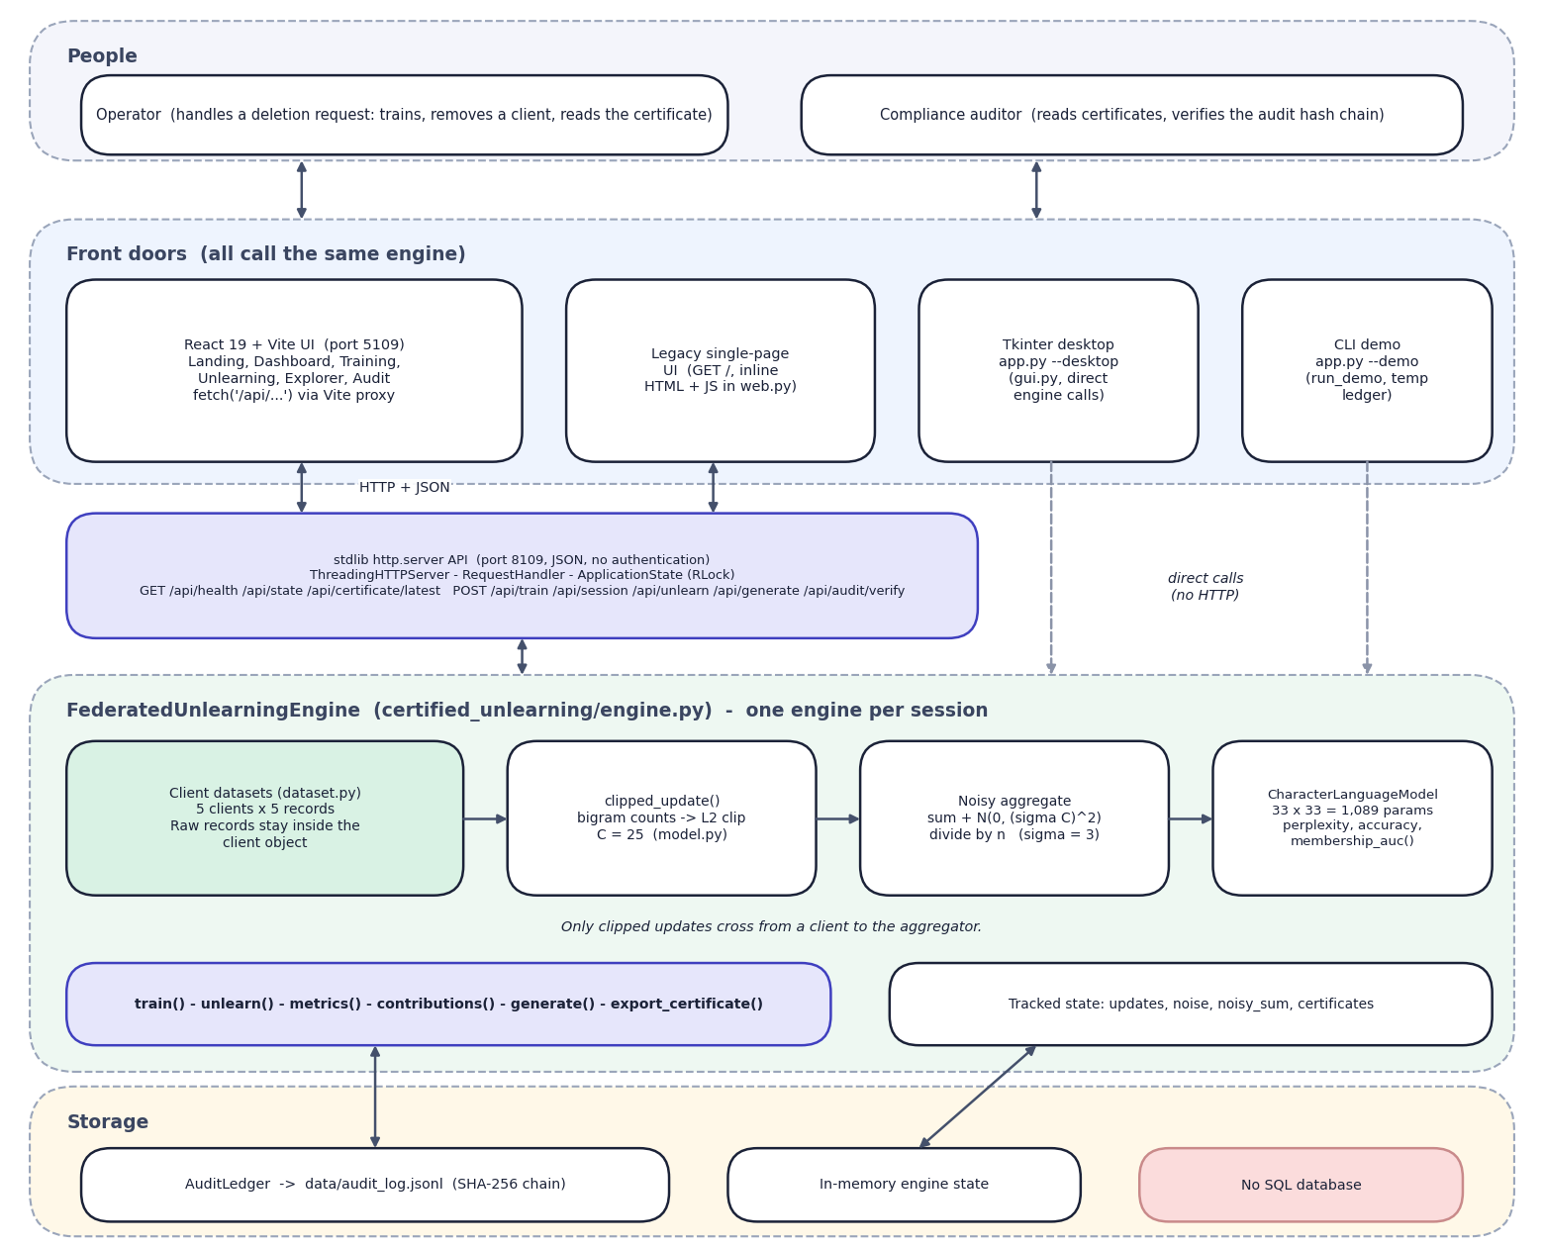
Fig. 5.1: System architecture of ForgetSafe
The diagram has five bands. At the top are the two kinds of person who use the system: the operator, who handles a deletion request by training, removing a client and reading the certificate, and the compliance auditor, who reads certificates and verifies the audit chain. Below them are four front doors that all call the same engine: the React web application on port 5109, which reaches the Python server through the Vite proxy with HTTP and JSON; the original single-page interface that the Python server returns at /; the Tkinter desktop window started with python app.py --desktop; and the terminal demonstration started with --demo. The last two call the engine directly (dashed arrows).
The third band is the standard-library API on port 8109 (ThreadingHTTPServer, the request handler and ApplicationState with its re-entrant lock; JSON, no authentication), and the figure lists the nine routes it serves. The fourth band is the FederatedUnlearningEngine, one per session. Inside it the client datasets, the clipped-update step, the noisy aggregate and the character language model form a left-to-right chain, a note states that only clipped updates cross from client to aggregator, and the engine's operations (train, unlearn, metrics, contributions, generate, export_certificate) and tracked state (updates, noise, noisy sum, certificates) sit below the chain. The bottom band is storage: the hash-chained ledger file, the in-memory engine state, and an explicit 'No SQL database' box.
Five design principles shaped the architecture.
1. Keep the guarantee in one place. Everything that decides whether a removal is certified lives in FederatedUnlearningEngine.unlearn(); the web handler, the React pages and the Tkinter window only call it and display what it returns, so no front end can certify something the engine did not.
2. Separate the model from the orchestration. The language model (model.py) knows only a flat parameter vector and four metrics. The engine treats the vector as the shared state, so the proxy can later be replaced by an adapter tensor of a real model without changing the orchestration, the certificate schema or the ledger. Reference [22] describes the low-rank adapter update that the proxy stands in for.
3. Make every deletion leave evidence. Training and unlearning both end in a ledger append; there is no code path that changes the model without writing an audit record.
4. Dependency-free back end. Using http.server, dataclasses, hashlib and json means the demonstration runs on any machine with Python 3.10 or newer, which matters for a project that is presented on a classroom computer.
5. Honest labelling. The interface states that the model is a demonstrator (a note in the sidebar), and the certificate shows its method string, so nobody reading it can mistake the proxy for a formally erased LLM.
Table 5.1: Layers of the architecture
Layer | Technology | Main files | Responsibility
Presentation (web) | React 19, React Router 7, Recharts, Framer Motion, Vite 8 | frontend/src/pages/*.jsx, components/ui/* | Landing page and five application pages; charts, tables, dialogs, toasts
Presentation (legacy) | HTML/JS string inside web.py; Tkinter | web.py (PAGE), gui.py | Original four-tab interface; desktop window
API | http.server.ThreadingHTTPServer | web.py | Routing, JSON encoding, input checks, status codes, one lock
Domain | Python dataclasses | engine.py | Training, unlearning, verification, certificate
Model | Pure Python lists | model.py | Bigram counts, clipping, probabilities, perplexity, accuracy, membership AUC
Evidence | SHA-256 over canonical JSON, JSONL file | audit.py, data/audit_log.jsonl | Append-only hash chain and its verification
Data | Python constants | dataset.py | Five client corpora, public evaluation set, non-member set

Trust boundary. The federated learning rule is that raw data stays with the client and only an update crosses to the coordinator. In ForgetSafe the clients are ClientDataset objects and the coordinator is the engine, in one process. train() reads client.records to build each update, and the engine keeps every clipped update afterwards, because exact subtraction needs them. The boundary is therefore a convention of the code and not a separation of machines, and the stored updates are exactly the sensitive artefacts that a real deployment would have to encrypt and restrict, as PROJECT_REPORT.md itself notes.

5.2 High-Level Workflow
The workflow of the lab has four user-visible steps, which the web application also shows as the numbered eyebrow of each page (Step 1 to Step 4) and as the three-step workflow card on the dashboard.
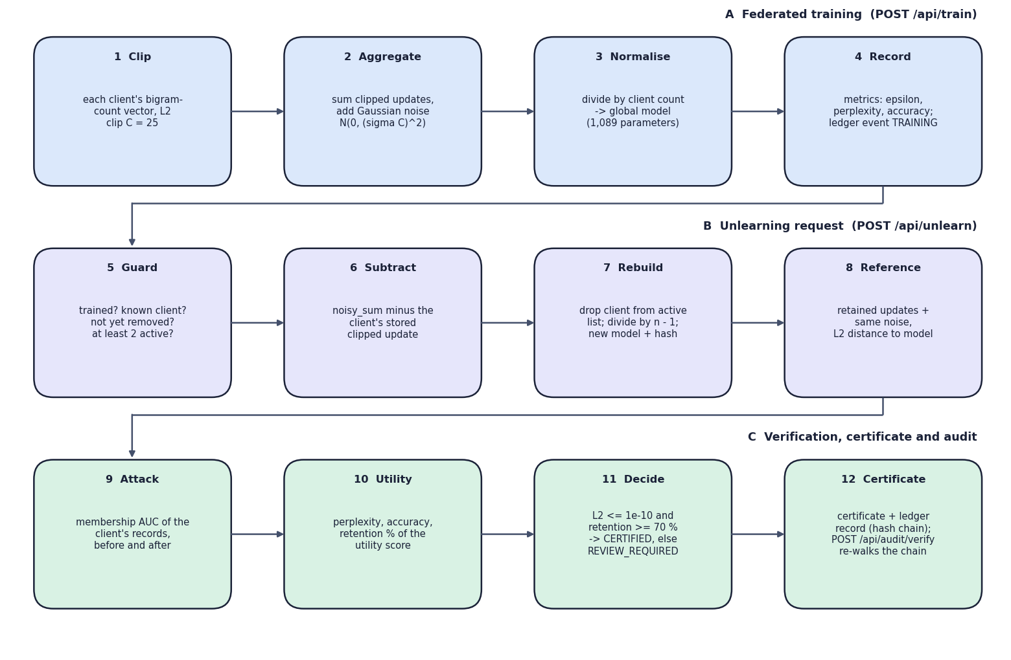
Fig. 5.2: High-level workflow of a training and an unlearning request
The workflow has twelve steps in three bands. Band A is federated training (POST /api/train): clip each client's bigram-count vector at C = 25, sum the clipped updates and add Gaussian noise, divide by the client count to obtain the 1,089-parameter global model, and record the metrics and a training event in the ledger. Band B is the unlearning request (POST /api/unlearn): check the guards, subtract the client's stored update from the noisy sum, drop the client from the active list and rebuild the model with a new hash, and recompute the retained-only reference and its L2 distance to the model. Band C is verification, certificate and audit: the membership AUC of the client's records before and after, the perplexity, accuracy and retention of the utility score, the decision CERTIFIED when the distance is at most 1e-10 and the retention at least 70 percent (otherwise REVIEW_REQUIRED), and the certificate with its ledger record, which POST /api/audit/verify can re-walk at any time.
Table 5.2: Workflow steps and the code that runs them
Step | Trigger | Engine call | Result
1. Train | Train federated model button; POST /api/train | train() | Clipped updates and noise stored, global model built, metrics returned, FEDERATED_TRAINING appended
2. Unlearn | Execute and certify, then Remove and certify in the dialog; POST /api/unlearn | unlearn(client_id) | Update subtracted, model rebuilt, reference check, attack, retention, certificate, CLIENT_UNLEARNING appended
3. Explore | Generate sample; POST /api/generate | generate(seed_text, length) | 180 characters sampled from the current model
4. Audit | Verify hash chain; POST /api/audit/verify | AuditLedger.verify() | Valid or the first broken record number
Reset | New session; POST /api/session | new FederatedUnlearningEngine | Untrained engine, new session id, ledger history kept

Two properties of the workflow are worth stating. First, retraining (pressing Train again) clears the certificates held in memory but not the ledger, so the ledger is a complete history across sessions while the certificate list describes only the current one. Second, the order is enforced by the engine and not only by the interface: unlearn() and generate() raise an error before training, and the API turns it into an HTTP 400 response.

5.3 Data-Flow Diagrams
Three levels of data-flow diagrams describe the movement of data. They follow the code: a data store is drawn only where the code keeps the data (an attribute of the engine or the ledger file), and a process only where a function transforms it.

5.3.1 Level 0: context
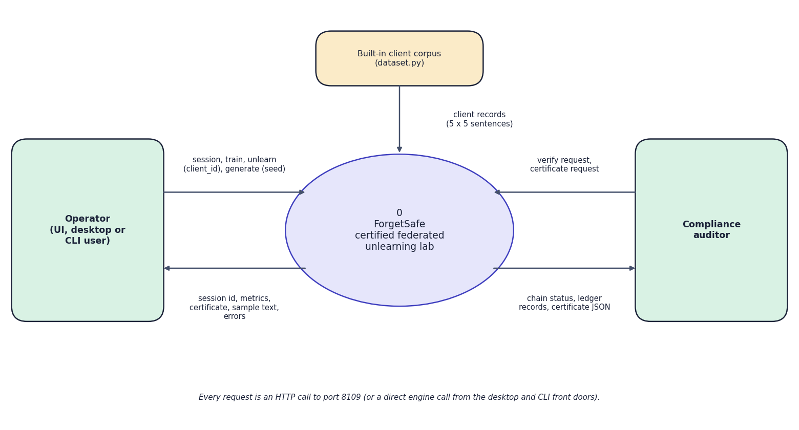
Fig. 5.3: Data-flow diagram, level 0 (context)
At the highest level ForgetSafe is one process, drawn as the circle labelled 0, with three external entities. The operator (a person using the web interface, the desktop window or the command-line demonstration) sends session and train requests, the client id to remove and a seed text, and receives the session id, the metrics (epsilon, perplexity, accuracy), the certificate as JSON, sample text and error messages. The compliance auditor sends verification and certificate requests and receives the chain status, the ledger records and the certificate JSON. The built-in client corpus in dataset.py (25 sentences) is the only data source and flows into the system. The note at the bottom states that every request is an HTTP call to port 8109 or a direct engine call from the desktop and command-line front doors; there is no database server, model hub or message queue.

5.3.2 Level 1: main processes
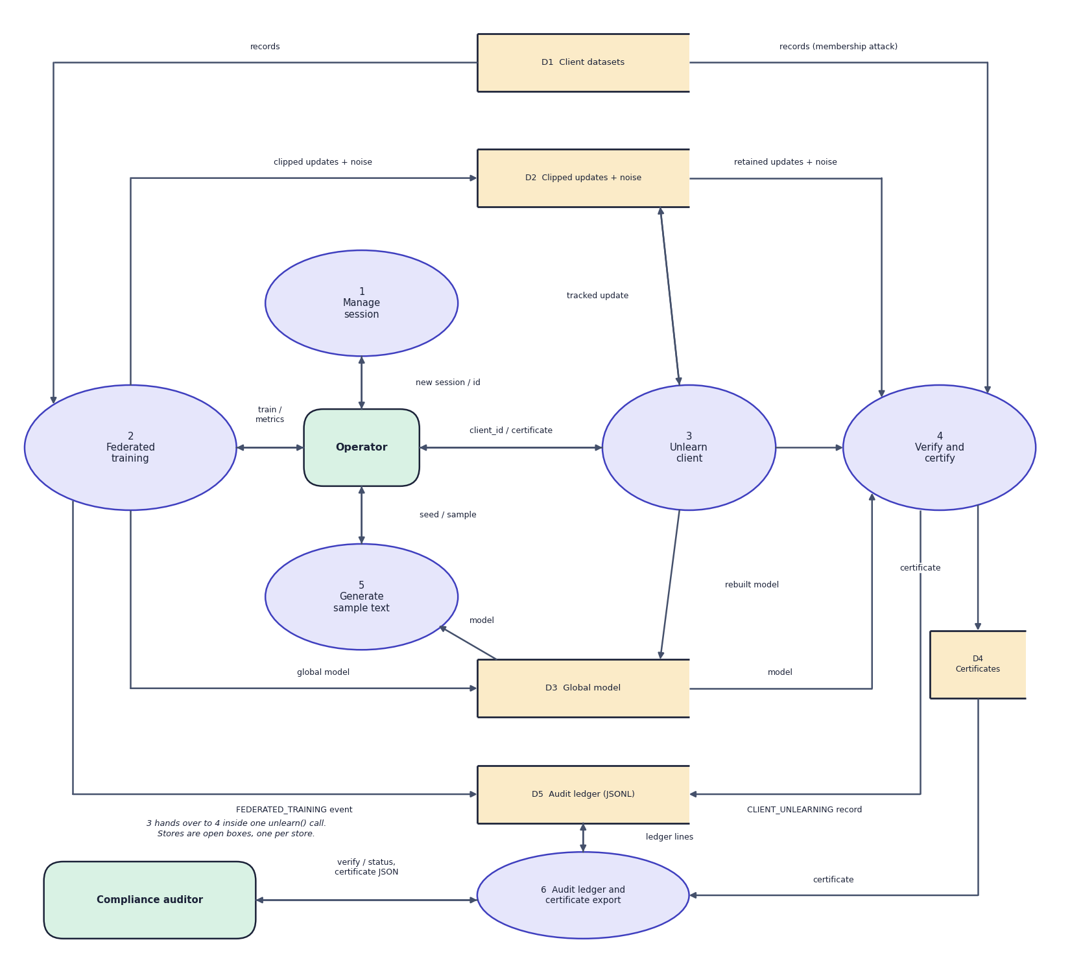
Fig. 5.4: Data-flow diagram, level 1
Level 1 divides the system into six processes: manage session (1), federated training (2), unlearn client (3), verify and certify (4), generate sample text (5), and audit ledger and certificate export (6). Five data stores appear as open boxes: the client datasets (D1, drawn twice to keep the arrows short), the clipped updates with the stored noise (D2), the global model (D3), the certificates held in memory (D4) and the audit ledger file (D5). Training reads D1 and writes D2 and D3; unlearning reads and rewrites D2 and D3; verification reads D1, D2 and D3 and writes D4 and D5; sample generation reads D3; and process 6 reads and writes the ledger and reads the certificates. D5 is the only store that survives a restart.
Table 5.3: Processes and data stores of the level-1 diagram
Process / store | Implemented by | Data in | Data out
1.0 Manage session | ApplicationState, FederatedUnlearningEngine.__init__ | New-session command | Fresh engine, session id (UUID)
2.0 Federated training | train(), clipped_update() | Client records (D1) | Clipped updates and noise (D2), model (D3), metrics, ledger event
3.0 Unlearn a client | unlearn() | Client id, updates (D2) | Reduced noisy sum, rebuilt model (D3)
4.0 Verify and certify | _reference_parameters(), membership_auc(), _utility_retention() | Model, updates, noise, public and non-member sets | Certificate (D4)
5.0 Generate sample text | generate() | Seed text, model (D3) | Text
6.0 Audit ledger and certificate export | AuditLedger, export_certificate() | Events, certificates | Records (D5), verification result, certificate JSON
D1 | dataset.py tuples | - | Records
D2 | engine.updates, update_metadata, noise, noisy_sum | - | Vectors of 1,089 floats
D3 | engine.model | - | Parameter vector
D4 | engine.certificates | - | Certificates of the current session
D5 | data/audit_log.jsonl | - | One JSON line per event

5.3.3 Level 2: unlearning and verification
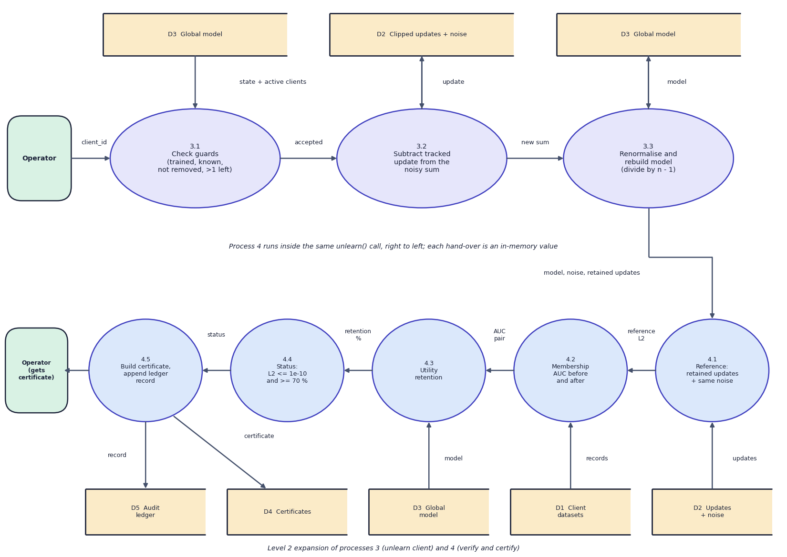
Fig. 5.5: Data-flow diagram, level 2 (unlearning and verification)
Level 2 expands the two processes that carry the contribution of the project. Unlearning (3) has three sub-processes: 3.1 checks the guards (trained, known client, not yet removed, more than one client left) against the model and the active clients, 3.2 subtracts the tracked update held in D2 from the noisy sum, and 3.3 renormalises, rebuilds the model and stores it in D3. Verification (4) runs, drawn right to left in the lower band, as five sub-processes inside the same unlearn() call: 4.1 builds the retained-only reference from the updates and the same noise and measures its distance to the model, 4.2 measures the membership AUC from the client records (D1) before and after, 4.3 computes the utility retention from the model, 4.4 decides the status, and 4.5 builds the certificate, stores it in D4 and appends the ledger record to D5. The operator receives the certificate.
The level-2 view makes one design fact visible: no raw record is read during unlearning. Process 3.0 and the reference recomputation in 4.0 use only the stored updates and the stored noise; the only place the client's raw sentences are touched again is the membership attack, which scores them against the model before and after the removal.

5.4 UML Diagrams
The behaviour and structure of the application are described by a use-case diagram, a class diagram, a sequence diagram and a flowchart of the central algorithm. The ER view of the data model follows in the Data Design section.

5.4.1 Use-case diagram
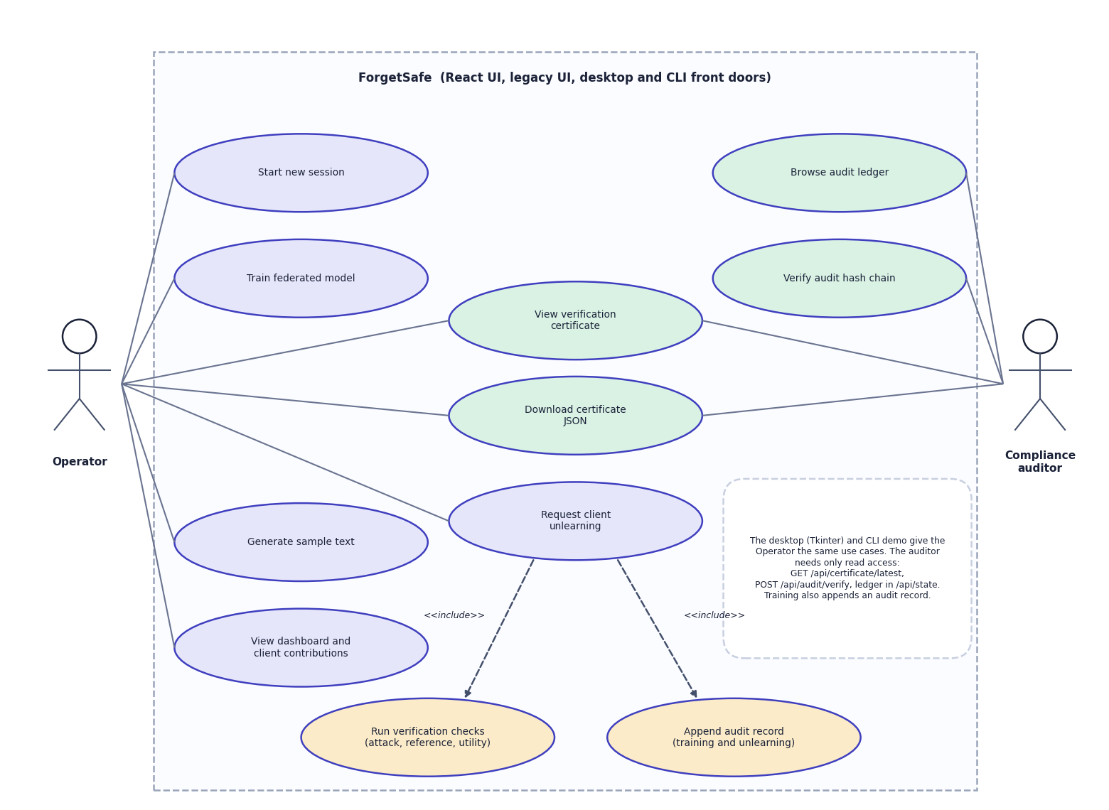
Fig. 5.6: Use-case diagram
Two actors use the system, which the frame labels as the React UI, the legacy UI and the desktop and command-line front doors. The operator starts a new session, trains the federated model, generates sample text, views the dashboard and the client contributions, and requests the unlearning of a client. That last use case includes two others, drawn with dashed include arrows: running the verification checks (attack, reference, utility) and appending an audit record for both training and unlearning events. The compliance auditor browses the audit ledger and verifies the hash chain. Viewing a verification certificate and downloading it as JSON are shared by both actors. A note on the diagram records that the desktop and command-line interfaces expose the same use cases to the operator and that the auditor needs only read access (GET /api/certificate/latest, POST /api/audit/verify, the ledger in /api/state). The diagram contains no login or role use case because the application has no authentication; that absence is recorded as a limitation of the system.

5.4.2 Class diagram
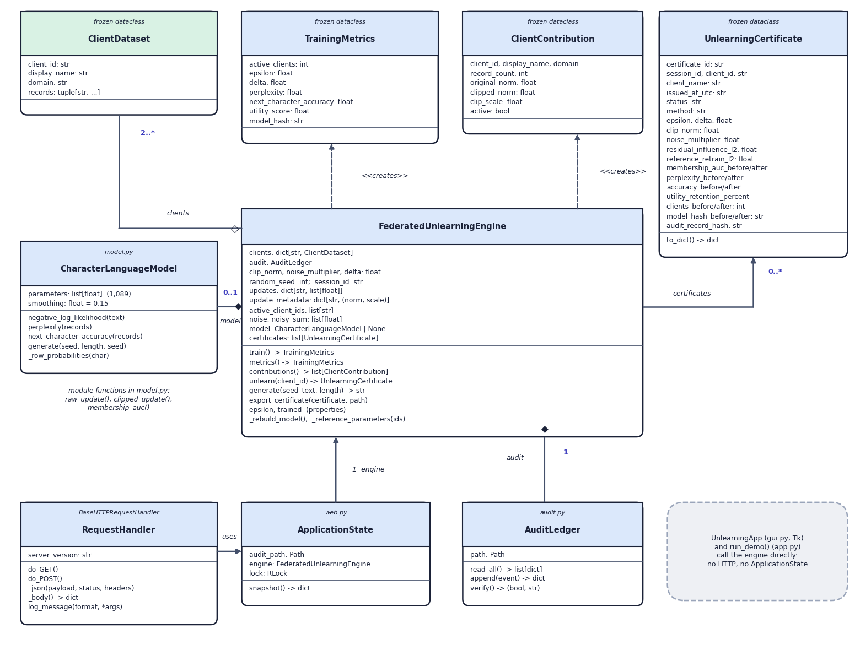
Fig. 5.7: UML class diagram
The class diagram shows the engine at the centre. FederatedUnlearningEngine aggregates two or more ClientDataset objects, holds at most one CharacterLanguageModel (composition, 0..1, because the engine starts untrained) and exactly one AuditLedger (composition), keeps zero or more UnlearningCertificate objects, and creates TrainingMetrics and ClientContribution values through dashed creates dependencies; all four value classes are frozen dataclasses. ApplicationState holds one engine and a re-entrant lock for the web layer, and the request handler built by make_handler uses it. A grey note states that the Tkinter class UnlearningApp and run_demo() call the engine directly, with no HTTP and no ApplicationState. The module-level functions of model.py (raw_update, clipped_update, membership_auc) are noted beside the model class.
Table 5.4: Classes of the back end
Class / module | Kind | Key members (from the code)
ClientDataset | frozen dataclass | client_id, display_name, domain, records (tuple of strings)
FederatedUnlearningEngine | class | clients, audit, clip_norm, noise_multiplier, delta, random_seed, session_id, updates, update_metadata, active_client_ids, noise, noisy_sum, model, certificates; train(), metrics(), contributions(), unlearn(), generate(), export_certificate(); properties trained, epsilon
CharacterLanguageModel | dataclass | parameters, smoothing (0.15); negative_log_likelihood(), perplexity(), next_character_accuracy(), generate()
TrainingMetrics | frozen dataclass | active_clients, epsilon, delta, perplexity, next_character_accuracy, utility_score, model_hash
ClientContribution | frozen dataclass | client_id, display_name, domain, record_count, original_norm, clipped_norm, clip_scale, active
UnlearningCertificate | frozen dataclass | 25 fields (see Data Design); to_dict()
AuditLedger | class | path; read_all(), append(), verify()
ApplicationState | class | audit_path, engine, lock (re-entrant); snapshot()
RequestHandler | class (inside make_handler) | do_GET(), do_POST(), _json(), _body(), log_message()
UnlearningApp | Tkinter class | four notebook tabs; _train(), _unlearn(), _generate(), _verify_audit(), _export_certificate()

5.4.3 Sequence diagram
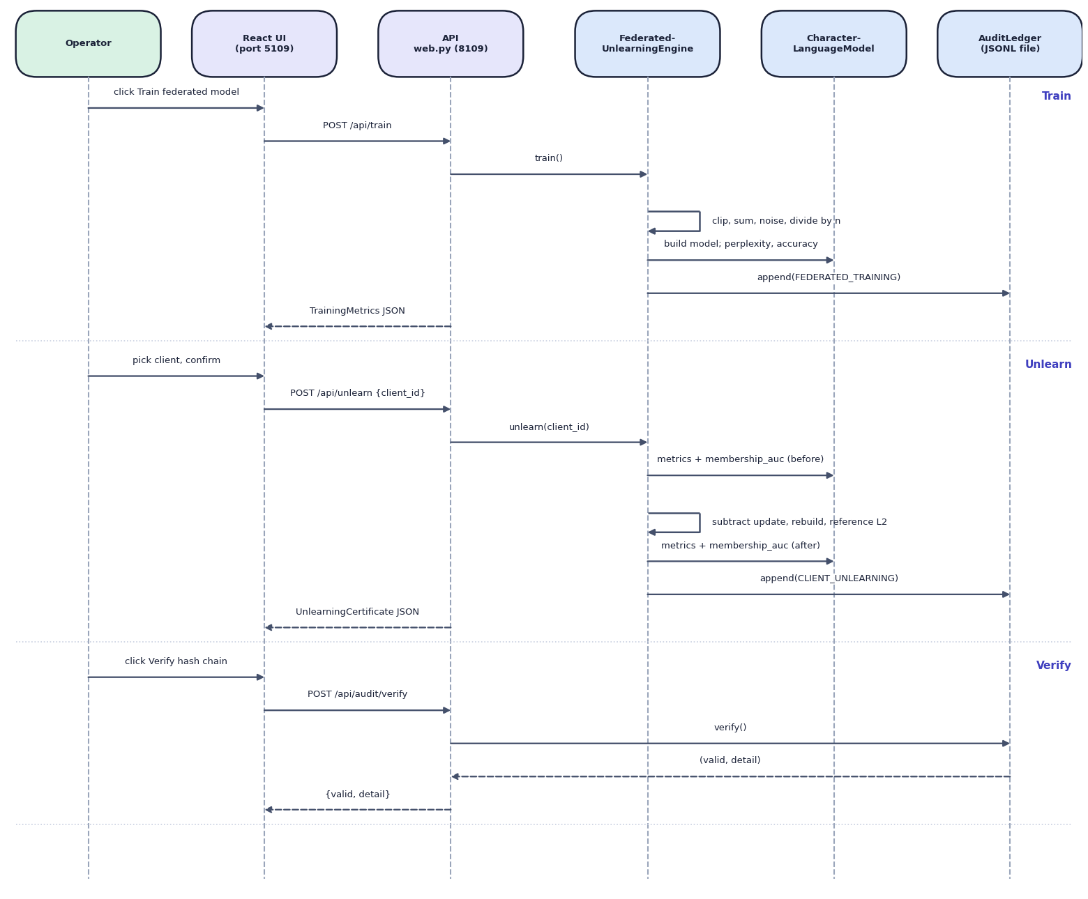
Fig. 5.8: Sequence diagram of training, unlearning and audit verification
Six lifelines run left to right: the operator, the React UI (port 5109), the API in web.py (port 8109), the engine, the character language model and the audit ledger. The Train band shows the operator pressing Train, the UI calling POST /api/train, the API calling train(), the engine clipping, summing, adding noise and dividing by n, asking the model for perplexity and accuracy, appending the FEDERATED_TRAINING event and returning the metrics JSON. In the Unlearn band the operator picks a client and confirms, the UI calls POST /api/unlearn with the client id, and the engine asks the model for metrics and the membership AUC before, subtracts the update and rebuilds, asks again after, appends CLIENT_UNLEARNING and returns the certificate JSON. In the Verify band the Verify button calls POST /api/audit/verify, the API calls the ledger's verify() directly, and the pair (valid, detail) returns as {valid, detail}.

5.4.4 Flowchart of the core algorithm
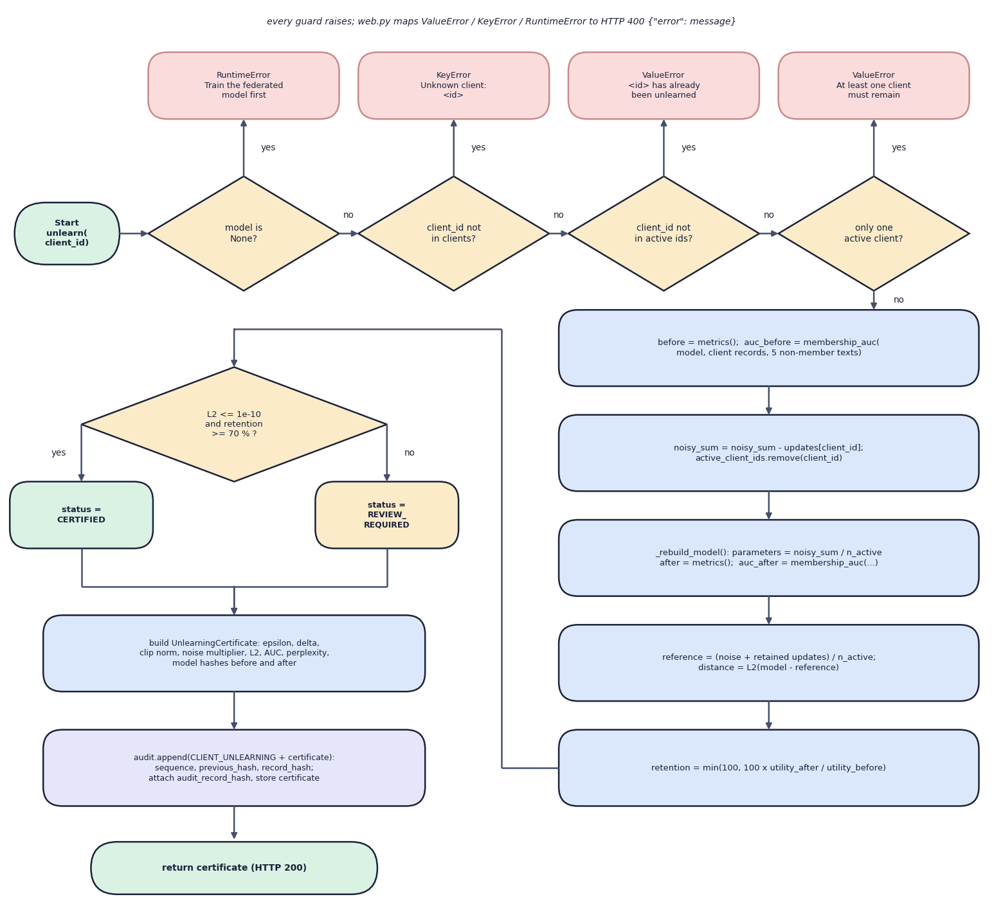
Fig. 5.9: Flowchart of the unlearning algorithm (`FederatedUnlearningEngine.unlearn`)
The flowchart follows unlearn() from the start terminal. Four diamonds are the guards: the model is untrained (RuntimeError), the client id is unknown (KeyError), the client has already been unlearned (ValueError), or only one client is active (ValueError); each 'yes' leaves through a red box and web.py maps all of them to HTTP 400. A request that passes records the metrics and the membership AUC, subtracts the tracked update and removes the client, rebuilds the model and measures again, recomputes the reference and its L2 distance, and computes the retention. The last diamond tests the distance against 1e-10 and the retention against 70 percent: both true gives CERTIFIED, otherwise REVIEW_REQUIRED. Either way the certificate is built, appended to the ledger and returned with HTTP 200.

5.5 Data Design
ForgetSafe has no SQL or document database. This is a deliberate consequence of the problem it demonstrates: the evidence that must last is the audit ledger, and the working state of a session is cheap to recompute from a seed. The data model therefore has two parts: state held in memory by the engine, and one append-only file.
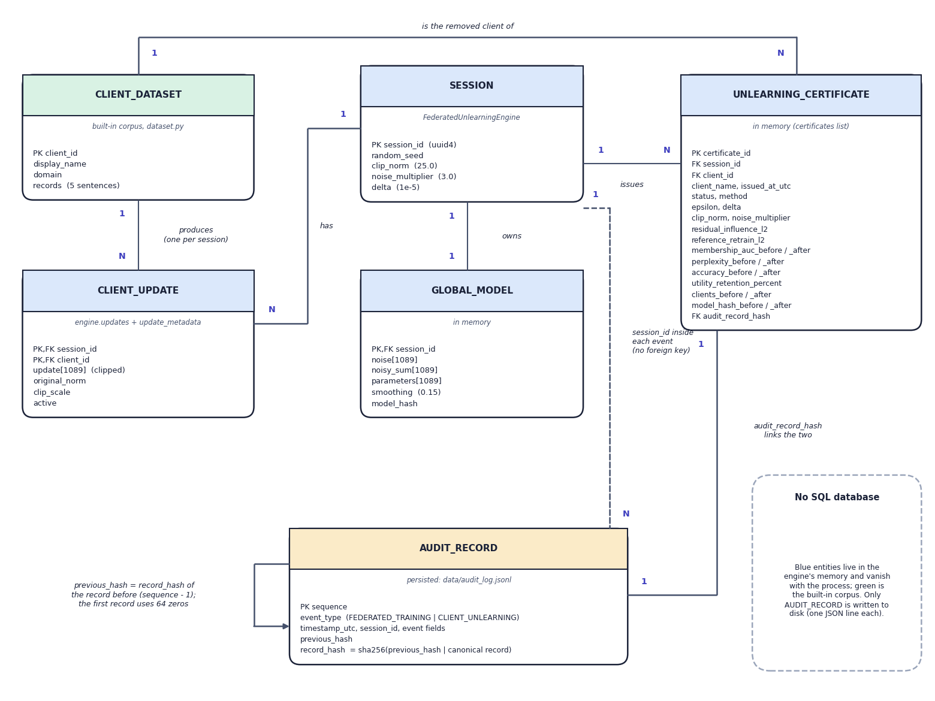
Fig. 5.10: Entity-relationship view of the data model (no SQL database)
ForgetSafe has no relational database, so the diagram shows the entities of its data model and how they relate; a note in the corner says so, and colour separates the in-memory entities (blue and green) from the persistent one (amber). A client dataset produces one client update per session, and a session has one update for each client, one global model (the noise, the noisy sum, the parameters and the model hash) and any number of certificates. Each certificate names the client dataset it removed and is linked one-to-one with an audit record through audit_record_hash. The audit record carries the session id inside its event fields but has no foreign key, and its previous_hash points to the record before it, the first record using 64 zeros, which is the self-link that forms the chain. Only the audit record is written to disk, as one JSON line of data/audit_log.jsonl.

5.5.1 In-memory state of a session
Table 5.5: Engine state
Attribute | Type | Set by | Meaning
session_id | str (UUID4) | __init__ | Identifies the session in events and certificates
clients | dict[str, ClientDataset] | __init__ | Five clients; raw records (D1)
updates | dict[str, list[float]] | train() | Clipped bigram-count vector per client, 1,089 floats each
update_metadata | dict[str, (float, float)] | train() | Original L2 norm and clip scale per client
active_client_ids | list[str] | train(), unlearn() | Clients still contributing to the model
noise | list[float] | train() | One Gaussian draw, standard deviation sigma times C per coordinate; kept for the whole session
noisy_sum | list[float] | train(), unlearn() | Sum of active clipped updates plus the noise
model | CharacterLanguageModel or None | _rebuild_model() | noisy_sum divided by the active-client count
certificates | list[UnlearningCertificate] | unlearn(); cleared by train() | Certificates of the current session

None of this state is written to disk. After a server restart the engine is untrained, and only the ledger shows what happened before. The random seed (2026 by default) makes the noise repeatable: the same seed gives the same noise and therefore the same model hash, which is what makes the experiments of the results chapter reproducible.

5.5.2 Audit ledger records
The ledger is a JSON-lines file; each line is one record. The path is data/audit_log.jsonl relative to the directory from which the server is started, and the file is excluded from version control. Every record carries the three chain fields, and the remaining fields depend on the event type.
Table 5.6: Ledger record schema
Field | Event types | Description
sequence | both | 1-based position in the ledger
previous_hash | both | record_hash of the preceding record; 64 zeros for the first
record_hash | both | SHA-256 of previous_hash, a vertical bar and the canonical JSON of the record without this field
event_type | both | FEDERATED_TRAINING or CLIENT_UNLEARNING
timestamp_utc | training | ISO-8601 time, seconds precision
session_id, active_clients, epsilon, delta, clip_norm, noise_multiplier, model_hash | training | Configuration and fingerprint of the trained model (epsilon rounded to 8 places)
all 25 certificate fields | unlearning | The certificate, whose issued_at_utc serves as the time

One detail follows from the order of operations. The certificate is appended to the ledger before its own record hash exists, so the ledger copy holds an empty audit_record_hash; the engine then stores the returned record_hash in the certificate object that is handed back to the caller. The certificate a user downloads therefore points to its ledger record, and the ledger record does not point back, which is acceptable because the record's position in the chain already identifies it.

5.5.3 Certificate schema
Table 5.7: The 25 fields of an unlearning certificate
Group | Fields
Identity | certificate_id (CERT- and 12 hex digits), session_id, client_id, client_name, issued_at_utc
Decision | status (CERTIFIED or REVIEW_REQUIRED), method (fixed string: tracked clipped-update subtraction with retained-client renormalization)
Privacy parameters | epsilon, delta, clip_norm, noise_multiplier
Verification | residual_influence_l2, reference_retrain_l2 (the same number in this implementation), membership_auc_before, membership_auc_after
Utility | perplexity_before, perplexity_after, accuracy_before, accuracy_after, utility_retention_percent
Population and integrity | clients_before, clients_after, model_hash_before, model_hash_after, audit_record_hash

Two limits of this design are stated here because they affect how the evidence can be used. The ledger append reads the whole file to find the previous hash, so its cost grows with the ledger (the results chapter measures 0.44 ms at one record and 19.6 ms at 2,000). And two server processes started in the same directory would write to the same file without any file lock; the RLock in ApplicationState protects threads of one process only.

5.6 Module Design
The code base is small enough to describe module by module. Line counts below were taken from the files when this report was built.
Table 5.8: Back-end and test modules
Module | Lines | Responsibility | Key functions and classes
certified_unlearning/engine.py | 297 | Lifecycle of a session: train, unlearn, verify, certify, export | FederatedUnlearningEngine, TrainingMetrics, ClientContribution, UnlearningCertificate, _vector_hash()
certified_unlearning/model.py | 122 | Character-bigram model and its numerical helpers | normalize_text(), raw_update(), clipped_update(), l2_norm(), CharacterLanguageModel, membership_auc()
certified_unlearning/audit.py | 65 | Append-only hash-chained ledger | AuditLedger.append(), verify(), read_all(), GENESIS_HASH
certified_unlearning/dataset.py | 101 | Built-in corpora | CLIENTS, PUBLIC_EVALUATION, NON_MEMBER_TEXTS, ClientDataset
certified_unlearning/web.py | 247 | HTTP server, JSON API and the legacy page | PAGE, ApplicationState, make_handler(), run_web()
certified_unlearning/gui.py | 379 | Tkinter desktop interface | UnlearningApp, run_gui()
app.py | 59 | Entry point with three modes | run_demo(), main() (--demo, --desktop, --port, --host, --open-browser)
tests/test_end_to_end.py | 85 | Unit and endpoint tests (5 tests) | FederatedUnlearningTests
scripts/smoke_test.py | 120 | End-to-end API check (14 checks) | run(), call(), check()

web.py holds the single largest block of text, but most of it is the embedded legacy page (about 90 lines of HTML, CSS and JavaScript); its Python logic is about 140 lines from ApplicationState to run_web().

5.6.1 Engine module
engine.py is the module that carries the project's claim. train() builds one clipped update per client, draws the noise with random.Random(seed).gauss, forms the noisy sum and builds the model. unlearn() guards the request, subtracts, rebuilds, measures and certifies. metrics() computes perplexity, accuracy, the composite utility score and the SHA-256 fingerprint of the parameter vector (the vector rounded to 12 decimals and serialised as compact JSON). contributions() exposes the per-client norms that the training page charts, and _reference_parameters() builds the retained-only recomputation that the certificate compares against.

5.6.2 Model module
model.py defines the 33-symbol alphabet (the start marker ^, the end marker $, space, the 26 lower-case letters and four punctuation marks), and keeps the 1,089-element parameter vector as a flat list in row-major order, so that the entry for the transition from character a to character b is at index(a) * 33 + index(b). Probabilities are computed row by row: the parameter is clamped at zero, the smoothing constant 0.15 is added, the entry for the start marker is zeroed so that the model never emits it, and the row is normalised. This clamping is what lets a noisy, partly negative parameter vector still define a valid distribution.

5.6.3 Audit module and web module
audit.py has no dependency on the rest of the package. It hashes with hashlib.sha256 and writes with an explicit \n newline so that the file is byte-identical across operating systems. web.py builds the handler class inside make_handler(application) so that the handler closes over one ApplicationState; the tests exploit this by starting a server on an spare port with their own temporary ledger.

5.6.4 Front-end modules
Table 5.9: Front-end modules
Path | Lines | Role
frontend/src/main.jsx | 22 | Mounts theme, toast and lab providers and the router
frontend/src/App.jsx | 43 | Route table; lazy-loads each page
frontend/src/lib/api.js | 40 | Thin fetch client for the eight JSON endpoints; turns {error} bodies into ApiError
frontend/src/lib/lab.jsx | 34 | LabProvider and useLab(): the single copy of GET /api/state
frontend/src/lib/theme.jsx | 46 | Light and dark theme, persisted in localStorage
frontend/src/pages/Dashboard.jsx | 93 | Workflow stepper, four metric tiles, client-norm chart, latest certificate
frontend/src/pages/Training.jsx | 125 | Train, retrain and new-session actions with confirmation dialogs; clients table and norm chart
frontend/src/pages/Unlearning.jsx | 136 | Client selector, confirmation dialog, certificate view, before and after charts
frontend/src/pages/Explorer.jsx | 88 | Seed field, sample list tagged with client count and model hash
frontend/src/pages/Audit.jsx | 62 | Chain status, searchable ledger table, record viewer
frontend/src/pages/Landing.jsx | 261 | Public landing page with live counters from /api/state
frontend/src/pages/shared.jsx | 193 | CertificateView, AuditTable, ClientsTable, status badges
frontend/src/pages/useAction.js | 30 | Runs an API call, refreshes state, shows a success or error toast
frontend/src/components/ui/* | 1296 | Button, Card, Table, Modal, Toast, Layout, Skeleton and other building blocks
frontend/src/components/charts/index.jsx | 202 | Recharts wrappers: bar, grouped bar, line, area

5.7 User Interface Design
The web application has one public landing page and a sidebar application with five pages: Dashboard (/app), Federated training (/app/training), Certified unlearning (/app/unlearning), Model explorer (/app/explorer) and Compliance audit (/app/audit). The pages are numbered Step 1 to Step 4 in their headers so that the order of the workflow is visible. A top bar shows an API-online indicator that polls /api/health every 30 seconds and a light and dark theme toggle; on screens narrower than 900 pixels the sidebar is replaced by a bottom navigation bar and a drawer.
All pages read one shared copy of the server state through useLab(), which calls GET /api/state once and again after every action. The shared useAction() hook wraps every mutating call: it marks the button busy, refreshes the state, and raises a success toast or an error toast that stays for eight seconds. Because the engine lives on the server, a browser reload does not lose the session.
Four interface states are handled on every page. While the first state request is in flight a skeleton is shown; when no model has been trained an empty state explains what to do and offers a button; when the API cannot be reached an error state offers a retry; and destructive actions (retraining, a new session, removing a client) ask for confirmation in a modal dialog that states the consequence in one sentence. The removal dialog reads, for example, that the client will be erased from the global model and that this cannot be undone in the session.
Several design decisions come from the nature of the content. Numbers a regulator would read (epsilon, delta, residual influence, reference distance, hashes) are shown in a monospaced style and in full on the certificate, with a Download JSON button that fetches /api/certificate/latest. Status is never colour alone: a certified result carries a shield icon and the word Certified, a failed chain carries a broken-shield icon and the word Broken. The landing page contains no invented statistics; its counters (registered clients, domains, ledger records) are read from the live API. The sidebar carries a standing note, Demonstrator, which says that the model is a character-level proxy for an LLM adapter update and that the product is not a legal compliance product.
Two of the screens are shown below to illustrate the design; the complete set of output screens, including the dark theme and the phone layout, is in the results chapter and Appendix C.
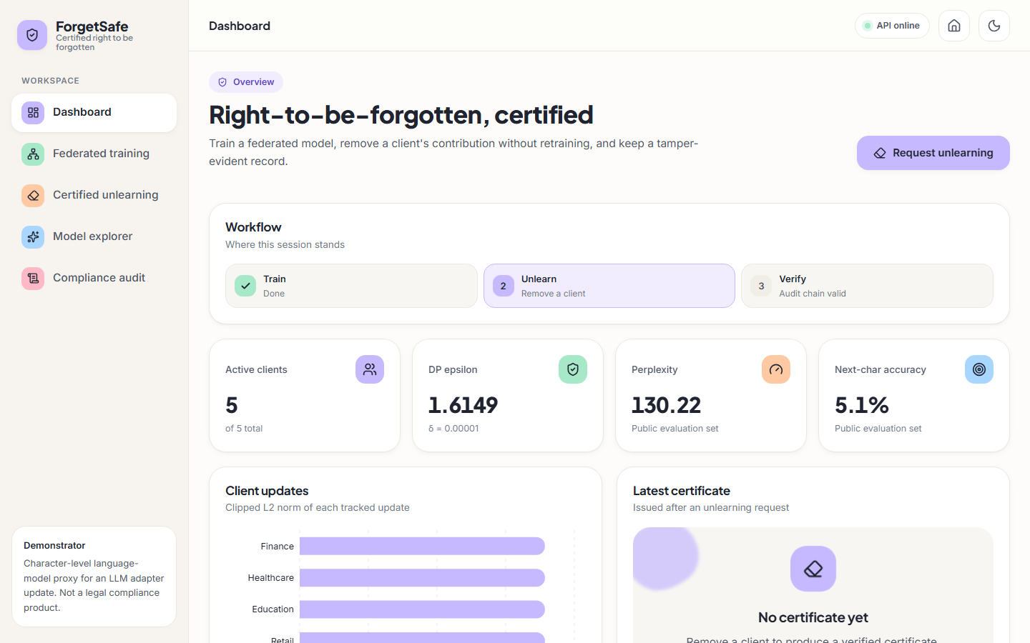  Fig. 5.11: Dashboard: workflow stepper, four metric tiles, client norms and certificate slot | 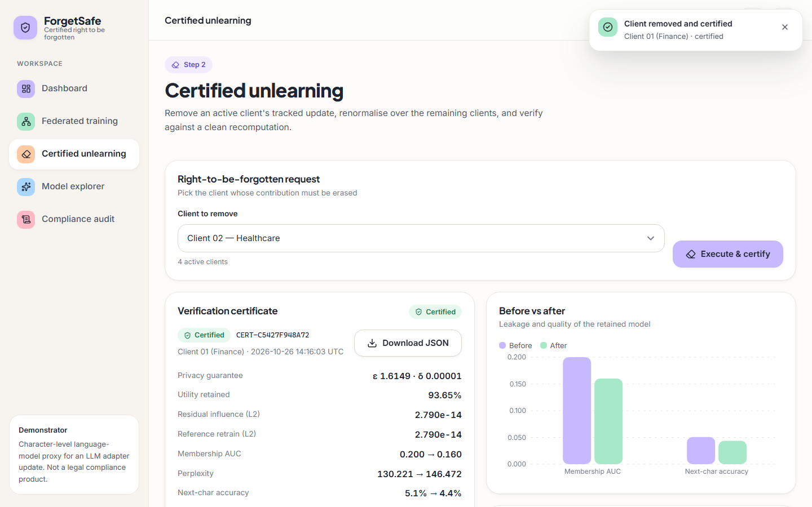  Fig. 5.12: Certified unlearning: confirmation result, certificate and before-and-after chart

One limitation of the interface should be recorded. The explorer shows what the model generates, and at the default noise level the text is a string of letters with little structure (the capture in the results chapter shows a sample beginning privacybsov), because the model is noise-dominated. The interface presents the sample honestly as the model's output rather than polishing it, but it also offers no warning that the quality is low; the metric tiles (perplexity 130.22, accuracy 5.1 percent) are the only indication.

CHAPTER 6
METHODOLOGY AND SOFTWARE IMPLEMENTATION

6.1 Overall Methodology
The methodology has two layers: the method that the product implements, and the method by which it was evaluated. The product method is a single pipeline of seven steps, from client updates to an audit record. The evaluation method is a set of repeatable experiments that treat the product as a black box and measure what its certificate does and does not establish.
The design of the product followed the review method of the base paper [1]: organise the existing approaches into a taxonomy, compare their strengths and limitations, and read the open gap from the comparison. The base paper applies that method to continuous sign-language recognition; the subject is unrelated, so no algorithm and no result was taken from it. Applied to machine unlearning, the method gave the decisions in the table below.
Table 6.1: Approach classes and the resulting design decisions
Approach class | Strength | Limitation | Decision in ForgetSafe
Full retraining | Strongest removal baseline | Cost grows with model and data | Used as the reference computation, and in the retrain-from-scratch experiment
Gradient or weight heuristics | Fast | No evidence that the data is gone | Not used for certification
Sharded training (SISA) [12] | Limits the retraining scope | Adds training-architecture complexity | Left as a future back end
Differentially private training [10], [11] | Bounds one client's influence | Privacy-utility trade-off | Gaussian noise and an (epsilon, delta) figure included
Tracked additive updates | Exact subtraction at O(d) cost | Requires protected storage of every update | Used by the demonstrator

6.1.1 The product pipeline
1. Build client updates. Each client's records are normalised and turned into a vector of character-bigram counts (1,089 coordinates).
2. Clip. The vector is scaled so that its L2 norm is at most C = 25; the original norm and the scale are kept.
3. Aggregate with noise. The coordinator sums the clipped updates, adds one Gaussian noise vector with standard deviation sigma times C (sigma = 3) per coordinate, and divides by the number of clients. The result is the global model.
4. Record. A FEDERATED_TRAINING event with the configuration and the model's SHA-256 fingerprint is appended to the ledger.
5. Remove a client. The client's stored clipped update is subtracted from the noisy sum, the sum is divided by the remaining client count, and the model is rebuilt. No raw record is read and nothing is retrained.
6. Verify. The engine recomputes a retained-only aggregate, measures the loss-based membership attack on the removed client's records before and after, measures perplexity and next-character accuracy on a public evaluation set, and computes the utility retained.
7. Certify and record. If the reference distance is at most 1e-10 and the retention is at least 70 percent the status is CERTIFIED, otherwise REVIEW_REQUIRED; the certificate is appended to the ledger, whose hash chain can be verified at any time.

6.1.2 The evaluation method
Because the application reports its own verdict, a verdict alone is weak evidence. The evaluation therefore adds experiments that the application does not run itself (scripts/run_experiments.py, each writing experiments/<name>/metrics.json): the default configuration (seed 2026); a study of 50 seeds with all five clients removed in turn (250 unlearning requests); a sweep of the noise multiplier from 0.001 to 10 with 20 seeds per value; a comparison of the unlearned model with a true retrain that draws fresh noise (200 pairs at each of two noise levels); a noise-free run that shows what the attack sees without noise; sequential removal from five clients to one; seven tampering attacks on the ledger; scaling from 5 to 500 synthetic clients; and 100 requests per endpoint against the live server. All of them run on one Intel Core i5-12500 machine with 15.7 GB of RAM and use only the standard library.

6.2 Dataset
ForgetSafe uses no external dataset. The corpus is defined in certified_unlearning/dataset.py and consists of three fixed sets of short English sentences: the records of five simulated clients, a public evaluation set, and a set of non-member sentences. It was written for the demonstrator, is shipped inside the source file, and so involves no download, licence or personal data. The clients are named by domain: Finance, Healthcare, Education, Retail and Travel, each holding five sentences.
Table 6.2: The five client corpora and their update vectors
Client | Domain | Records | Characters | Bigram transitions | Non-zero cells | Raw L2 norm | Largest count
Client 01 | Finance | 5 | 240 | 245 | 123 of 1,089 | 26.589 | 7
Client 02 | Healthcare | 5 | 256 | 261 | 131 of 1,089 | 28.231 | 8
Client 03 | Education | 5 | 248 | 253 | 135 of 1,089 | 26.401 | 7
Client 04 | Retail | 5 | 245 | 250 | 140 of 1,089 | 25.219 | 7
Client 05 | Travel | 5 | 244 | 249 | 143 of 1,089 | 26.552 | 9

Together the clients hold 25 sentences, 1,258 bigram transitions, and 268 distinct non-zero cells out of the 1,089 possible. The samples below show the character of the text; every sentence is a short, generic statement tied to the client's domain.
- Finance: "private banking records require careful access control."
- Healthcare: "patient records remain private during medical analysis."
- Education: "students learn data science through practical projects."
- Retail: "the store processes an online order securely."
- Travel: "the traveler books a quiet hotel near the station."
The public evaluation set has 5 sentences (275 transitions) on privacy and learning themes and is used to compute perplexity and next-character accuracy for every model state. The non-member set has 5 sentences (262 transitions) that no client holds; it supplies the negative class of the membership attack. Measured against the union of the client corpora, 3.3 percent of the public-set transitions and 5.7 percent of the non-member transitions never occur in training, which is why the smoothing constant of the model matters.
Table 6.3: Roles of the three fixed sets
Set | Sentences | Role | Used by
Client records | 5 per client, 25 in all | Source of each client's update; the 'member' class of the attack | train(), membership_auc()
Public evaluation | 5 | Utility measurement on data that no client owns | metrics()
Non-member texts | 5 | 'Non-member' class of the attack | unlearn()

There is no train, validation and test split in the machine-learning sense, because nothing is fitted by optimisation; the three sets have disjoint roles instead. The size is the main limitation of the data. Twenty-five sentences give a membership attack with only 5 member and 5 non-member scores, so the AUC moves in steps of 0.04, and a single sentence can change it by 0.2. The experiments compensate by repeating the whole procedure over 50 seeds, but they cannot make the corpus larger.

6.3 Preprocessing
Preprocessing has three steps, all in certified_unlearning/model.py: text normalisation, bigram counting and clipping. Together they turn a client's sentences into the vector that the federated protocol treats as the client's update.

6.3.1 Normalisation
Listing: alphabet, index and `normalize_text()` (model.py)
ALPHABET = "^$ abcdefghijklmnopqrstuvwxyz.,?!"
INDEX = {character: position for position, character in enumerate(ALPHABET)}
DIMENSION = len(ALPHABET) * len(ALPHABET)

def normalize_text(text: str) -> str:
cleaned = "".join(character if character in INDEX else " " for character in text.lower())
return re.sub(r"\s+", " ", cleaned).strip()

Text is lower-cased, every character outside the 33-symbol alphabet is replaced by a space, runs of whitespace are collapsed and the ends are stripped. The alphabet is the start marker ^, the end marker $, the space, the 26 lower-case letters and the four punctuation marks ., ,, ? and !. Digits, accented letters and other punctuation are therefore lost, which is acceptable for the English sentences of the corpus and would be the first thing to change for a real tokenizer.

6.3.2 Bigram counting
Listing: `_offset()` and `raw_update()` (model.py)
def _offset(left: str, right: str) -> int:
return INDEX[left] * len(ALPHABET) + INDEX[right]

def raw_update(records: Iterable[str]) -> list[float]:
counts = [0.0] * DIMENSION
for record in records:
text = normalize_text(record)
sequence = f"^{text}$"
for left, right in zip(sequence, sequence[1:]):
counts[_offset(left, right)] += 1.0
return counts

Each normalised record is wrapped as ^text$, and every pair of adjacent symbols adds one to a cell of a 33 x 33 table stored as a flat list; the cell for the transition from a to b is at index(a) * 33 + index(b). As a worked example, the record go. becomes ^go.$ and adds one to the cells (^, g), (g, o), (o, .) and (., $). A client's raw update is the sum over its five records, and its largest single count in the corpus is 9. The vector is a count of events, which makes the aggregate linear in the data: adding or removing a record adds or removes its counts, the property that exact unlearning will rely on.

6.3.3 Clipping
Listing: `clipped_update()` (model.py)
def clipped_update(records: Iterable[str], clip_norm: float) -> tuple[list[float], float, float]:
update = raw_update(records)
original_norm = l2_norm(update)
scale = min(1.0, clip_norm / original_norm) if original_norm else 1.0
return [value * scale for value in update], original_norm, scale

The raw update is scaled by min(1, C / norm) with C = 25. All five raw norms (25.219 to 28.231) exceed C, so all five clients are clipped, with scales from 0.886 to 0.991 and a clipped norm of exactly 25. Clipping serves two purposes: it bounds the influence of any one client, which is what the differential-privacy calibration needs, and it equalises the five clients. Its cost is distortion: the client with the largest raw norm (Healthcare, 28.231) is scaled down by 11.4 percent.

6.4 Algorithm Choice and Justification
The central choice is how to remove a client's influence. The table lists the alternatives considered and the reason each was not adopted; the descriptions come from the cited works and are about the technique in general, not about their reported numbers.
Table 6.4: Alternatives considered
Alternative | Idea | Why it was not used here
Retrain from scratch | Train again on the retained clients | Exact, but it is the cost that motivates the problem; used only as a reference
SISA sharding [12] | Train shard models and retrain only the shard that held the data | Needs a different training architecture and an ensemble; no shard structure in a single aggregate
Gradient ascent and weight heuristics | Move the weights away from the data to be forgotten | No evidence of removal and no clean reference; the batch literature survey lists this as a weakness
Certified removal by a Newton step [13] | One second-order update with noise gives an (epsilon, delta) removal guarantee for convex models | Needs a convex loss and a Hessian; the proxy has no loss to optimise
Influence-based unlearning [14] | Remove influence with an approximate update and bounded excess risk | Same requirement of a differentiable empirical risk
FedEraser [17] | Reconstruct the global model from stored historical client updates, calibrated with a few rounds | Aimed at multi-round training; ForgetSafe aggregates once, so exact subtraction is possible
Memorisation pruning [2] | Reset parameters responsible for memorised content | Needs a trained deep model and a memorisation metric
Federated LLM unlearning [3] | Unified framework of federated algorithms and unlearning algorithms for LLMs | Needs an LLM and GPUs; the target of the future back end

Why tracked additive updates. The aggregate is a sum. If the coordinator stores each client's clipped update, then removing client j is the subtraction of a stored vector, and the result is the same vector that a recomputation over the remaining clients would give. The cost is one vector operation, independent of the amount of data; the evidence is an identity that can be checked to floating-point precision; and the method needs no access to the removed client's raw records. These properties fit the six objectives of the project better than any approximate method could, and they make the verification step meaningful to implement.
What the choice costs. Exact subtraction is possible only because the model is a linear function of a single round of updates. Real federated averaging [9] runs many rounds in which each client's update depends on the global model of the previous round, so a client's influence is entangled with later updates and cannot be removed by subtracting one stored vector; this is the reason the literature turns to approximate and statistical removal. The method also requires the coordinator to keep every update, which are the most sensitive artefacts in the system. The project therefore describes the result as an exact removal in a one-round linear setting, not as a method for LLM unlearning in general.
Gaussian mechanism with clipping. Clipping bounds the L2 sensitivity of the sum to C when a client is added or removed, and Gaussian noise scaled to that sensitivity is the standard mechanism for L2-bounded releases [10]. Its use here follows the practice of DP training [11], applied once to the aggregate. Loss-threshold membership inference. An example is predicted to be a training member when its loss is low [15], [16]; the AUC of that score over member and non-member texts is a threshold-free summary. It is the simplest attack that needs only the model's outputs, and it is the one most often used as a first check of unlearning claims. SHA-256 hash chain. Linking each record to its predecessor makes ordinary edits detectable with the standard library alone; signatures and external anchoring were left out of scope.

6.5 Mathematical Formulation
The formulation below is written in plain text and is exactly what the code computes. Let V = 33 be the alphabet size, d = V x V = 1,089 the number of parameters, K = 5 the number of clients and n the number of active clients.
Listing: training
Client update phi_k in R^d, phi_k[a,b] = number of times symbol b follows symbol a in "^record$", summed over client k's records
Clipping u_k = phi_k * min(1, C / ||phi_k||_2), C = 25
Noisy aggregate s = sum_{k active} u_k + z, z ~ N(0, (sigma*C)^2 I_d), sigma = 3
Global model theta = s / n
Release (epsilon) epsilon = sqrt(2 ln(1.25 / delta)) / sigma, delta = 1e-5

With delta = 1e-5 the numerator is sqrt(2 ln 125000) = 4.8448, so sigma = 3 gives epsilon = 1.6149, and the noise has standard deviation 75 per coordinate of the sum and 15 per coordinate of the model. Adding or removing one client changes the sum s by at most C in L2 norm, so the release of s is a Gaussian mechanism with sensitivity C and noise scale sigma times C; theta is a post-processing of it.

6.5.1 Validity of the reported epsilon
The expression above is the classical calibration of the Gaussian mechanism [10], which is proved for epsilon below 1, that is for sigma above 4.845. The default sigma = 3 gives epsilon = 1.615, outside that range. The exact condition for a Gaussian mechanism with sensitivity ratio 1/sigma to be (epsilon, delta)-differentially private is given by Balle and Wang [19]: Phi(1/(2 sigma) - epsilon sigma) - e^epsilon Phi(-1/(2 sigma) - epsilon sigma) <= delta, where Phi is the standard normal distribution function. Solving it numerically for delta = 1e-5 gives the table below.
Table 6.5: Reported and exact epsilon for the Gaussian mechanism (delta = 1e-5)
sigma | epsilon reported (classical formula) | epsilon exact (analytic Gaussian) [19] | Reported value is
0.5 | 9.690 | 9.997 | optimistic (smaller than exact)
1 | 4.845 | 4.377 | conservative (larger than exact)
2 | 2.422 | 1.993 | conservative (larger than exact)
3 | 1.615 | 1.271 | conservative (larger than exact)
4.85 | 0.999 | 0.750 | conservative (larger than exact)
10 | 0.484 | 0.341 | conservative (larger than exact)

At the default noise level the reported figure is conservative: the exact value is about 1.27, lower than 1.615. At low noise it is not: below sigma of about 0.6 the classical formula reports a smaller epsilon than the exact one, which is the region where the model is useful. The application does not distinguish the two cases, and it does not account for repeated releases. Both are stated as limitations. The table was computed when this report was built, by the function _eps_exact in scripts/rc_method.py, from the formula of [19]; it is not an output of the application.

6.5.2 Unlearning, reference and certificate
Listing: unlearning and certification
Unlearning of j s' = s - u_j , n' = n - 1 , theta' = s' / n'
Reference theta_ref = ( z + sum_{k active, k != j} u_k ) / n' (same stored z and u_k)
Reference distance D = || theta' - theta_ref ||_2 (floating-point rounding only)
Residual influence R = D (reported twice in the certificate)
Status CERTIFIED iff D <= 1e-10 and retention >= 70

Because s = z + sum of all u_k and the engine stores z and every u_k, the identity theta' = theta_ref holds exactly in real arithmetic, and D is only rounding error: 2.79e-14 at most over the five removals of the default run, and 3.25e-14 at most over the 250 requests of the seed study. The check therefore confirms that the code subtracted the right vector; it does not test the claim that the model is statistically indistinguishable from a model trained without the client. Section 'Key Code Walkthroughs' shows the lines, and the results chapter tests the stronger claim with fresh noise.

6.5.3 A consequence of reusing the noise
The noise vector z is drawn once and kept for the whole session, so the model before and after a removal contain the same noise. If an observer saw the parameter vectors of both, the noise would cancel: n x theta - (n - 1) x theta' = u_j. The function _differencing_error() performed this computation on the default run when this report was built and recovered the removed client's clipped update to within 1.3e-13 (L2). The API never returns parameter vectors, only metrics, hashes and generated text, so the issue is not reachable through the application, but a deployment that published both models would give away exactly the information that the unlearning is meant to protect. Drawing fresh noise at each release, with a privacy accountant, is the corrective design.

6.5.4 Model and metrics
Listing: model and metrics
Row probabilities p(b | a) = (max(0, theta[a,b]) + 0.15) / sum_b' (max(0, theta[a,b']) + 0.15), p(^ | a) = 0
Loss of a record L(r) = -(1/T) sum_t ln p(x_t | x_{t-1}) (T transitions of "^r$")
Perplexity PPL = exp( mean over records of L(r) )
Accuracy fraction of transitions whose true next symbol is the arg max of p(. | previous)
Utility Q = 0.65 * accuracy + 0.35 / (1 + ln(1 + PPL))
Retention 100 * min(1, Q_after / Q_before)
Membership AUC fraction of (member, non-member) pairs with -L(member) > -L(non-member), ties counted 1/2

A uniform model over the 32 symbols that can be emitted has perplexity 32 and accuracy near 1/32, which gives a reference for the numbers that follow. The default model has perplexity 130.22 and accuracy 5.09 percent, so it is worse than uniform. The utility score weights accuracy more than perplexity and compresses perplexity logarithmically; it is a dashboard indicator that the project defined, not a standard metric, and a retention of 100 percent means only that the score did not fall.

6.6 Model Architecture and Training
The language model is a character-bigram table: a 33 x 33 matrix of parameters that gives, for each previous character, a distribution over the next one. It has 1,089 parameters, no hidden layers and no gradient-trained weights. It is not a neural network and not a language model of the kind that the project title refers to; it is the smallest object that has the properties the federated unlearning protocol needs (a flat parameter vector, an additive update, a loss that can be measured per record) and runs offline. The source file says so, and the user interface repeats it in a standing note.
'Training' is correspondingly simple. There are no epochs, no optimiser and no learning rate. One federated round consists of computing the five clipped updates, summing them, adding the noise and dividing by five; the default run took 5.4 ms. The configuration is fixed in the engine's constructor and shown in the next table.
Table 6.6: Configuration of the demonstrator
Setting | Value | Where set
Clients / records | 5 clients, 5 sentences each (25 records) | dataset.py
Parameter dimension | 1,089 (33 x 33) | model.py, DIMENSION
Clip norm C | 25.0 | FederatedUnlearningEngine(clip_norm=25.0)
Noise multiplier sigma | 3.0 (noise std 75 per coordinate of the sum) | noise_multiplier=3.0
Delta | 1e-5 | delta=1e-5
Reported epsilon | 1.6149 | epsilon property
Random seed | 2026 | random_seed=2026
Probability smoothing | 0.15 | CharacterLanguageModel.smoothing
Utility weights | 0.65 accuracy, 0.35 perplexity term | metrics()
Certification thresholds | reference distance <= 1e-10, retention >= 70 percent | unlearn()
Sample length | 180 characters through the API, 120 by default | web.py, engine.generate()

6.6.1 Why the default model is noise-dominated
The size of the signal and the noise explains the quality of the default model. Each client contributes at most 9 to a cell, and after division by five the largest signal in a cell is about 1.8. The noise has standard deviation 75 in the sum and 15 in the model. The model keeps only the positive part of each parameter and adds 0.15, so each row of the table is dominated by random positive values of mean about 6 (15 divided by the square root of 2 pi) and spread of the same order, and the signal in the 268 non-zero cells is small against them. The result on the public set is perplexity 130.22 and next-character accuracy 5.09 percent for seed 2026; over 50 seeds the perplexity is 142.2 plus or minus 27.5. Section 'Results' of the report shows how this changes with sigma: useful quality needs sigma of 0.1 or less, where epsilon is 48 or more.
The consequence for the design is that the default values were chosen to make the privacy figure look moderate, not to make the model useful. The demonstrator is honest about the pipeline and the verification, and the project reports its limits instead of tuning the defaults to hide them.

6.7 Application Architecture
At run time ForgetSafe is two processes. The Python process serves the API on port 8109 (python app.py --port 8109; the default when no port is given is 8000, which serves the original interface). The Node process runs the Vite development server on port 5109 with strictPort, bound to 127.0.0.1, and proxies /api to the Python process, so the browser sees one origin and no cross-origin headers are needed. The two port numbers are read from the project's environment file by run.bat and by vite.config.js (BACKEND_PORT and FRONTEND_PORT), with 8109 and 5109 as defaults.
Inside the Python process ThreadingHTTPServer starts one thread per connection. A single ApplicationState holds the engine and a re-entrant lock; every route that touches the engine runs inside with application.lock, so two simultaneous requests are serialised and the engine never sees a half-updated state. The engine is replaced as a whole on POST /api/session, and there is exactly one engine for all callers: two browser tabs share one session.
Table 6.7: Technology stack
Component | Technology (as declared) | Purpose
Back end | Python 3.10+ standard library (measured on 3.11.9) | Engine, model, ledger, HTTP server
UI framework | React 19, React DOM 19 | Pages and components
Routing | React Router 7 | Seven routes: landing, five application pages and a not-found page
Build and dev server | Vite 8, @vitejs/plugin-react | Bundling, hot reload, /api proxy
Charts | Recharts 3 | Bar, grouped-bar, line and area charts
Motion | Framer Motion 14, GSAP 3, Lenis | Page transitions, count-up, smooth scrolling
Icons and effects | lucide-react, canvas-confetti | Icons
Desktop UI | Tkinter (standard library) | Original desktop window

The front end can also be built for production with npm run build; npm run preview serves the build on the same port and keeps the same proxy. The Python server does not serve the React build, so a deployment would need a reverse proxy in front of both. This is recorded as future work and is not hidden by the run script.

6.8 Key Code Walkthroughs
Five short excerpts carry the logic of the system. They are copied from the source files without change. Here the two central ones are shown; the other listings are in Appendix A.

6.8.1 Training: clip, sum, add noise
Listing: `FederatedUnlearningEngine.train()` (engine.py)
def train(self) -> TrainingMetrics:
rng = random.Random(self.random_seed)
self.updates.clear()
self.update_metadata.clear()
self.active_client_ids = list(self.clients)
clean_sum = [0.0] * DIMENSION
for client_id, client in self.clients.items():
update, original_norm, scale = clipped_update(client.records, self.clip_norm)
self.updates[client_id] = update
self.update_metadata[client_id] = (original_norm, scale)
for index, value in enumerate(update):
clean_sum[index] += value

noise_stddev = self.noise_multiplier * self.clip_norm
self.noise = [rng.gauss(0.0, noise_stddev) for _ in range(DIMENSION)]
self.noisy_sum = [value + noise for value, noise in zip(clean_sum, self.noise)]
self._rebuild_model()

The random generator is seeded, so the same seed reproduces the same noise and the same model hash. Each client's update is computed by clipped_update, stored in self.updates together with its original norm and scale, and added to clean_sum. The noise vector is drawn once, with a standard deviation of noise multiplier times clip norm for every coordinate, and added to form noisy_sum; the model is noisy_sum divided by the client count. Only noisy_sum and the model are used for the model; the stored updates and noise are what make removal possible later.

6.8.2 Unlearning: guards
Four conditions raise before any state changes: the model has not been trained, the client id is unknown, the client was already removed, or only one client is left. The untrained case raises RuntimeError, the unknown id KeyError, and the other two ValueError; the web layer maps all of them to HTTP 400.

6.8.3 Unlearning: subtraction, reference and decision
Listing: core of `unlearn()` (engine.py)
target_update = self.updates[client_id]
self.noisy_sum = [aggregate - value for aggregate, value in zip(self.noisy_sum, target_update)]
self.active_client_ids.remove(client_id)
self._rebuild_model()

after = self.metrics()
auc_after = membership_auc(self.model, client.records, NON_MEMBER_TEXTS)
reference = self._reference_parameters(self.active_client_ids)
difference = [actual - expected for actual, expected in zip(self.model.parameters, reference)]
reference_distance = l2_norm(difference)
# Because the stored update is subtracted algebraically, its coefficient
# in the retained aggregate is exactly zero (within floating-point error).
residual_influence = reference_distance
retention = self._utility_retention(before, after)
status = "CERTIFIED" if reference_distance <= 1e-10 and retention >= 70.0 else "REVIEW_REQUIRED"

The first three statements are the unlearning: subtract the stored update from the noisy sum, drop the client from the active list and rebuild the model. The reference is then recomputed by _reference_parameters, which starts from the same stored noise and adds the retained updates. The comment in the source records the point made earlier in this chapter: the coefficient of the removed update in the retained aggregate is zero by algebra, so the distance is rounding error. The decision on the last line combines that distance with the retention threshold.

6.8.4 Membership inference
The score of a text is its negative loss, so a lower loss means a higher membership score. The function counts the fraction of (member, non-member) pairs that the score orders correctly, with ties worth one half, which is the Mann-Whitney form of the area under the ROC curve. With five texts on each side there are 25 pairs, so the value moves in steps of 0.04. When a set is empty the function returns 0.5.

6.8.5 The audit ledger
append reads the whole ledger, takes the previous record's hash (or 64 zeros), adds the sequence number and the previous hash to the record, hashes the string of previous hash, a bar and the canonical JSON (sorted keys, compact separators, ASCII only), and writes the record with its own hash as one line. verify walks the file from the start, recomputes each hash from the record minus its record_hash field, and checks the sequence number, the link and the hash; it returns the number of the first record that fails. Reading the file in append is why the cost grows with the ledger, and the absence of any secret in the hash is why a forger who recomputes every hash cannot be detected.

6.9 Implementation Decisions and Their Reasoning
A small system is made of a small number of decisions, and each of them fixes something that the evidence of Chapters 7 and 8 later measures. The table lists the main decisions, the reason for each and what it cost; the paragraphs that follow explain the three decisions that shape the results most.
Table 6.8: Main implementation decisions
Decision | Reason | Cost
Python standard library only for the engine and the API | runs offline on a classroom computer with no installation; every line is inspectable; reproducible by python app.py | hand-written HTTP handler: no authentication, HTML 501 for unsupported methods, aborted connection on oversized bodies
Character-bigram model as a stand-in for an LLM adapter | a 1,089-value parameter vector lets subtraction, verification and the attack run in milliseconds; the orchestration is separate from the model, so a LoRA tensor could replace it | no claim about real LLMs can be made; the model is useless at the default noise
Additive aggregation with stored per-client updates | makes removal an exact vector subtraction without access to raw records | the server must keep every client's clipped update, which is itself sensitive; only linear aggregation is supported
L2 clipping at C = 25 before aggregation | bounds each client's contribution (the sensitivity of the sum) so that Gaussian noise can be calibrated | all five raw norms (25.2 to 28.2) exceed C, so all updates are scaled to the same length
Noise drawn once per training session and kept | the retained-only recomputation can reproduce the unlearned model exactly; the model is a deterministic function of its inputs | the reference check is an identity; the privacy accounting of a second release is not addressed
Classical Gaussian formula ε = sqrt(2 ln(1.25/δ)) / σ | standard, easy to state and to verify in a test | valid only for ε < 1; the default σ = 3 gives ε = 1.6149, outside that range
Loss-based membership attack on ten sentences | cheap, deterministic, needs no shadow models | AUC resolution 0.04; uninformative at the default noise
CERTIFIED if reference L2 <= 1e-10 and retention >= 70 % | two explicit, documented thresholds for a demonstration | the first can never fail and the second never binds (minimum observed retention 79.9 %)
Append-only JSONL ledger with SHA-256 chaining | human-readable, trivial to append and to verify, no database | append re-reads the whole file; no signatures or external anchor
React frontend over the unchanged API (ports 5109 and 8109) | the working engine and the original interface stay untouched; Vite proxies /api, so no CORS change | two processes to start; the legacy page is kept in parallel
One shared engine guarded by a lock | simple and correct for one operator | no multi-user separation
Fixed random seed 2026 in the default engine | reproducible demonstrations and tests | a single noise draw unless seeds are varied (the experiments vary them)

6.9.1 Why subtraction instead of an approximate algorithm
The literature offers many ways to unlearn: retraining, sharded retraining [12], influence-function updates with a certified bound [13][14], client-level calibration [17] and, more recently, pruning of memorising parameters [2] and primal-dual optimisation [4]. ForgetSafe takes the simplest exact route that its own aggregation allows. Because the released model is theta = (sum of clipped updates + noise) / n, a client's contribution is a known additive term, and removing it needs no optimisation and no access to the client's data. The price of exactness is the storage of every client's clipped update on the coordinator and the restriction to one-shot linear aggregation. Neither restriction would survive in a real LLM pipeline with several rounds of non-linear local training, which is why the report presents the result as a verified workflow rather than as an algorithm that scales.

6.9.2 Why the noise is kept
The unlearned model is (noisy_sum - u_j) / (n - 1) and the reference is (noise + sum of retained updates) / (n - 1). Keeping the same noise vector makes the two identical, which is what lets the engine state its certificate as an equality with a tolerance. The alternative, drawing fresh noise at every release, gives a more honest comparison with retraining (as the added experiment shows) but then the equality is only distributional, and the cumulative privacy loss over several releases has to be accounted for. The project chose the first option for the demonstration and measured the second separately; the report treats this as the most important design limitation of the certificate.

6.9.3 Why a frontend rebuild left the backend alone
The backend already exposed a complete JSON API for the original single-page interface. A modern React interface was added on top of it without changing certified_unlearning/ or app.py; the Vite development server proxies /api to port 8109, and ports are read from .env by run.bat and vite.config.js. This kept the tested engine stable (the five unit tests and the smoke test never needed to change) and kept the original interface, the Tkinter desktop window and the command-line demonstration working. The cost is that API weaknesses such as the missing authentication remain visible in the new interface.

6.10 API Design
The API is a small JSON interface over HTTP defined in certified_unlearning/web.py. All responses use Content-Type: application/json; charset=utf-8 and Cache-Control: no-store, except the legacy page at /, which is HTML. Errors are always an object with one error string. Request bodies are JSON objects; the only endpoints that read a body are /api/unlearn (client_id) and /api/generate (seed).
Table 6.9: API endpoints
Method | Path | Request body | Success response | Error responses
GET | / | - | HTML page of the original interface | -
GET | /api/health | - | {status, service} | -
GET | /api/state | - | {trained, session_id, metrics, contributions[], active_clients[], latest_certificate, audit{valid, detail, records[]}} | 500
GET | /api/certificate/latest | - | Certificate fields plus audit_valid, audit_verification; Content-Disposition attachment | 404 if none
POST | /api/train | none | TrainingMetrics | 400, 500
POST | /api/session | none | {session_id} | 400, 500
POST | /api/unlearn | {client_id} | UnlearningCertificate (25 fields) | 400 untrained, unknown, repeated, last client, missing id
POST | /api/generate | {seed} | {text} | 400 before training
POST | /api/audit/verify | none | {valid, detail} | 400, 500

The handler maps exceptions to status codes in one place: ValueError, KeyError, RuntimeError and json.JSONDecodeError raised in a POST become HTTP 400 with the exception text; any other exception becomes HTTP 500; an unknown route is HTTP 404. A certificate request before any removal is HTTP 404. The example below is the certificate returned when Client 01 (Finance) is removed in the default run (seed 2026); the fields are abbreviated to the ones that decide the outcome.
Listing: request and (abbreviated) response
POST /api/unlearn {"client_id": "client_finance"}
{
"certificate_id": "(random per run)",
"client_name": "Client 01 (Finance)",
"status": "CERTIFIED",
"epsilon": 1.6149350875351296,
"delta": 1e-05,
"reference_retrain_l2": 2.7903189690385764e-14,
"membership_auc_before": 0.2,
"membership_auc_after": 0.16,
"perplexity_before": 130.22138531571318,
"perplexity_after": 146.47196760072828,
"utility_retention_percent": 93.64532042042157,
"clients_before": 5,
"clients_after": 4
}

Behaviour at the edges was measured against the live server (the results chapter discusses it). The table gives the observed status for each case; an oversized body does not reach the client as an HTTP response.
Table 6.10: Measured API behaviour at the edges
Case | HTTP status | Observed response
unlearn before training | 400 | Train the federated model before requesting unlearning
generate before training | 400 | Train the federated model first
certificate before any unlearning | 404 | No certificate is available
unknown route (GET) | 404 | Route not found
unknown route (POST) | 404 | Route not found
malformed JSON body | 400 | Expecting property name enclosed in double quotes: line 1 column 2 (ch...
JSON array instead of object | 400 | JSON body must be an object
oversized body (2 MB) | connection aborted | [WinError 10053] An established connection was aborted by the software...
unlearn without client_id | 400 | client_id is required
unlearn unknown client id | 400 | 'Unknown client: client_nobody'
unlearn with SQL-ish id | 400 | "Unknown client: x'; DROP TABLE--"
generate with empty seed | 200 | accepted
generate with unicode seed | 200 | accepted
generate with 5,000-char seed | 200 | accepted
unsupported method (PUT) | 501 | stdlib HTML 501 page
unlearn first client ok | 200 | accepted
repeat unlearn same client | 400 | client_finance has already been unlearned
unlearn the last remaining client | 400 | At least one client must remain in the model
path traversal on / | 404 | Route not found
legacy single-page UI at / | 200 | html

Two behaviours are defects rather than design. When a body exceeds 1,000,000 bytes the handler raises before reading it and the connection is closed, so a client sees a reset instead of a clean 400. And a method that the handler does not define (for example PUT) returns the HTML error page of the standard library, not a JSON error. Neither affects the main flow.

6.11 Security and Error Handling
ForgetSafe is a local demonstrator, and its security measures match that role. This section lists what the code does, and then what it does not do, because the second list matters more to anyone who might reuse the design.

6.11.1 What the code does
- Localhost binding. The server binds to 127.0.0.1 unless --host is given, and the Vite server is bound to 127.0.0.1 too.
- Input checks. The body size is limited to 1,000,000 bytes, the body must be a JSON object, client_id must be present, and an id that is not one of the five known clients is rejected before any engine state changes. Seed text for generation is normalised to the 33-symbol alphabet, so it cannot carry markup into the model; a 5,000-character seed was accepted and processed (measured).
- No file serving. The server has no static-file route, so a path such as /../../etc/passwd returns 404 (measured). The ledger path is fixed in code.
- Output escaping. The legacy page escapes every server value with an esc() function before inserting it as HTML; React escapes by default.
- Thread safety. One re-entrant lock serialises engine access inside a process.
- Failure isolation. Exceptions are caught per request and returned as JSON; one failing request does not stop the server.
- Tamper evidence. The ledger detects ordinary edits, deletions and re-ordering.

6.11.2 What the code does not do
Table 6.11: Security gaps of the demonstrator
Gap | Consequence
No authentication or authorisation | Anyone who can reach the port can train, remove a client or start a new session; there is no distinction between operator and auditor
One global engine | All callers share one session; a second tab can reset or modify the first user's state
No TLS, no rate limit | Acceptable on localhost, unacceptable on a network
Noise reused across releases, no privacy accountant | Releasing both the pre- and post-removal models would reveal the removed client's update exactly (Section 'Mathematical Formulation'); the certificate repeats the training-time epsilon
Updates stored unprotected in memory | They are the most sensitive artefacts; a real deployment would encrypt them and restrict access
Ledger has no signature or external anchor | Three of seven tampering attacks go undetected: truncate the newest record(s) from the tail; edit a record AND recompute every hash (forgery); append a forged record with a valid hash
No file lock on the ledger | Two server processes writing the same file could interleave records
Error text echoed to the client | Exception messages, including the unknown client id supplied by the caller, are returned in the JSON error

6.11.3 Error handling in the user interface
The front end turns every failed call into a toast that shows the server's message and stays for eight seconds, keeps the page usable, and offers a retry in the full-page error state when the first state request fails. Buttons are disabled while an action is running, which prevents double submission, and the unlearning page shows an explanatory empty state when fewer than two clients remain. These measures handle the user's mistakes; they are not security controls, because the server does not depend on them.

6.12 Installation and Execution
The prerequisites are Python 3.10 or newer, with no third-party packages, and Node.js 18 or newer with npm for the React front end. The system was developed and measured with Python 3.11.9 and Node.js 24.19 on Windows 11.

6.12.1 One command (Windows)
Listing: starts both servers and opens the browser
run.bat

run.bat reads BACKEND_PORT and FRONTEND_PORT from the environment file when it exists, opens one console for the API (python app.py --port 8109) and one for the UI (npm run dev in frontend), installs frontend/node_modules on the first run, waits four seconds and opens http://127.0.0.1:5109.

6.12.2 Manual start
Listing: manual start
python app.py --port 8109 # API; also serves the original page at /
cd frontend
npm install
npm run dev # UI on 5109, proxies /api to 8109

Table 6.12: Ways to run the application
Command | What it starts
python app.py | Original single-page interface on http://127.0.0.1:8000
python app.py --port 8109 | API and original page on the chosen port
python app.py --desktop | Tkinter desktop window
python app.py --demo | Headless demonstration: trains, removes the first client and prints the certificate as JSON
npm run build, npm run preview | Production build of the React front end and a preview server on port 5109

6.12.3 Tests and measurements
Listing: verification commands
python -m unittest discover -s tests -v # 5 tests
python scripts/smoke_test.py # 14 end-to-end API checks
python scripts/run_experiments.py # writes experiments/*/metrics.json
python scripts/make_charts.py # writes docs/charts/*.png

CHAPTER 7
SYSTEM TESTING

7.1 Testing Strategy
ForgetSafe has three layers that can fail independently: the numerical engine (certified_unlearning/engine.py, model.py), the hash-chained audit ledger (audit.py) and the HTTP surface (web.py) with the React interface on top of it. The testing strategy therefore follows the layers from the inside out. The engine and the ledger are covered by deterministic unit tests that run in under a second; the HTTP surface is covered by an in-process server test and by an end-to-end smoke script that talks to a real server over TCP; the measurement suite scripts/run_experiments.py adds the probes that a test suite normally would not contain (fresh-noise retraining, a noise sweep, tamper attacks, API edge cases and latency); and the user interface was exercised by a scripted browser session (Playwright with Chrome) that also produced the screenshots in Chapter 8.
The strategy has one deliberate limit that is stated here so that it is not mistaken for something else later: the product is a demonstrator on a 1,089-parameter bigram model, so the tests establish that the workflow and the bookkeeping are correct and reproducible. They do not, and cannot, establish that a real federated large language model has been forgotten.
Table 7.1: Test layers and instruments
Layer | What is checked | Instrument | Where reported
Engine and model | training, unlearning, certificate fields, guards | 5 unittest cases; 14 smoke checks | Unit and integration testing
Audit ledger | hash chain, tamper detection, export | unit test; 8 tamper experiments | Unit and security testing
HTTP API | routes, status codes, JSON errors, edge cases | smoke script; 20 probe cases | Integration and validation
User interface | train, explore, unlearn, audit, dark mode, mobile | scripted Playwright session | User acceptance
Performance | latency per endpoint, cost of unlearning against retraining, ledger growth | timing probes on 127.0.0.1 | Performance testing

All tests and probes ran on the development machine described in Chapter 6 (Intel Core i5-12500, 15.7 GB RAM, Windows 11, Python 3.11.9, no GPU). Every timing is therefore a statement about that machine under a quiet single-user load, not a benchmark.

7.2 Unit Testing
The unit tests live in tests/test_end_to_end.py and are run with python -m unittest discover -s tests -v. All five pass in 0.79 s. Each test builds a fresh FederatedUnlearningEngine whose audit ledger is a temporary file, so the tests never touch the real data/audit_log.jsonl.
Table 7.2: The five unit tests
No. | Test | What it asserts | Result
1 | test_complete_training_and_unlearning_workflow | after train() there are 5 active clients, epsilon > 0 and perplexity > 0; after unlearn("client_finance") the status is CERTIFIED, clients go 5 -> 4, reference_retrain_l2 <= 1e-10, the model hash changes, an audit record hash is present and the ledger verifies | pass
2 | test_unlearning_is_not_repeatable_for_same_client | a second unlearn("client_health") after the first raises ValueError | pass
3 | test_audit_detects_tampering | the epsilon field of the first ledger record is rewritten to 999; AuditLedger.verify() returns False and the message contains "failed" | pass
4 | test_certificate_export_is_machine_readable | export_certificate writes JSON whose certificate_id equals the in-memory certificate and whose audit_verification says "Verified" | pass
5 | test_localhost_health_and_state_endpoints | a ThreadingHTTPServer on an OS-chosen port answers /api/health with status ok and /api/state with trained false and 5 contributions | pass

Two properties of these tests deserve comment. First, they use the default configuration and the fixed random seed 2026, so they are repeatable but exercise a single numerical case; the 50-seed study in Chapter 8 supplies the missing variation (250 unlearning requests, all CERTIFIED, largest reference distance 3.25e-14). Second, test 1 asserts the reference distance with the same tolerance (1e-10) that the engine itself uses to grant the CERTIFIED status. The assertion therefore confirms that the code is internally consistent; it is not an independent check of forgetting, because the reference model re-uses the stored noise and the stored updates (the results chapter discusses what an independent check looks like).

7.3 Integration Testing
Integration testing joins the engine, the ledger and the HTTP handler. It was done with scripts/smoke_test.py, which starts app.py on a spare port from a throw-away working directory (so the real ledger is untouched) and drives the JSON API with urllib. It can also be pointed at an already running server with --url. The script prints PASS or FAIL for fourteen checks and stops at the first failure; all fourteen pass.
Table 7.3: The fourteen smoke checks
No. | Check | Expectation
1 | health endpoint | HTTP 200, status = ok
2 | fresh state | trained false and 5 contributions
3 | unlearn before training | HTTP 400 with an error field
4 | generate before training | HTTP 400
5 | training | HTTP 200, 5 active clients, epsilon > 0
6 | generate | HTTP 200, text starts with the seed "privacy"
7 | unlearning | HTTP 200, status CERTIFIED, clients_after 4
8 | certificate verifies | reference_retrain_l2 <= 1e-10 and a 64-character audit record hash
9 | repeat unlearning | HTTP 400 for the same client
10 | certificate download | /api/certificate/latest returns the same id with audit_valid true
11 | audit verification | /api/audit/verify returns valid true
12 | ledger order | events are exactly FEDERATED_TRAINING then CLIENT_UNLEARNING
13 | new session | /api/session returns a different session id
14 | history kept | the new session is untrained and the ledger still holds 2 records

The checks cover the whole path an operator uses in the interface: train, sample, unlearn, download the certificate, verify the ledger and start a new session. Check 14 matters for the compliance claim, because it shows that opening a new session does not discard earlier audit history.

7.4 Functional Testing
Functional testing compares each feature of the application with its description. The table records what was exercised, how, and the observed outcome. The user-interface rows come from the scripted browser session (screens are shown in Chapter 8); the engine rows come from the unit, smoke and experiment runs.
Table 7.4: Functional test results
Feature | How it was exercised | Observed outcome
Federated training | UI button and POST /api/train | 5 clients aggregated; epsilon 1.6149; perplexity 130.22; accuracy 5.09 %
Clipping | per-client norms on the training screen | all five raw norms (25.22 - 28.23) exceed C = 25 and are clipped to 25.000
Certified unlearning | UI: Client 01 then Client 02; API for all five clients | 5/5 certified on the default seed; 250/250 over 50 seeds
Guard: untrained model | API probe | HTTP 400 "Train the federated model before requesting unlearning"
Guard: repeat request | API probe | HTTP 400 "client_finance has already been unlearned"
Guard: last client | sequential experiment and API probe | 5th removal refused: "At least one client must remain in the model"
Sequential removal | 5 -> 4 -> 3 -> 2 clients | 4/4 CERTIFIED; perplexity 130.2 -> 302.8; ledger verifies 5 records
Model explorer | seed "privacy" before and after a removal | text produced both times; the two 44-character samples are identical (see the results chapter)
Certificate download | GET /api/certificate/latest | JSON with audit_valid true; 404 when no certificate exists
Audit verification | UI button and API | "Verified 4 audit record(s)" in the capture session
New session | UI confirm dialog and API | engine reset, audit history preserved
Dark mode and mobile layout | UI at 1440 x 900 and 390 px | both render; bottom navigation replaces the sidebar on the narrow screen
Legacy interface | GET / on the API port | original four-tab page loads and shows the same session state

No functional defect was found in the engine paths that the product actually offers. The defects and weak points that were found are not functional failures but design limits, and are collected in the security, validation and limits sections of this chapter and in the results chapter.

7.5 Security Testing
Security testing in this project is narrow and is reported as such. The product has no authentication, no user accounts and no encryption, so the tests concern input handling and the integrity of the audit ledger, which are the two security-relevant features it does claim.

7.5.1 Input handling
Table 7.5: Input-handling probes against the live API
Probe | HTTP status | Observation
malformed JSON body | 400 | rejected with the parser message, no crash
JSON array instead of object | 400 | rejected: "JSON body must be an object"
unlearn without client_id | 400 | rejected: "client_id is required"
unlearn unknown client id | 400 | rejected, id echoed as data in the JSON error
unlearn with SQL-ish id | 400 | treated as an unknown client; there is no SQL layer to inject into
path traversal on / | 404 | 404 "Route not found"; the server serves no files from disk
oversized body (2 MB) | no response | no clean 400: the connection is aborted (client saw WinError 10053)
unsupported method (PUT) | 501 | stdlib HTML 501 page instead of a JSON error

The handler limits request bodies to 1,000,000 bytes and raises before reading anything larger. On the tested machine that produced a connection abort rather than a readable 400 response, which is safe for the server but poor behaviour for a client. The legacy single-page interface escapes server values through a small esc helper before inserting them into the page and the React interface relies on React's default escaping; this was read in the code and was not attacked with payloads, so it is recorded as code inspection and not as a test result.

7.5.2 Audit-ledger tamper tests
Table 7.6: Tamper experiments on the hash-chained ledger
Manipulation of a three-record ledger | Detected | verify() message
untouched ledger | no | Verified 3 audit record(s)
edit a numeric field in a middle record | yes | Hash-chain verification failed at record 2
flip a certificate status | yes | Hash-chain verification failed at record 2
delete a middle record | yes | Sequence mismatch at record 2
swap two records | yes | Sequence mismatch at record 2
truncate the newest record(s) from the tail | no | Verified 2 audit record(s)
edit a record AND recompute every hash (forgery) | no | Verified 3 audit record(s)
append a forged record with a valid hash | no | Verified 4 audit record(s)

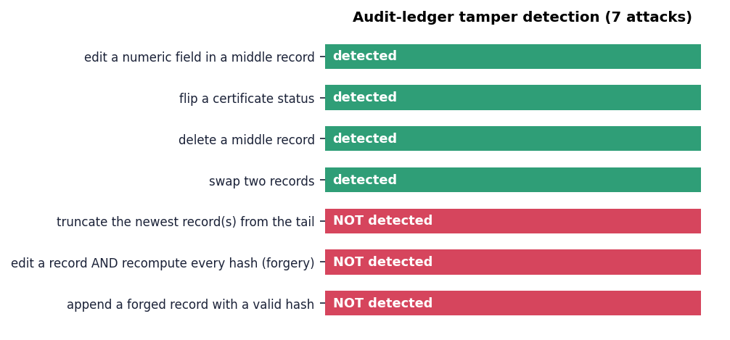
Fig. 7.1: Seven manipulations of the audit ledger: four are detected, three are not
The chain does what a simple hash chain can do: any edit to a field, any deletion from the middle and any swap of two records breaks a link and is reported with the position of the first bad record. Three manipulations pass verification: removing the newest records from the end of the file, rewriting a record and then recomputing every later hash, and appending a forged record with a correctly computed hash. All three follow from the same fact: the chain has no secret, no digital signature and no copy of the latest hash held outside the file, so whoever can write the file can also write a consistent chain. The ledger is therefore tamper-evident against careless edits, not tamper-proof against a motivated insider. This is stated in the project report (PROJECT_REPORT.md) as a production extension and is repeated in the limitations below.

7.5.3 Not tested
- authentication and authorisation (none exists: every endpoint is open and one engine is shared by all callers);
- transport security, cross-origin policy and denial-of-service resistance;
- a penetration test or any automated vulnerability scan;
- confidentiality of the stored clipped updates, which the design requires to be protected because they are what makes subtraction possible.

7.6 Validation and Edge Cases
Validation asks whether the system behaves sensibly on unusual input. The probes below were sent to a live server by scripts/run_experiments.py (experiment api) in a fixed order, so state-dependent cases such as the repeat and last-client guards run after the cases that create the state.
Table 7.7: API edge-case probes (experiments/api)
Case | HTTP | Response
unlearn before training | 400 | Train the federated model before requesting unlearning
generate before training | 400 | Train the federated model first
certificate before any unlearning | 404 | No certificate is available
unknown route (GET) | 404 | Route not found
unknown route (POST) | 404 | Route not found
malformed JSON body | 400 | Expecting property name enclosed in double quotes: line 1 c...
JSON array instead of object | 400 | JSON body must be an object
oversized body (2 MB) | no response | [WinError 10053] An established connection was aborted by t...
unlearn without client_id | 400 | client_id is required
unlearn unknown client id | 400 | 'Unknown client: client_nobody'
unlearn with SQL-ish id | 400 | "Unknown client: x'; DROP TABLE--"
generate with empty seed | 200 | ok
generate with unicode seed | 200 | ok
generate with 5,000-char seed | 200 | ok
unsupported method (PUT) | 501 | <!DOCTYPE HTML> <html lang="en"> <head> <meta c...
unlearn first client ok | 200 | ok
repeat unlearn same client | 400 | client_finance has already been unlearned
unlearn the last remaining client | 400 | At least one client must remain in the model
path traversal on / | 404 | Route not found
legacy single-page UI at / | 200 | html

Of the twenty probes, eighteen behave as intended: invalid or premature requests get a 400 or 404 with a JSON error message, valid requests succeed, and unusual but legal text (an empty seed, a Unicode seed with an emoji, and a 5,000-character seed) is normalised by normalize_text into the 33-symbol alphabet and handled without error. The two exceptions are the rough edges described above, the oversized body and the PUT method.
Model-level validation was done by the experiments rather than by single cases. The membership statistic is a rank statistic over five member and five non-member sentences, so its resolution is 0.04 and individual values such as 0.04 or 0.48 in the baseline table are noisy; this is why the 50-seed study reports AUC as 0.524 +/- 0.219 before and 0.495 +/- 0.222 after removal. The unlearn guards were also validated in sequence: removing clients one by one down to a single client works, and the removal of the fifth is refused.

7.7 Performance Testing
Performance was measured on 127.0.0.1 with a single client. (Measured against localhost on this machine, Python clients pay about two seconds per call for an IPv6 fall-back, which would have inflated every figure fourfold, so the loop-back address was used.) Each endpoint was called 30 to 100 times; the table gives the median and 95th percentile.
Table 7.8: API response times on 127.0.0.1
Endpoint | Calls | Median (ms) | p95 (ms) | Max (ms)
GET /api/health | 100 | 3.0 | 25.4 | 28.7
GET /api/state (untrained) | 100 | 5.4 | 24.3 | 41.3
POST /api/train | 50 | 36.5 | 60.0 | 69.0
GET /api/state (trained) | 100 | 20.8 | 44.3 | 56.5
POST /api/generate | 50 | 7.3 | 23.6 | 26.8
POST /api/audit/verify | 50 | 5.8 | 25.2 | 37.4
POST /api/unlearn | 30 | 57.9 | 82.4 | 109.3
GET /api/state (grown ledger) | 30 | 22.3 | 33.4 | 37.9

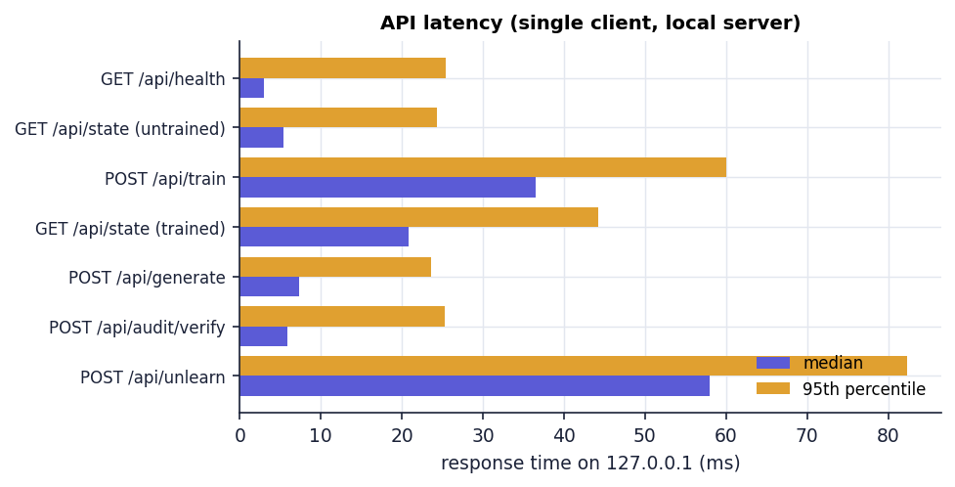
Fig. 7.2: Median and 95th-percentile response time per endpoint
Training answers in 36 ms and a full unlearning request, including the two membership-attack evaluations, the metric recomputation and the ledger write, in 58 ms (p95 82 ms). The /api/state call is the slowest read because it re-reads and re-verifies the whole ledger on every request; it takes about 21 ms with a trained model against 5 ms untrained.

7.7.1 Unlearning against retraining
Table 7.9: Cost of `unlearn()` against re-running the proxy training (median of 5 runs, synthetic clients)
Clients | Records | Train (ms) | unlearn() (ms) | Retrain on retained (ms) | Retrain / unlearn
5 | 25 | 14.0 | 45.3 | 13.4 | 0.30x
25 | 500 | 32.3 | 72.0 | 30.5 | 0.42x
100 | 5,000 | 159.6 | 115.8 | 159.5 | 1.38x
250 | 25,000 | 691.2 | 195.8 | 709.6 | 3.62x
500 | 50,000 | 1425.6 | 204.0 | 1384.8 | 6.79x

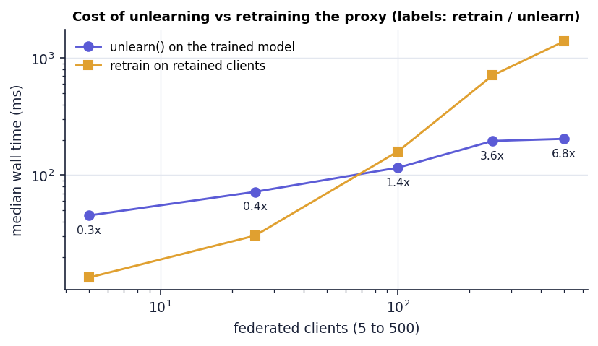
Fig. 7.3: Median wall time of unlearning and of retraining the proxy against the number of clients
The result is not the one the narrative of unlearning usually promises. On the five-client demonstration unlearn() (45.3 ms) is about three times slower than simply re-running the proxy training on the four retained clients (13.4 ms), because it carries a fixed cost that retraining does not: two membership evaluations, two metric evaluations and a ledger write. The two curves cross near 100 clients (1.38x in favour of unlearning); at 500 clients and 50,000 synthetic records unlearning is 6.8x faster. Unlearning is nearly flat in the number of clients because it touches one stored vector of 1,089 values, while retraining grows with the number of records. The comparison says nothing about a real large language model, where retraining costs hours rather than milliseconds; it only shows that the engine's own overhead is small and does not grow with the data.

7.7.2 Growth of the audit ledger
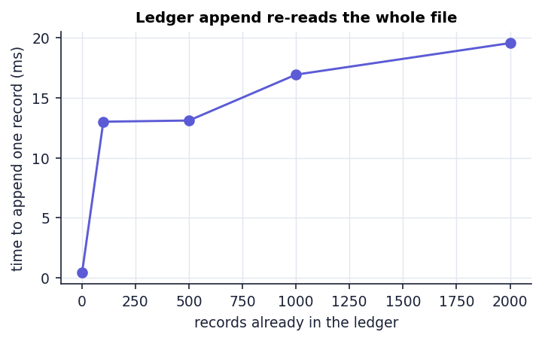
Fig. 7.4: Time to append one record against the number of records already in the ledger
AuditLedger.append reads the entire file to find the previous hash, so each append costs more as the ledger grows: 0.44 ms at the first record, 13.0 ms at 100, 16.9 ms at 1,000 and 19.6 ms at 2,000 records. Writing 2,000 records took 45.3 s and verifying them 43.6 ms. For an interactive demonstrator this is irrelevant; for a service that logs every deletion request it would call for an index or a tail read.

7.8 User Acceptance Testing
No user study was carried out. No external user, compliance officer or teacher used the application, and no questionnaire or acceptance sign-off exists. What this section reports is an acceptance walk-through performed by the project team with a scripted browser session (scripts/capture_screens.py, Playwright with Chrome at 1440 x 900), which doubles as the source of every screenshot in Chapter 8.
1. Open the landing page and wait for the count-up animations to finish; open the lab.
2. Train the federated model through the interface (the toast reads "5 clients aggregated, epsilon 1.6149").
3. Generate a sample from the seed "privacy" on the explorer screen.
4. Request removal of Client 01 (Finance), confirm the dialog, and read the certificate (status Certified, utility retained 93.65 %, membership AUC 0.200 to 0.160).
5. Generate a second sample; compare it with the first.
6. Remove Client 02 (Healthcare) and read the second certificate (utility retained 98.30 %).
7. Open the dashboard and the training screen and confirm that three clients remain active.
8. Open the audit screen, press Verify hash chain and read "Verified 4 audit record(s)".
9. Switch to dark mode, return to light mode, and repeat the unlearning page in a 390-pixel-wide viewport.
All nine steps completed without a browser-console error. The walk-through shows that the flow an operator needs is discoverable and coherent; it is not evidence of usability for real users, of accessibility compliance (no screen-reader or keyboard audit was run) or of fitness for a regulator's purposes.

7.9 Limits of the Testing Done
The testing reported in this chapter is real, repeatable and honest about its scope, and the following limits apply to every conclusion drawn from it.
- The system under test is a proxy. Passing tests show that clipping, noisy aggregation, subtraction, the reference recomputation, the attack, the certificate and the ledger work as coded on 1,089 bigram parameters. They say nothing about LoRA adapters, a transformer or a real client population.
- Fixed seeds and one corpus. Unit and smoke tests use seed 2026 and the five built-in clients (25 sentences). The 50-seed and sweep studies vary the noise seed but not the data; no other corpus was tried.
- The certification check cannot fail. Because the reference re-uses the stored noise and updates, reference_retrain_l2 is zero up to floating-point error (largest value over 250 requests 3.25e-14); a test that cannot fail does not test forgetting. The retraining comparison with fresh noise is an experiment added by this project, not part of the shipped test suite.
- Weak statistical power of the attack. Five member and five non-member sentences give an AUC resolution of 0.04; at the default noise the attack is at chance even before unlearning, so it cannot show that anything was removed.
- No load, concurrency or soak testing. One client at a time was used; the server shares one engine behind a lock, and concurrent operators were not tested.
- No penetration test, no authentication test (there is no authentication), and no accessibility audit.
- No real user testing, as stated under user acceptance testing.
- No code-coverage measurement was made; the five unit tests exercise the engine, ledger and two endpoints, and the remaining routes are covered by the smoke script.

CHAPTER 8
RESULTS AND OUTPUT SCREENS

8.1 Output Screens
The screens below were captured from the running application (Python API on port 8109, React interface on port 5109) at 1440 x 900 pixels by a scripted Chrome session. The interface was driven by clicks, so every value shown was produced by the application: one session with the default configuration (seed 2026, clip norm 25, noise multiplier 3, δ = 1e-5), training through the interface, then removal of Client 01 (Finance) and of Client 02 (Healthcare). Each caption describes only what is visible in the picture.
  Fig. 8.1: Landing page with the live lab status | 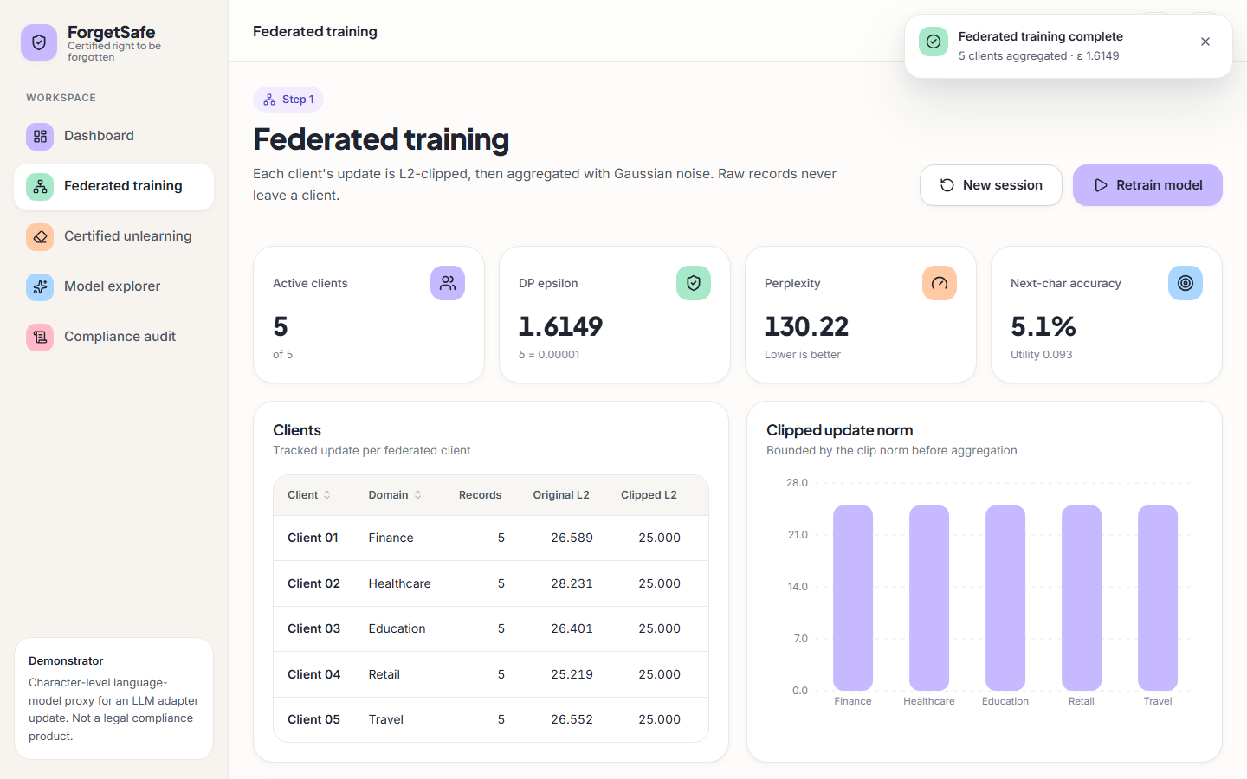  Fig. 8.2: Federated training screen after training

The landing page carries the ForgetSafe name and the tag line "Certified right to be forgotten", a navigation bar (How it works, Screens, Live), a dark-mode toggle and an Open the lab button. The headline reads "Forget a client, prove it, keep the model useful." On the right, a Live lab status card is filled from GET /api/state: the badge says Connected, the session is "Not trained yet", there are "5 registered" active clients in the domains Finance, Healthcare, Education, Retail and Travel, and the audit ledger shows "1 record(s), chain valid" (the ledger already held one training event from an earlier session of the capture run). Two floating chips name the guarantees the product claims, "ε · δ DP guarantee" and "SHA-256 hash-chained ledger"; three tags below the buttons read Differential privacy, Membership-inference check and Audit trail.
After pressing Train federated model a toast reads "Federated training complete, 5 clients aggregated, ε 1.6149". The four tiles show 5 of 5 active clients, DP epsilon 1.6149 with δ = 0.00001, perplexity 130.22 and next-character accuracy 5.1 % (utility 0.093). The Clients table lists Client 01 to Client 05 with their domains, 5 records each, original L2 norms of 26.589, 28.231, 26.401, 25.219 and 26.552, and a clipped L2 of 25.000 for every client. The Clipped update norm chart beside it shows five bars of equal height under an axis that runs to 28, which is the visual form of the clipping: every update leaves the client at the same length.
Fig. 8.3: Dashboard after training | 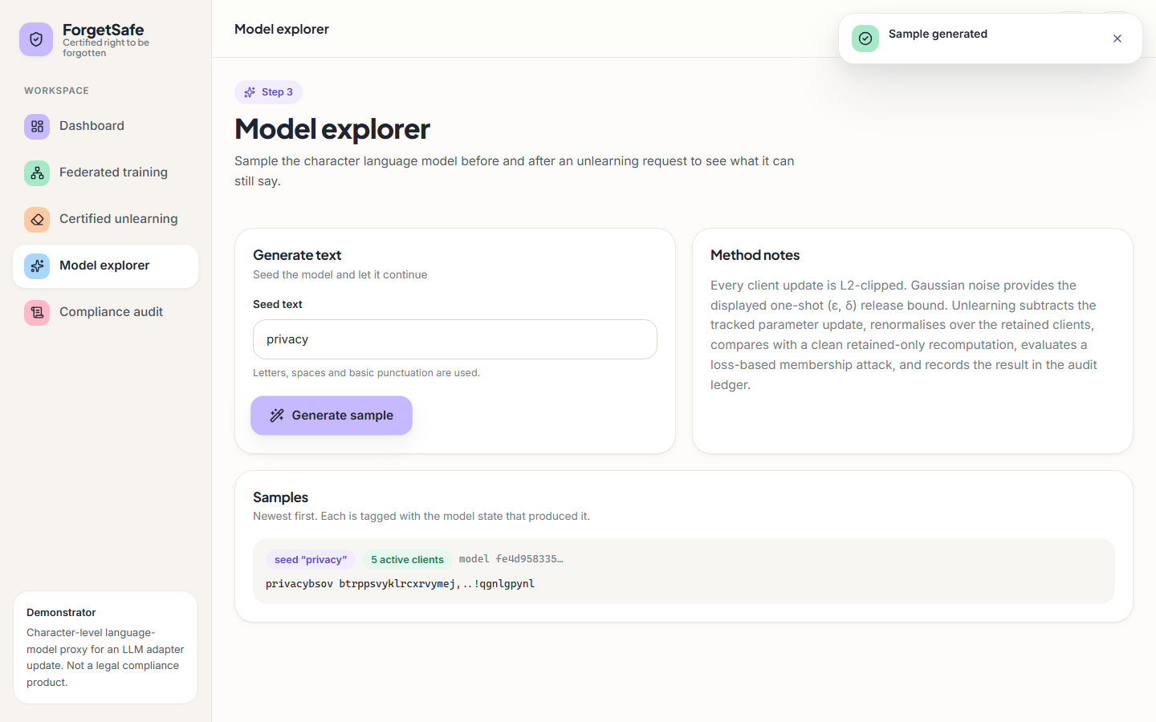  Fig. 8.4: Model explorer before any removal

The dashboard headline reads "Right-to-be-forgotten, certified". The Workflow card is a three-step stepper: Train is ticked and marked Done, Unlearn ("Remove a client") is highlighted as the current step and Verify shows "Audit chain valid". The summary tiles repeat the training figures (5 of 5 clients, ε 1.6149, perplexity 130.22, accuracy 5.1 %, both labelled with the public evaluation set). Below, Client updates draws the clipped norm of each client as a horizontal bar and Latest certificate still shows "No certificate yet" with a Request unlearning button, because no removal has been made.
The explorer offers a Seed text field (here "privacy"), a Generate sample button and a Method notes card that summarises clipping, Gaussian noise, subtraction and the membership attack. The Samples list, newest first, tags the generated text with the seed, the model state ("5 active clients") and the first characters of the model hash (fe4d958335…). The text is "privacybsov btrppsvyklrcxrvymej,..!qgnlgpynl": a string of characters with no words, which is what a bigram model dominated by noise produces.
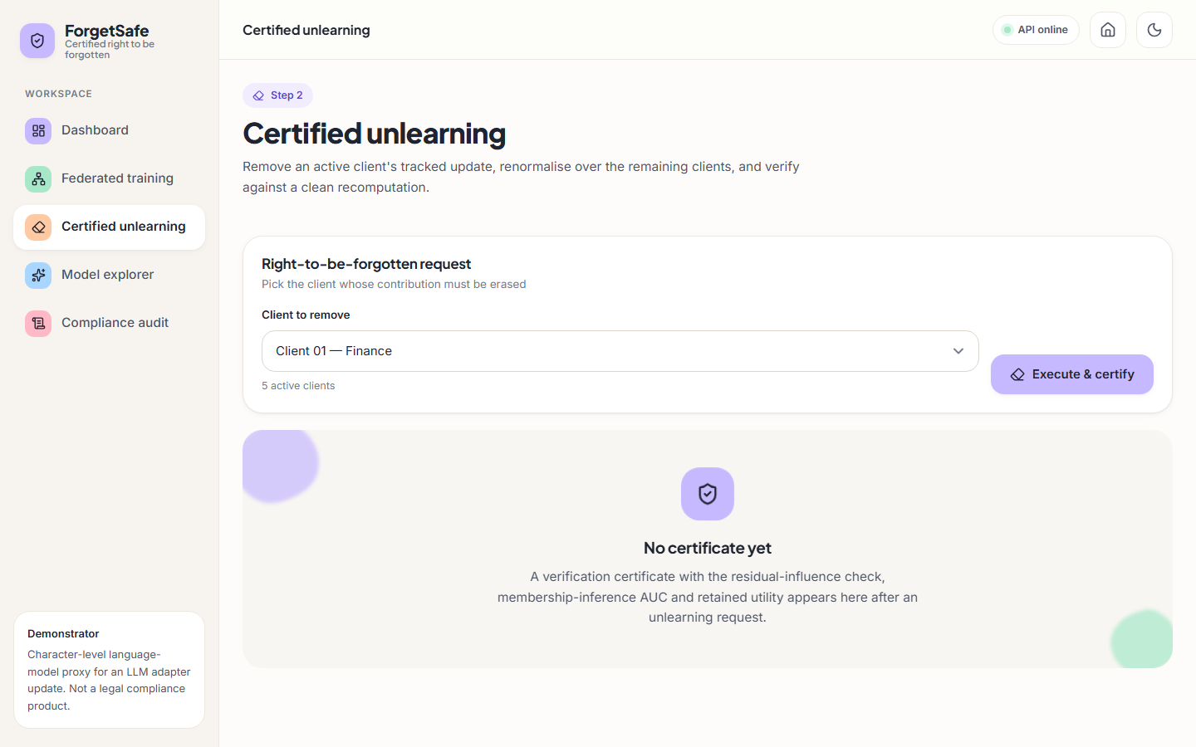  Fig. 8.5: Certified unlearning screen before a request | Fig. 8.6: Verification certificate after removing Client 01

The Right-to-be-forgotten request card shows a drop-down labelled Client to remove set to "Client 01 — Finance", the note "5 active clients" and the Execute & certify button. The area underneath is an empty state: "No certificate yet. A verification certificate with the residual-influence check, membership-inference AUC and retained utility appears here after an unlearning request."
A toast confirms "Client removed and certified, Client 01 (Finance) · certified". The drop-down now offers the four remaining clients (Client 02 — Healthcare is selected, "4 active clients"). The Verification certificate card shows the badge Certified, the identifier CERT-C5427F948A72, the client and the UTC time (2026-10-26 14:16:03) and a Download JSON button, followed by the measured fields: privacy guarantee ε 1.6149 · δ 0.00001, utility retained 93.65 %, residual influence (L2) 2.790e-14, reference retrain (L2) 2.790e-14, membership AUC 0.200 → 0.160, perplexity 130.221 → 146.472 and next-character accuracy 5.1 % → 4.4 %. The Before vs after chart on the right draws the membership AUC and the accuracy as paired bars.
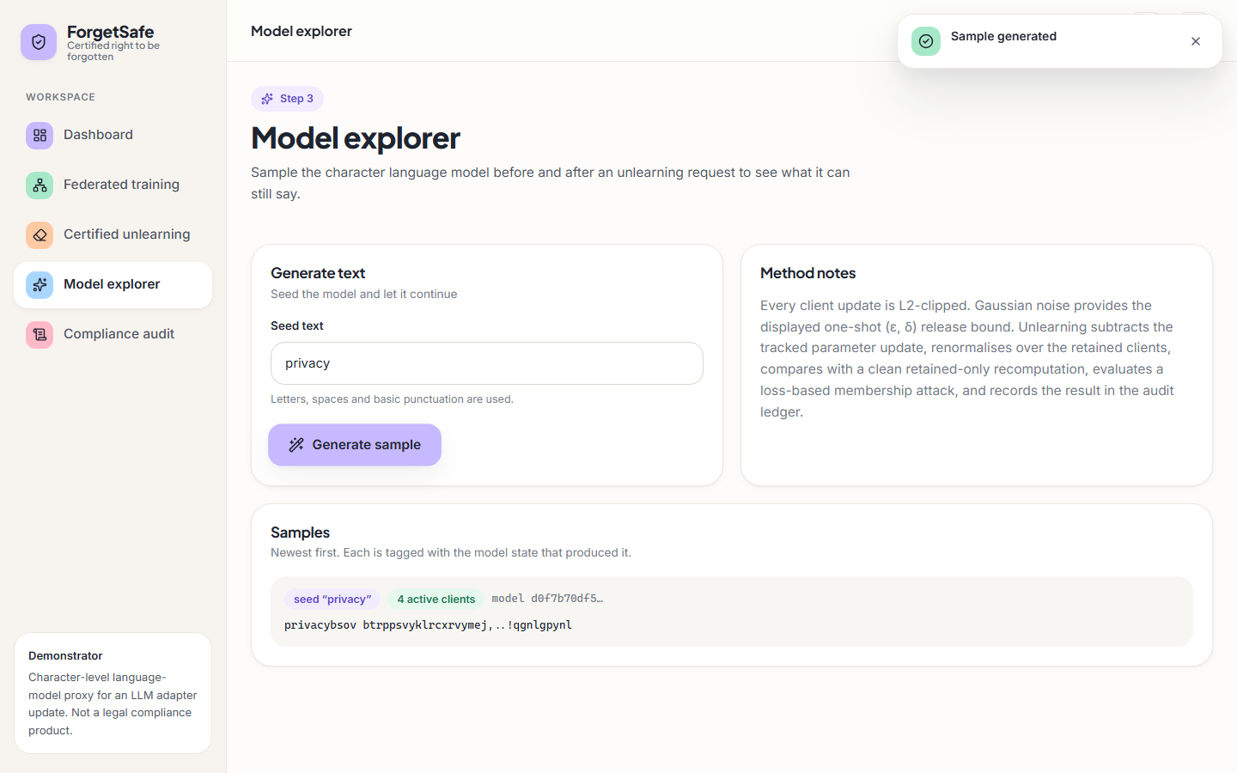  Fig. 8.7: Model explorer after removing Client 01 | 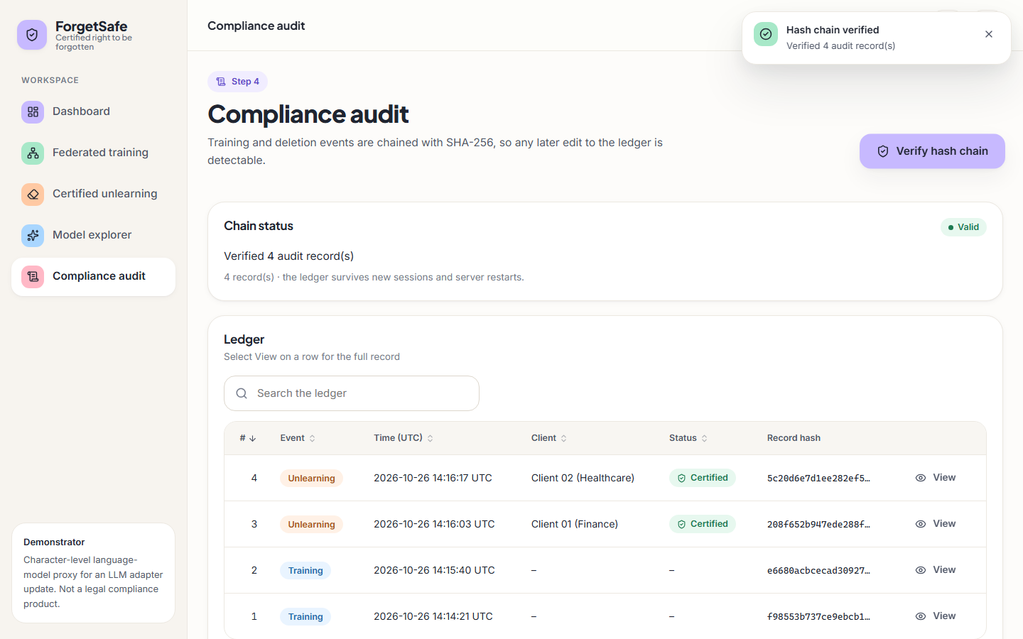  Fig. 8.8: Compliance audit screen with a verified hash chain

The same seed "privacy" now produces a sample tagged "4 active clients" and model hash d0f7b70df5…, and the text is again "privacybsov btrppsvyklrcxrvymej,..!qgnlgpynl", character for character the same as before the removal. The generator uses a fixed random seed and the noisy probabilities changed too little to alter any draw, so the explorer cannot show, by eye, that a client was removed (Section on sample inputs and outputs).
After pressing Verify hash chain a toast reads "Hash chain verified, Verified 4 audit record(s)" and the Chain status card shows the badge Valid and the note that the ledger "survives new sessions and server restarts". The Ledger table lists the four records, newest first, with sequence number, event type (Unlearning or Training), UTC time, client, status and the first characters of the record hash: #4 Unlearning, Client 02 (Healthcare), Certified, 5c20d6e7d1ee282ef5…; #3 Unlearning, Client 01 (Finance), Certified, 208f652b947ede288f…; #2 and #1 Training. A search box and a View action on each row open the full record.
The remaining screens (untrained state, confirmation dialog, full-page certificate, second certificate, dashboard after two removals, dark mode, mobile layout and the legacy interface) are reproduced in Appendix C.

8.2 Model and Verification Results
All results in this section were produced by scripts/run_experiments.py on the development machine and are stored in experiments/*/metrics.json. Throughout, perplexity and next-character accuracy are measured on the five public evaluation sentences, membership AUC is the loss-based attack of Chapter 6 (a client's five records against five fixed non-member sentences, so its resolution is 0.04), and utility retention is the utility score after removal divided by the score before, capped at 100 %.

8.2.1 Baseline run with the default configuration
With seed 2026, clip norm 25, noise multiplier 3 and δ = 1e-5 the trained model has ε = 1.6149, perplexity 130.22 and next-character accuracy 5.09 % (utility 0.0926; training took 5.4 ms). A model that spread probability evenly over the 32 symbols it can emit would have perplexity 32, so the trained model is worse than uniform. The table gives the result of removing each client in turn from a freshly trained model.
Table 8.1: Removing each client from the default model (seed 2026)
Client removed | Status | Reference L2 | Membership AUC | Perplexity | Accuracy | Retention %
Client 01 (Finance) | Certified | 2.79e-14 | 0.20 → 0.16 | 130.2 → 146.5 | 5.09 % → 4.36 % | 93.65
Client 02 (Healthcare) | Certified | 2.61e-14 | 0.48 → 0.44 | 130.2 → 147.1 | 5.09 % → 5.09 % | 98.71
Client 03 (Education) | Certified | 2.62e-14 | 0.08 → 0.12 | 130.2 → 146.3 | 5.09 % → 5.09 % | 98.76
Client 04 (Retail) | Certified | 2.54e-14 | 0.32 → 0.28 | 130.2 → 146.7 | 5.09 % → 5.09 % | 98.73
Client 05 (Travel) | Certified | 2.54e-14 | 0.04 → 0.04 | 130.2 → 145.6 | 5.09 % → 4.36 % | 93.71

All five requests are CERTIFIED and the reference distance is of the order of 1e-14 (largest 2.79e-14). Utility retention is between 93.65 % and 98.76 % (mean 96.71 %). The two lowest values, Finance and Travel, are the two cases in which next-character accuracy fell from 5.09 % to 4.36 %, that is by two correct predictions out of 275 characters; the retention figure is therefore dominated by a tiny accuracy count. The membership AUC values (0.04 to 0.48 before removal) scatter on both sides of 0.5: with ten sentences and a noisy model they carry no signal about membership.

8.2.2 Fifty seeds: how stable is the default result?
To separate the behaviour of the method from the luck of one noise draw, the procedure was repeated for 50 noise seeds and for all five clients, giving 250 unlearning requests.
Table 8.2: Fifty-seed study with the default configuration
Quantity | Mean | Std. dev. | Min | Max
Perplexity before removal (50 models) | 142.2 | 27.5 | 81.6 | 215.7
Accuracy before removal (50 models) | 3.71 % | 1.76 % | 1.09 % | 8.73 %
Perplexity after removal (250 requests) | 164.5 | 33.0 | 92.2 | 256.0
Membership AUC before removal | 0.524 | 0.219 | 0.04 | 1.00
Membership AUC after removal | 0.495 | 0.222 | 0.04 | 1.00
Change in AUC (after - before) | -0.029 | 0.040 | -0.24 | +0.04
Utility retention (%) | 97.14 | 3.47 | 79.90 | 100.00

250 of 250 requests are CERTIFIED, none falls below the 70 % retention floor (the minimum is 79.9 %) and the largest reference distance is 3.25e-14. These numbers are stable, but what they stabilise is the bookkeeping. The informative result is the membership AUC: 0.524 before removal, which is chance, and 0.495 after, a mean change of only -0.029. At the default noise the attacker learns nothing about a client either before or after the removal, so the experiment has no leakage to show disappearing. The perplexity of about 142 (range 82 to 216) confirms that the aggregate is noise-dominated: the expected noise vector has an L2 norm of 2475, while a clipped client update has norm 25 (about 1 % of the noise).

8.2.3 Noise sweep: the privacy-utility trade-off
The noise multiplier σ was varied from 0.001 to 10 (20 seeds, five clients each, 100 requests per value). The reported ε follows the engine's formula ε = sqrt(2 ln(1.25/δ)) / σ with δ = 1e-5, so ε = 4.8448 / σ.
Table 8.3: Noise sweep (mean over 100 requests per row)
σ | ε | Perplexity | Accuracy | AUC before | AUC after | Retention %
0.001 | 4844.805 | 12.5 | 24.6 % | 0.992 | 0.542 | 99.6
0.01 | 484.481 | 12.7 | 24.5 % | 0.983 | 0.543 | 99.6
0.05 | 96.896 | 14.2 | 24.2 % | 0.922 | 0.550 | 98.7
0.1 | 48.448 | 16.3 | 23.5 % | 0.856 | 0.550 | 96.5
0.3 | 16.149 | 27.4 | 15.5 % | 0.708 | 0.544 | 88.1
0.5 | 9.690 | 39.1 | 9.9 % | 0.653 | 0.534 | 89.6
1 | 4.845 | 65.6 | 5.4 % | 0.597 | 0.520 | 91.6
2 | 2.422 | 110.1 | 3.8 % | 0.563 | 0.527 | 97.6
3 | 1.615 | 145.2 | 3.6 % | 0.552 | 0.522 | 97.5
4.85 | 0.999 | 197.9 | 3.4 % | 0.539 | 0.525 | 97.7
6 | 0.807 | 225.5 | 3.3 % | 0.538 | 0.524 | 96.3
10 | 0.484 | 304.5 | 3.0 % | 0.530 | 0.524 | 98.5

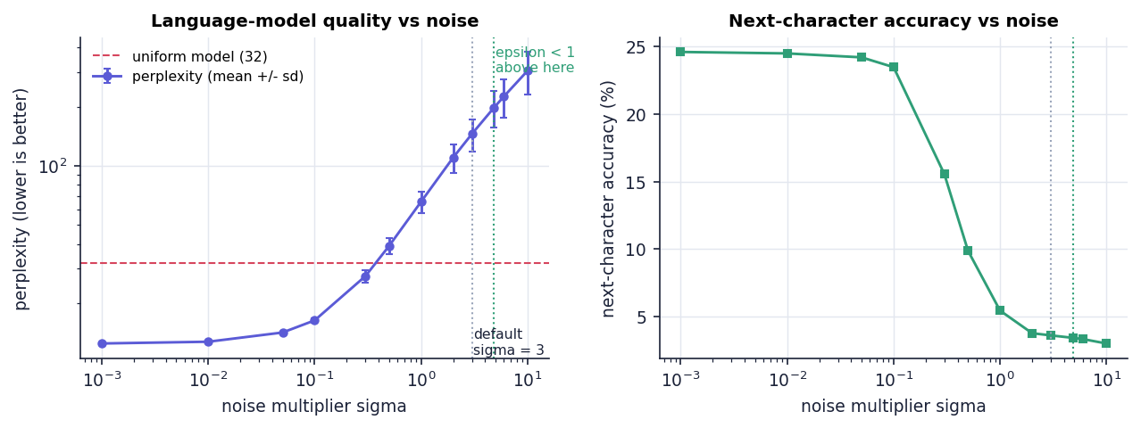
Fig. 8.9: Perplexity and next-character accuracy against the noise multiplier (dotted lines: default σ = 3 and the ε < 1 boundary at σ = 4.85)
Three regimes are visible. For σ <= 0.1 (ε >= 48) the model is a useful bigram model: perplexity 12.5 to 16.3, accuracy about 24 %, and the membership attack works (AUC 0.86 to 0.99 before removal). For 0.3 <= σ <= 1 quality degrades quickly (perplexity 27 to 66, accuracy 15 % to 5 %). From σ = 2 upward the model is no better than noise; at the default σ = 3 perplexity is 145 against 32 for a uniform model, and at σ = 10 it is 305.
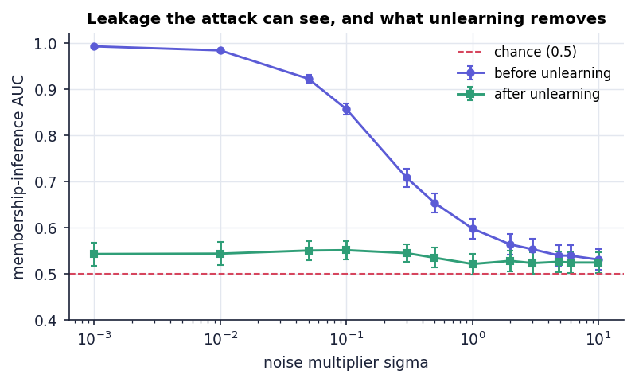
Fig. 8.10: Membership AUC before and after removal against the noise multiplier (error bars: standard error)
The attack gives the second half of the story. Where there is something to find (small σ) the removal clearly works: the mean AUC drops from 0.992 to 0.542 at σ = 0.001 and from 0.856 to 0.550 at σ = 0.1. Where the noise is large the attack is already at 0.52 to 0.55 before removal, so unlearning has nothing to remove. A privacy-preserving noise level and a measurable forgetting effect are therefore mutually exclusive in this configuration: the noise that makes the leakage invisible also makes the removal invisible.
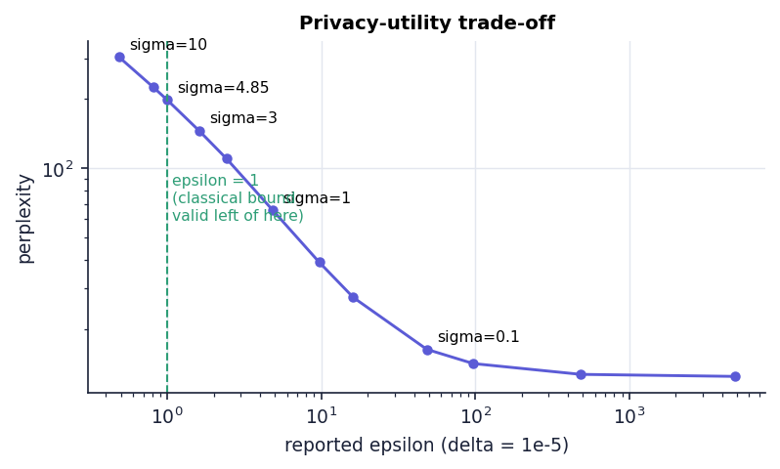
Fig. 8.11: Reported ε against perplexity: the classical bound is valid only to the left of ε = 1
The classical one-shot Gaussian bound is valid for ε < 1, which needs σ > 4.84. At σ = 4.85 the model has perplexity 198 and accuracy 3.4 %. At the default σ = 3, the reported ε = 1.6149 lies outside the range for which that bound is proved. There is no point on the curve that is both inside the proven range and useful.

8.2.4 What unlearning removes when there is no noise
Table 8.4: Removal with σ = 1e-6 (essentially no noise)
Client | Member NLL (before → after) | Membership AUC (before → after) | Retention %
Finance | 2.379 → 2.590 | 1.00 → 0.76 | 98.92
Health | 2.383 → 2.562 | 1.00 → 0.88 | 100.00
Education | 2.448 → 2.676 | 1.00 → 0.20 | 100.00
Retail | 2.435 → 2.621 | 0.96 → 0.52 | 99.59
Travel | 2.462 → 2.649 | 1.00 → 0.36 | 99.80

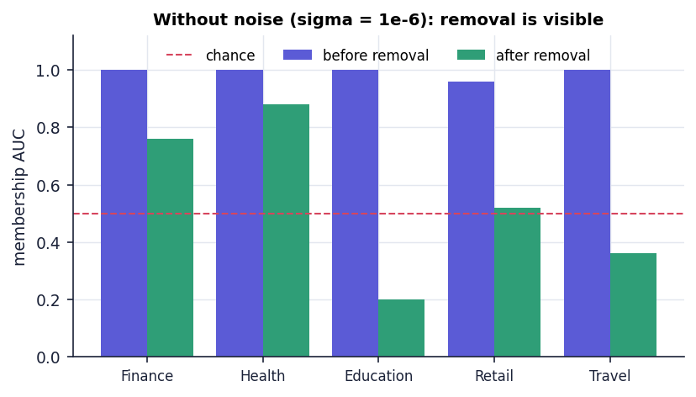
Fig. 8.12: Membership AUC before and after removal with almost no noise
To check that removal itself works, the noise was effectively switched off. The attack then separates a client's records from non-members almost perfectly (mean AUC 0.992), and after subtraction it falls to 0.544, close to chance; the mean per-character loss on the removed client's own sentences rises from 2.421 to 2.619. Individual AUCs after removal range from 0.20 to 0.88 because the attack uses only ten sentences. This is the evidence that subtracting the stored update really removes the client's statistical footprint from the model, and it is the experiment that the default configuration cannot provide.

8.2.5 An independent check: comparison with retraining on fresh noise
The shipped certificate compares the unlearned model with a "reference" built from the retained clients' stored updates and the same stored noise; the two sides share every input, so their distance is zero up to rounding by construction. A real retraining would draw new noise. The experiment gold_retrain therefore compares each unlearned model with models retrained on the retained clients with independent noise (200 pairs for each σ), and compares two independent retrainings with each other as the yardstick for how far two honest runs differ.
Table 8.5: Unlearned model against retraining with independent noise (200 pairs per σ)
σ | L2: unlearned vs fresh retrain | L2: fresh retrain vs fresh retrain | AUC (unlearned / retrain) | Perplexity | Accuracy
3 | 875.3 ± 16.0 | 881.4 ± 18.2 | 0.481 / 0.552 | 167.1 / 152.8 | 3.35 % / 3.95 %
0.5 | 145.9 ± 2.7 | 146.9 ± 3.0 | 0.505 / 0.547 | 46.0 / 44.6 | 8.06 % / 8.64 %

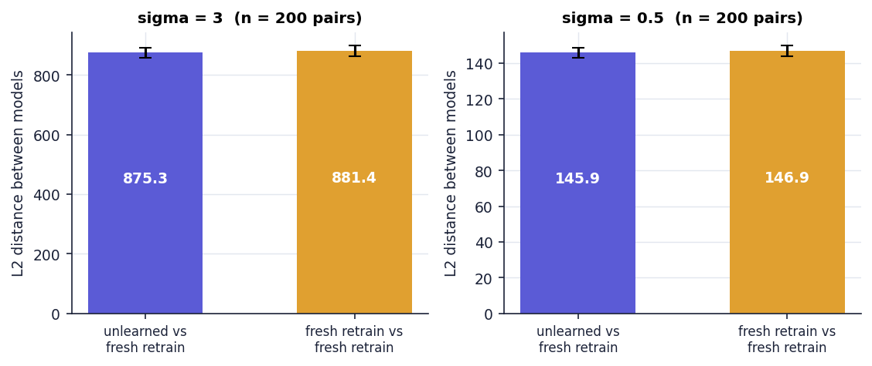
Fig. 8.13: Distance between the unlearned model and a fresh retrain, compared with the distance between two fresh retrains
At σ = 3 the unlearned model is 875.3 away from a fresh retrain and two fresh retrains are 881.4 apart; at σ = 0.5 the figures are 145.9 and 146.9. The unlearned model is therefore exactly as far from a retrained model as retrained models are from each other: the distance is the injected noise, and the unlearned model behaves like one more retrained model. Perplexity and accuracy agree to within the noise (167 against 153 at σ = 3, 46.0 against 44.6 at σ = 0.5), and the membership AUC of the unlearned model is, if anything, closer to chance than that of the retrained model (0.481 against 0.552 at σ = 3). This is the evidence that the unlearned model is distributed like a retrained one, which the 1e-14 reference distance does not demonstrate on its own.

8.2.6 Sequential removal
Table 8.6: Removing four of the five clients in turn (seed 2026)
Step | Removed | Active clients | Perplexity | Accuracy | Retention % | Status
0 | - | 5 | 130.2 | 5.09 % | - | -
1 | Finance | 4 | 146.5 | 4.36 % | 93.65 | Certified
2 | Health | 3 | 171.3 | 4.36 % | 98.30 | Certified
3 | Education | 2 | 213.6 | 4.36 % | 97.70 | Certified
4 | Retail | 1 | 302.8 | 4.36 % | 96.59 | Certified

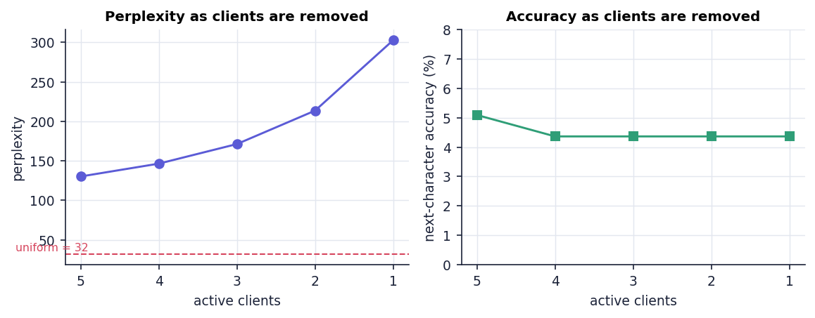
Fig. 8.14: Perplexity and accuracy as clients are removed one after another
All four removals are CERTIFIED and the ledger verifies afterwards ("Verified 5 audit record(s)"). Perplexity rises from 130 to 303 as the five clients are reduced to one: the noise vector is unchanged while the aggregate is divided by a smaller client count, so the relative weight of the noise grows. Removing the fifth client is refused with "At least one client must remain in the model". Retention values remain above 93 % at every step because each is measured against the previous model, which is already poor.

8.3 Certificate, Ledger and API Results
The product's visible output is the certificate and the ledger record behind it. The first removal of the default session (Client 01, Finance) produced the following values; the field names are those of the JSON that GET /api/certificate/latest returns.
Table 8.7: Fields of the unlearning certificate
Field | Value (default session, seed 2026)
certificate_id / status | CERT-6DCAB9E98480 / CERTIFIED
client | Client 01 (Finance)
method | Tracked clipped-update subtraction with retained-client renormalization
epsilon, delta | 1.6149, 1e-05
clip_norm, noise_multiplier | 25, 3
residual_influence_l2 = reference_retrain_l2 | 2.790e-14
membership_auc_before → after | 0.20 → 0.16
perplexity_before → after | 130.221 → 146.472
accuracy_before → after | 5.09 % → 4.36 %
utility_retention_percent | 93.65
clients_before → after | 5 → 4
model_hash_before | fe4d958335a7a158acdf8d5d441073a3…
model_hash_after | d0f7b70df52c5d17097b83b9144b0062…
audit_record_hash | c5a6d39418d916e3b60023556ba8ea72…

Two fields deserve a remark. residual_influence_l2 and reference_retrain_l2 are always equal: the engine assigns one to the other (the comment in engine.py explains that the stored update is subtracted algebraically, so its coefficient in the retained aggregate is zero within floating-point error). And epsilon is the training-time value; the certificate does not recompute any privacy figure after the removal.
Every training and every unlearning event becomes one line of data/audit_log.jsonl. A record keeps its event fields and adds sequence, previous_hash and record_hash, where the hash is the SHA-256 of the predecessor's hash, a vertical bar and the canonical (sorted, compact) JSON of the record. The first record's predecessor is 64 zeros. The certificate's audit_record_hash equals the hash of its own ledger record, which is how a certificate is tied to the ledger: in the capture session certificate CERT-C5427F948A72 carries 208f652b947ede28…, the hash shown in row 3 of the ledger screen.
The API returned the expected status codes for all 14 smoke checks and for 18 of the 20 edge-case probes (Chapter 7); the two exceptions are described there. Typical latencies on the local loop-back were 36 ms for training and 58 ms for a complete unlearning request, and a certificate is available for download as JSON with the audit verdict attached.

8.4 Comparison with the Base Paper and Related Work
The comparison has to begin with a plain statement of what can and cannot be compared. The base paper recorded in the batch files, Khan et al. [1], is a review of deep-learning approaches to continuous sign language recognition. Its subject is unrelated to federated unlearning, it reports no unlearning, privacy or language-model measurement, and this project adopts only its review method: a taxonomy of approaches, a comparison of strengths and limitations and the identification of open gaps. No numerical comparison with [1] is possible, and none is made.
The technically closest works are [2] (the paper named in the project's base-paper record as the 2026 base paper), [3] and [4]. They were read from the PDFs kept in the project's archive; the table lists what they evaluate. ForgetSafe's numbers are not comparable with theirs: those works train real neural networks on public benchmarks, while ForgetSafe measures a 1,089-parameter bigram model on 25 hand-written sentences.
Table 8.8: What the closest works evaluate, and why the numbers are not comparable
Work | Setting and data | Method | What it reports | Relation to ForgetSafe
[1] Khan et al. (IEEE Access, 2025) | Review of continuous sign language recognition | Taxonomy of spatial, temporal and alignment approaches | Survey of studies, datasets, challenges and gaps | Review method only; subject unrelated; no results to compare
[2] Wei et al. (KDD 2026) | Federated unlearning on CIFAR-10, CIFAR-100 and EMNIST with ResNet-18, ResNet-34 and VGG-9; six baselines | FedMemPrune: pruning of parameters that carry memorised information, guided by a grouped memorisation metric | Abstract: closely matches retraining-based baselines while eliminating memorisation more effectively than existing methods | Same goal (client-level removal in FL); ForgetSafe subtracts a stored update instead of pruning, and has no image or example-level evaluation
[3] Zhang et al., Oblivionis (arXiv, 2025) | Federated LLM fine-tuning and unlearning with Llama-2-7B and Llama-3.x models on the TOFU and MUSE benchmarks | Framework combining 6 federated-learning and 5 unlearning algorithms | Forget quality and model utility across algorithm pairs; motivated by GDPR erasure | Same problem at LLM scale; ForgetSafe is a bigram stand-in without any LLM
[4] Jiang et al., FedORA (arXiv, 2025) | Vertical federated learning on Income (48,842 samples), MedMNIST, CIFAR-10, CIFAR-100 and Tiny-ImageNet | Primal-dual optimisation with a theoretical bound to training from scratch | Unlearning effectiveness comparable to retraining at lower computation and communication | Provides a formal bound where ForgetSafe provides an identity check; different FL setting (vertical)

Three qualitative observations follow. First, [2] and [4] both state their guarantee or their evidence against retraining, and ForgetSafe's fresh-noise experiment adopts the same yardstick; what the other works have and ForgetSafe lacks is a benchmark that exercises real models. Second, [3] shows that the federated-LLM setting needs forget-quality and utility metrics on real text; the bigram perplexity here is the crudest member of that family. Third, what ForgetSafe adds is not a stronger result but an end-to-end, inspectable workflow in which the guarantee, the attack, the utility check and the audit record are produced together for every request, with the weaknesses of each step measured and reported.

8.5 Sample Inputs and Outputs
The following requests and responses were captured from a live server started for this purpose (scripts/capture_samples.py, port 8197, a temporary working directory), using the default configuration; they are stored in docs/sample_io/samples.json. Certificate identifiers and timestamps differ from run to run, the numerical fields do not.
Listing: Training request and response
POST /api/train -> HTTP 200
{
"active_clients": 5,
"epsilon": 1.6149350875351296,
"delta": 1e-05,
"perplexity": 130.22138531571318,
"next_character_accuracy": 0.05090909090909091,
"utility_score": 0.0926462600496639,
"model_hash": "fe4d958335a7a158acdf8d5d441073a39f9d1bb70fc95141ae3dd49d5869bbba"
}

Listing: Text generated before the removal
POST /api/generate {"seed": "privacy"} -> HTTP 200
{
"text": "privacybsov btrppsvyklrcxrvymej,..!qgnlgpynl"
}

Listing: Unlearning request and the certificate it returns
POST /api/unlearn {"client_id": "client_finance"} -> HTTP 200
{
"certificate_id": "CERT-E4834FD06896",
"session_id": "d79d22d9-f68e-4c4b-9611-e8ed4e49e751",
"client_id": "client_finance",
"client_name": "Client 01 (Finance)",
"issued_at_utc": "2026-10-26T14:29:18+00:00",
"status": "CERTIFIED",
"method": "Tracked clipped-update subtraction with retained-client renormalization",
"epsilon": 1.6149350875351296,
"delta": 1e-05,
"clip_norm": 25.0,
"noise_multiplier": 3.0,
"residual_influence_l2": 2.7903189690385764e-14,
"reference_retrain_l2": 2.7903189690385764e-14,
"membership_auc_before": 0.2,
"membership_auc_after": 0.16,
"perplexity_before": 130.22138531571318,
"perplexity_after": 146.47196760072828,
"accuracy_before": 0.05090909090909091,
"accuracy_after": 0.04363636363636364,
"utility_retention_percent": 93.64532042042157,
"clients_before": 5,
"clients_after": 4,
"model_hash_before": "fe4d958335a7a158acdf8d5d441073a39f9d1bb70fc95141ae3dd49d5869bbba",
"model_hash_after": "d0f7b70df52c5d17097b83b9144b00621123921d6c60d960604fc2de312ac898",
"audit_record_hash": "c21d202b7a2ee6c91eba527d5d72127df7bf9b92660e16561b08403337d1dc7d"
}

Listing: Text generated after the removal
POST /api/generate {"seed": "privacy"} -> HTTP 200
{
"text": "privacybsov btrppsvyklrcxrvymej,..!qgnlgpynl"
}

Listing: Audit verification and a repeated request
POST /api/audit/verify -> HTTP 200
{
"valid": true,
"detail": "Verified 2 audit record(s)"
}

POST /api/unlearn {"client_id": "client_finance"} -> HTTP 400
{
"error": "client_finance has already been unlearned"
}

Reading the samples: the training response carries the privacy and quality figures and the SHA-256 fingerprint of the parameter vector; the unlearning response carries every field of the certificate, including the model hash before and after (they differ, so the parameters changed) and the audit record hash. The two generated texts are identical: the generator draws from a fixed random seed and the noisy probabilities changed too little to alter a draw. The text therefore cannot be used to see the removal, and the evidence for it has to come from the attack and the retraining comparison above. The repeated request is refused with a clear JSON error and leaves the model and the ledger unchanged.
Table 8.9: The two ledger records written by this sequence of requests
Seq. | Event | previous_hash (first 16) | record_hash (first 16)
1 | FEDERATED_TRAINING | 0000000000000000… | be69f32ebfec00d6…
2 | CLIENT_UNLEARNING | be69f32ebfec00d6… | c21d202b7a2ee6c9…

8.6 Success and Failure Analysis

8.6.1 What worked
Table 8.10: Cases in which the system succeeds
Success | Evidence
The unlearning workflow is complete and repeatable | train → request → subtract → verify → certificate → ledger for every client; 250/250 certified over 50 seeds; 5 unit tests and 14 smoke checks pass
Removal is real when there is something to remove | noise-free mean AUC 0.992 → 0.544; member loss 2.421 → 2.619 (Section on model and verification results)
The unlearned model behaves like a retrained one | L2 distance to a fresh retrain 875.3 against 881.4 between two fresh retrains (σ = 3); 145.9 against 146.9 (σ = 0.5)
Guards protect the model | untrained, unknown-client, repeat and last-client requests are all refused with a JSON error
The ledger catches ordinary tampering | edits, status flips, deletions and re-orderings are detected, with the position of the first bad record
The interface is usable end to end | scripted session without console errors; light, dark and 390-px layouts; the original interface still works

8.6.2 What did not work, or does not show what it claims
Table 8.11: Cases in which the system fails or the evidence is weak
Failure or weak point | Evidence | Consequence
The default model is noise-dominated | perplexity 142 ± 28 against 32 for a uniform model; accuracy 3.7 %; noise norm about 100 times a client's signal | retained "utility" of 97 % is measured against a model that is already almost useless
Nothing is visible to remove at the default setting | membership AUC 0.524 before and 0.495 after (chance) | the attack neither supports nor refutes forgetting at σ = 3
The certificate cannot fail | reference distance 1e-14 on 250/250 requests; the reference shares the stored noise and updates | CERTIFIED states that the arithmetic was done correctly, not that a retrained model would look the same
ε is outside its proven range and is not updated | ε = 1.6149 > 1 at σ = 3; the same noise is re-used after removal; no accountant | the privacy figure printed on the certificate is a training-time, one-release number
No setting is both private and useful | ε < 1 needs σ > 4.85 (perplexity 198, accuracy 3.4 %); useful models need σ <= 0.1 (ε >= 48) | the trade-off is inherent to the Gaussian mechanism at this tiny dimension and corpus
The explorer cannot show the effect | the 44-character samples before and after a removal are identical | the screen is illustrative only
The ledger is not tamper-proof | tail truncation, re-hash forgery and appended forged records are not detected | the ledger needs signatures and an external anchor to support a regulator
Unlearning is not faster on the demo | 45.3 ms against 13.4 ms for retraining the proxy; break-even near 100 clients | the efficiency claim holds only at scale, and only for the proxy
API rough edges | oversized body aborts the connection; PUT returns an HTML 501 page; no authentication | acceptable for a local demonstrator, not for a service

8.7 Limitations of the Results
- A proxy, not a language model. The results describe a character-bigram model with 1,089 parameters trained on 25 sentences. They do not transfer to LoRA adapters or to a transformer, and no LLM was fine-tuned.
- Synthetic, tiny corpus. Five clients with five hand-written sentences each; five public evaluation and five non-member sentences. The membership AUC has a resolution of 0.04 and a large spread (standard deviation 0.22 over 250 requests).
- Utility metrics are weak. Perplexity and next-character accuracy are computed on five sentences; accuracy moves in steps of 0.36 percentage points (one character in 275); retention is a ratio of two small numbers.
- Verification partly circular. The shipped reference check shares noise and updates with the unlearned model; the independent evidence comes from the added fresh-noise retraining experiment.
- One machine, one run of timing. Latency and scaling figures were measured once on one machine; medians are reported, but run-to-run variation was not studied.
- No comparison with other unlearning algorithms. Gradient ascent, SISA-style sharding, pruning [2] and primal-dual methods [4] were not implemented, so no performance ranking is possible.
- Differential privacy is single-release. The bound is the classical one-shot Gaussian one, used outside its proven ε < 1 range at the default; no composition across sessions, releases or removals is tracked.

8.8 Objectives Against Outcomes
The six objectives come from the project's objectives and problem statement. The verdicts below use the evidence of this chapter and of Chapter 7.
Table 8.12: Objectives measured against outcomes
No. | Objective | Outcome | Verdict
1 | Set up federated fine-tuning of an LLM across multiple clients | Federated aggregation of clipped, noised updates across 5 simulated clients on a bigram proxy; no LLM is fine-tuned | Partly met
2 | Remove a client's influence by parameter-level unlearning without full retraining | Exact subtraction of the tracked clipped update; 250/250 requests completed; noise-free AUC 0.992 → 0.544; behaves like a fresh retrain | Met on the proxy
3 | Certify forgetting with differential-privacy based guarantees | ε and δ reported; ε = 1.6149 outside the classical Gaussian range (needs ε < 1); noise reused; no accountant; certificate is an algebraic check | Partly met
4 | Verify with membership-inference tests and comparison with retraining | Attack and reference check run on every request; attack at chance at default noise (AUC 0.52); fresh-noise retraining comparison added (L2 875 vs 881) | Met as implemented, with caveats
5 | Preserve model utility on the remaining data | Mean retention 97.1 % ± 3.5 over 250 requests, but the baseline model is near-useless at σ = 3; at σ <= 0.1 retention is 96.5 % to 99.6 % with a useful model | Met by the metric, weak in substance
6 | Provide auditable compliance records for each request | Every training and removal is a hash-chained ledger record linked to its certificate; edits, deletions and swaps detected; truncation and re-hash forgery not | Met with limits

CHAPTER 9
CONCLUSION

9.1 Summary of the Work
Machine unlearning promises that a participant's influence can be removed from a trained model on request, and the General Data Protection Regulation's right to erasure [20] is the usual motivation. For federated language models the difficulty is double: the data never leaves the clients, yet each client's influence stays in the shared parameters, and retraining a large model for every request is impractical. The project asked what a certified and auditable removal workflow for such a setting would look like, and answered it with ForgetSafe, a working demonstrator.
ForgetSafe simulates five federated clients, clips each client's update, aggregates the updates with calibrated Gaussian noise into a global character-level language model that stands in for an LLM adapter, and removes a client by subtracting its stored update. Each removal is verified against a retained-only recomputation, evaluated with a loss-based membership-inference attack, measured for retained utility, and written as a certificate and as a SHA-256 hash-chained ledger record. The system is delivered as a standard-library Python engine and API, a React web interface, the original single-page interface, a Tkinter desktop window and a command-line demonstration, with 5 unit tests, 14 smoke checks and an experiment suite that produced every number in this report.

9.2 Objectives Achieved
Table 9.1: Objectives and verdicts
Objective | Verdict | Basis
1. Federated fine-tuning of an LLM across clients | Partly met | aggregation across 5 simulated clients on a bigram proxy; no LLM fine-tuned
2. Parameter-level unlearning without full retraining | Met on the proxy | exact subtraction; 250/250 requests completed; behaves like a fresh retrain
3. Certification with differential-privacy guarantees | Partly met | ε and δ reported, but ε = 1.6149 is outside the classical range, noise is reused and there is no accountant
4. Verification by membership inference and comparison with retraining | Met with caveats | both run on every request; the attack is at chance at the default noise; fresh-noise comparison added
5. Utility preserved on the remaining data | Met by the metric, weak in substance | mean retention 97.1 %, but the baseline model is almost useless
6. Auditable compliance record per request | Met with limits | every event hash-chained and linked to its certificate; truncation and re-hash forgery undetected

Four of the six objectives are met as stated, with the caveats shown, and two are met only in part. The partial ones are the same two whose ambition exceeds what a one-person-month demonstrator can deliver: fine-tuning a real large language model, and a privacy guarantee that stays valid across releases.

9.3 Key Findings
1. At the default noise the model is dominated by noise. Perplexity is 142 ± 28 over 50 seeds against 32 for a uniform model, and next-character accuracy is 3.7 %.
2. Nothing measurable is left to remove at the default setting. The membership attack is at chance before removal (AUC 0.52) and after (0.50).
3. The removal itself is real. With the noise switched off the attack separates members almost perfectly (mean AUC 0.992) and subtraction brings it to 0.544.
4. The shipped certificate is an identity, not an independent proof. The reference reuses the stored noise and updates, so its distance is about 1e-14 on all 250 requests; it cannot fail.
5. The unlearned model is distributed like a retrained one. Its distance to a fresh-noise retrain (875.3) equals the distance between two fresh retrains (881.4) at σ = 3.
6. Privacy and utility do not meet. ε < 1 needs σ > 4.84 (perplexity about 198 or worse); a useful model needs σ <= 0.1 (ε >= 48). The default ε = 1.6149 lies outside the range in which the classical bound is proved.
7. The audit ledger catches careless tampering only. Edits, deletions and swaps are detected; tail truncation, a full re-hash forgery and an appended forged record are not.
8. Unlearning pays off only at scale. On the 5-client demonstration unlearn() (45 ms) is slower than retraining the proxy (13 ms); it is 6.8x faster at 500 clients.
Fig. 9.1: Without noise the removal is clearly visible to the membership attack

9.4 Practical Applications
ForgetSafe is not a compliance product and does not claim that any real model has been formally erased. Within that boundary it has three practical uses.
- A teaching and demonstration tool for federated learning, differential privacy, membership inference and tamper-evident logging, with every step visible in a browser and reproducible offline.
- A reference workflow and certificate schema. The order of operations (train, track, subtract, verify, certify, record) and the 25 fields of the certificate can be reused when the proxy model is replaced by a real adapter.
- A harness for checking unlearning claims. The fresh-noise comparison and the noise-free attack are small, general checks that expose a certificate which cannot fail; they can be pointed at other unlearning implementations.

9.5 Known Limitations
- The model is a 1,089-parameter bigram proxy trained on 25 hand-written sentences; no LLM, GPU, Flower, Hugging Face or Opacus component is used.
- The membership attack uses ten sentences (resolution 0.04) and is uninformative at the default noise.
- The certificate's reference shares noise and updates with the unlearned model and therefore cannot fail; ε is the training-time value, outside its proven range at σ = 3, with no accountant.
- The audit ledger has no signature or external anchor and re-reads the whole file on every append.
- The API has no authentication, one shared engine, and rough edges for oversized bodies and unsupported methods.
- Tests are small and use fixed seeds; there is no load, concurrency, penetration or user testing; timing was measured once on one machine.
- Three of the five papers in the batch literature survey could not be retrieved and are listed without claims about their contents.

CHAPTER 10
FUTURE SCOPE

10.1 Improvements to the Existing System
1. Draw fresh noise at every release and add a privacy accountant (Rényi or zero-concentrated DP) so that ε is updated after each training and removal, and replace the classical formula by the analytic Gaussian calibration [19], which is valid for any ε > 0.
2. Make the certificate able to fail. Add the fresh-noise retraining comparison and the noise-free attack of this project to the verification step, with a stated statistical test, instead of the identity check.
3. Strengthen the attack. Use many more member and non-member records, calibrated thresholds, shadow-model or likelihood-ratio attacks [15][16], and report AUC with confidence intervals.
4. Sign and anchor the ledger. Sign each record, publish the latest hash to an external witness, and read only the tail of the file on append.
5. Fix the API rough edges. Return a JSON 413 for oversized bodies, a JSON 405/501 for unsupported methods, and add request validation and rate limits.

10.2 Additional Features
- Authentication and roles (data-subject representative, compliance officer, operator) with an approval step before a removal.
- A request queue and batch removal of several clients, with the ledger recording the request, approval and completion times.
- Printable or signed certificates (PDF or JSON-LD) and a public verification page that re-checks a certificate against the ledger.
- Sample-level and label-level unlearning in addition to client-level removal, as treated in [4].
- Multiple training rounds with per-round update storage, so that removal can be studied for iterative FedAvg [9].

10.3 Scalability and Deployment
- Run the API under an ASGI or WSGI server behind a reverse proxy with TLS, in a container image with .env-based configuration.
- Replace the in-memory engine by per-tenant sessions backed by a database, and the JSONL file by an append-only store with signed batches.
- Encrypt the stored clipped updates at rest, restrict their access, and define a retention policy; they are the artefact that makes removal possible and are sensitive.
- Add secure aggregation so that the coordinator never sees an individual client's update in the clear, and study how per-client subtraction can be supported without it.
- Measure load and concurrency (the present tests are single-client) and add monitoring of request latency and ledger length.

10.4 Further Research
1. Real federated LLM adapters. Replace the bigram vector by a LoRA adapter [22] on a small Hugging Face language model, with Flower for federation and Opacus for accounted DP-SGD, and repeat the noise sweep and the fresh-noise comparison at that scale.
2. Benchmarks with forget-quality metrics. Evaluate on TOFU- and MUSE-style benchmarks and compare with the algorithms studied in [3] (gradient ascent, gradient difference, NPO, SimNPO and retraining).
3. Baselines from the literature. Implement sharded retraining [12], FedEraser-style calibration [17], certified removal [13][14] and pruning-based unlearning [2] behind the same certificate interface and compare cost, utility and verification strength.
4. Extraction and memorisation tests. Test whether a removed client's text can still be extracted from the model [21], and measure memorisation at the example level as in [2] rather than only through a loss-based attack.
5. Larger and real corpora. Replace the 25 hand-written sentences by public text partitioned across clients, with realistic non-identical distributions, and study how overlapping content between clients affects what removal should erase.
6. A formal statement of what a certificate means under the GDPR [20]: which guarantee (distributional closeness to retraining, bounded influence, or empirical non-membership) a regulator should accept, and how it composes over repeated requests.

REFERENCES
[1] A. Khan, S. Jin, G.-H. Lee, G. E. Arzu, L. M. Dang, T. N. Nguyen, W. Choi, and H. Moon, "Deep learning approaches for continuous sign language recognition: A comprehensive review," IEEE Access, vol. 13, pp. 55524-55544, 2025, doi: 10.1109/ACCESS.2025.3554046.
[2] J. Wei, Y. Zhang, H. Zhang, L. Y. Zhang, C. Chen, K.-L. Ong, J. Zhang, and Y. Xiang, "Rethinking federated unlearning via the lens of memorization," in Proc. 32nd ACM SIGKDD Conf. Knowledge Discovery and Data Mining (KDD '26), Jeju Island, South Korea, Aug. 2026, doi: 10.1145/3770855.3817785; arXiv:2605.24545.
[3] F. Zhang, X. Yan, T. Wu, W. Li, T. Chen, Y. Cao, R. Yan, L. Huang, W. Y. B. Lim, and Q. Yang, "Oblivionis: A lightweight learning and unlearning framework for federated large language models," arXiv:2508.08875, Aug. 2025.
[4] Y. Jiang, X. Tong, Z. Liu, X. Zhang, K.-Y. Lam, and C. W. Tan, "Certifying the right to be forgotten: Primal-dual optimization for sample and label unlearning in vertical federated learning," arXiv:2512.23171, 2025.
[5] "Federated illusion: Multi-level geometric privacy audit for federated graph unlearning," Information, 2026 (listed in the batch literature survey; not independently retrieved).
[6] "Computationally efficient federated unlearning," in Proc. 26th Int. Middleware Conf., 2025 (listed in the batch literature survey; not independently retrieved).
[7] W. Zhang, "A comprehensive investigation of federated unlearning: Challenges, methods and future prospects in privacy-sensitive applications," in Proc. 2nd Int. Conf. Data Analysis and Machine Learning (DAML), SciTePress, 2024, pp. 569-573, doi: 10.5220/0013528500004619.
[8] "Unlearning under siege: Robustness risks of certified machine unlearning," Neurocomputing, 2026 (listed in the batch literature survey; not independently retrieved).
[9] H. B. McMahan, E. Moore, D. Ramage, S. Hampson, and B. Aguera y Arcas, "Communication-efficient learning of deep networks from decentralized data," in Proc. 20th Int. Conf. Artificial Intelligence and Statistics (AISTATS), PMLR vol. 54, 2017, pp. 1273-1282.
[10] C. Dwork and A. Roth, "The algorithmic foundations of differential privacy," Foundations and Trends in Theoretical Computer Science, vol. 9, no. 3-4, pp. 211-407, 2014.
[11] M. Abadi, A. Chu, I. Goodfellow, H. B. McMahan, I. Mironov, K. Talwar, and L. Zhang, "Deep learning with differential privacy," in Proc. ACM SIGSAC Conf. Computer and Communications Security (CCS), 2016, pp. 308-318.
[12] L. Bourtoule, V. Chandrasekaran, C. A. Choquette-Choo, H. Jia, A. Travers, B. Zhang, D. Lie, and N. Papernot, "Machine unlearning," in Proc. IEEE Symp. Security and Privacy (SP), 2021, pp. 141-159.
[13] C. Guo, T. Goldstein, A. Hannun, and L. van der Maaten, "Certified data removal from machine learning models," in Proc. 37th Int. Conf. Machine Learning (ICML), PMLR vol. 119, 2020, pp. 3832-3842.
[14] A. Sekhari, J. Acharya, G. Kamath, and A. T. Suresh, "Remember what you want to forget: Algorithms for machine unlearning," in Advances in Neural Information Processing Systems (NeurIPS), vol. 34, 2021, pp. 18075-18086.
[15] R. Shokri, M. Stronati, C. Song, and V. Shmatikov, "Membership inference attacks against machine learning models," in Proc. IEEE Symp. Security and Privacy (SP), 2017, pp. 3-18.
[16] S. Yeom, I. Giacomelli, M. Fredrikson, and S. Jha, "Privacy risk in machine learning: Analyzing the connection to overfitting," in Proc. IEEE 31st Computer Security Foundations Symp. (CSF), 2018, pp. 268-282.
[17] G. Liu, X. Ma, Y. Yang, C. Wang, and J. Liu, "FedEraser: Enabling efficient client-level data removal from federated learning models," in Proc. IEEE/ACM 29th Int. Symp. Quality of Service (IWQoS), 2021, pp. 1-10.
[18] Y. Cao and J. Yang, "Towards making systems forget with machine unlearning," in Proc. IEEE Symp. Security and Privacy (SP), 2015, pp. 463-480.
[19] B. Balle and Y.-X. Wang, "Improving the Gaussian mechanism for differential privacy: Analytical calibration and optimal denoising," in Proc. 35th Int. Conf. Machine Learning (ICML), PMLR vol. 80, 2018, pp. 394-403.
[20] European Parliament and Council, "Regulation (EU) 2016/679 (General Data Protection Regulation)," Official Journal of the European Union, L 119, May 2016, Art. 17 (right to erasure).
[21] N. Carlini, F. Tramer, E. Wallace, M. Jagielski, A. Herbert-Voss, K. Lee, A. Roberts, T. Brown, D. Song, U. Erlingsson, A. Oprea, and C. Raffel, "Extracting training data from large language models," in Proc. 30th USENIX Security Symp., 2021, pp. 2633-2650.
[22] E. J. Hu, Y. Shen, P. Wallis, Z. Allen-Zhu, Y. Li, S. Wang, L. Wang, and W. Chen, "LoRA: Low-rank adaptation of large language models," in Proc. Int. Conf. Learning Representations (ICLR), 2022.
Note: references [1] to [4] and [9] to [22] were checked against their sources or are standard published works; [5], [6], [8] are titles taken from the batch literature survey that could not be located by independent search, so they are listed as given and no claim in this report depends on their content. Reference [1] is the base paper recorded in the batch files; only its review method is adopted. Reference [2] is the 2026 paper named in the project's base-paper archive.

APPENDIX A
IMPORTANT CODE
The listings are extracted from the source files when this document is built, so they are exactly the code that produced the results. They show the five functions on which the certificate depends.

A.1 Federated Training and Unlearning (engine.py)
Listing: FederatedUnlearningEngine.train() in certified_unlearning/engine.py
def train(self) -> TrainingMetrics:
rng = random.Random(self.random_seed)
self.updates.clear()
self.update_metadata.clear()
self.active_client_ids = list(self.clients)
clean_sum = [0.0] * DIMENSION
for client_id, client in self.clients.items():
update, original_norm, scale = clipped_update(client.records, self.clip_norm)
self.updates[client_id] = update
self.update_metadata[client_id] = (original_norm, scale)
for index, value in enumerate(update):
clean_sum[index] += value

noise_stddev = self.noise_multiplier * self.clip_norm
self.noise = [rng.gauss(0.0, noise_stddev) for _ in range(DIMENSION)]
self.noisy_sum = [value + noise for value, noise in zip(clean_sum, self.noise)]
self._rebuild_model()
self.certificates.clear()
metrics = self.metrics()
self.audit.append(
{
"event_type": "FEDERATED_TRAINING",
"timestamp_utc": _utc_now(),
"session_id": self.session_id,
"active_clients": metrics.active_clients,
"epsilon": round(metrics.epsilon, 8),
"delta": metrics.delta,
"clip_norm": self.clip_norm,
"noise_multiplier": self.noise_multiplier,
"model_hash": metrics.model_hash,
}
)
return metrics

Listing: FederatedUnlearningEngine.unlearn() in certified_unlearning/engine.py
def unlearn(self, client_id: str) -> UnlearningCertificate:
if self.model is None:
raise RuntimeError("Train the federated model before requesting unlearning")
if client_id not in self.clients:
raise KeyError(f"Unknown client: {client_id}")
if client_id not in self.active_client_ids:
raise ValueError(f"{client_id} has already been unlearned")
if len(self.active_client_ids) <= 1:
raise ValueError("At least one client must remain in the model")

client = self.clients[client_id]
before = self.metrics()
auc_before = membership_auc(self.model, client.records, NON_MEMBER_TEXTS)
model_hash_before = before.model_hash

target_update = self.updates[client_id]
self.noisy_sum = [aggregate - value for aggregate, value in zip(self.noisy_sum, target_update)]
self.active_client_ids.remove(client_id)
self._rebuild_model()

after = self.metrics()
auc_after = membership_auc(self.model, client.records, NON_MEMBER_TEXTS)
reference = self._reference_parameters(self.active_client_ids)
difference = [actual - expected for actual, expected in zip(self.model.parameters, reference)]
reference_distance = l2_norm(difference)
# Because the stored update is subtracted algebraically, its coefficient
# in the retained aggregate is exactly zero (within floating-point error).
residual_influence = reference_distance
retention = self._utility_retention(before, after)
status = "CERTIFIED" if reference_distance <= 1e-10 and retention >= 70.0 else "REVIEW_REQUIRED"

certificate = UnlearningCertificate(
certificate_id=f"CERT-{uuid.uuid4().hex[:12].upper()}",
session_id=self.session_id,
client_id=client_id,
client_name=f"{client.display_name} ({client.domain})",
issued_at_utc=_utc_now(),
status=status,
method="Tracked clipped-update subtraction with retained-client renormalization",
epsilon=self.epsilon,
delta=self.delta,
clip_norm=self.clip_norm,
noise_multiplier=self.noise_multiplier,
residual_influence_l2=residual_influence,
reference_retrain_l2=reference_distance,
membership_auc_before=auc_before,
membership_auc_after=auc_after,
perplexity_before=before.perplexity,
perplexity_after=after.perplexity,
accuracy_before=before.next_character_accuracy,
accuracy_after=after.next_character_accuracy,
utility_retention_percent=retention,
clients_before=before.active_clients,
clients_after=after.active_clients,
model_hash_before=model_hash_before,
model_hash_after=after.model_hash,
)
audit_event = {"event_type": "CLIENT_UNLEARNING", **certificate.to_dict()}
record = self.audit.append(audit_event)
certificate = UnlearningCertificate(
**{**certificate.to_dict(), "audit_record_hash": record["record_hash"]}
)
self.certificates.append(certificate)
return certificate

A.2 Hash-Chained Audit Ledger (audit.py)
Listing: AuditLedger.append() and AuditLedger.verify() in certified_unlearning/audit.py
def append(self, event: dict[str, Any]) -> dict[str, Any]:
records = self.read_all()
previous_hash = records[-1]["record_hash"] if records else GENESIS_HASH
record = dict(event)
record["sequence"] = len(records) + 1
record["previous_hash"] = previous_hash
record_hash = hashlib.sha256(f"{previous_hash}|{_canonical(record)}".encode("utf-8")).hexdigest()
record["record_hash"] = record_hash
with self.path.open("a", encoding="utf-8", newline="\n") as handle:
handle.write(json.dumps(record, sort_keys=True) + "\n")
return record

def verify(self) -> tuple[bool, str]:
previous_hash = GENESIS_HASH
try:
records = self.read_all()
except ValueError as error:
return False, str(error)
for expected_sequence, record in enumerate(records, start=1):
stored_hash = record.get("record_hash", "")
payload = {key: value for key, value in record.items() if key != "record_hash"}
calculated = hashlib.sha256(f"{previous_hash}|{_canonical(payload)}".encode("utf-8")).hexdigest()
if record.get("sequence") != expected_sequence:
return False, f"Sequence mismatch at record {expected_sequence}"
if record.get("previous_hash") != previous_hash or stored_hash != calculated:
return False, f"Hash-chain verification failed at record {expected_sequence}"
previous_hash = stored_hash
return True, f"Verified {len(records)} audit record(s)"

A.3 Clipping and Membership Attack (model.py)
Listing: clipped_update() and membership_auc() in certified_unlearning/model.py
def clipped_update(records: Iterable[str], clip_norm: float) -> tuple[list[float], float, float]:
update = raw_update(records)
original_norm = l2_norm(update)
scale = min(1.0, clip_norm / original_norm) if original_norm else 1.0
return [value * scale for value in update], original_norm, scale

def membership_auc(model: CharacterLanguageModel, members: Iterable[str], non_members: Iterable[str]) -> float:
"""Return attack AUC where lower language-model loss predicts membership."""

member_scores = [-model.negative_log_likelihood(text) for text in members]
non_member_scores = [-model.negative_log_likelihood(text) for text in non_members]
if not member_scores or not non_member_scores:
return 0.5
wins = 0.0
for member in member_scores:
for non_member in non_member_scores:
if member > non_member:
wins += 1.0
elif member == non_member:
wins += 0.5
return wins / (len(member_scores) * len(non_member_scores))

APPENDIX B
INSTALLATION AND USER GUIDE

B.1 Installation Guide
ForgetSafe needs Python 3.10 or newer (the project was run on 3.11.9) and, for the React interface, Node.js 18 or newer with npm (run with Node 24.19 and npm 11.17). The Python engine and API use only the standard library, so there is nothing to install for them.
1. Open the 8.ProjectCode folder. If .env is missing, copy .env.example to .env; it holds BACKEND_PORT=8109 and FRONTEND_PORT=5109.
2. On Windows run run.bat. It starts the API with python app.py --port 8109, installs frontend/node_modules on first use, starts the interface with npm run dev and opens http://127.0.0.1:5109.
3. To start the parts by hand: python app.py --port 8109 in one terminal; cd frontend, npm install, npm run dev in another. The development server proxies /api to port 8109 and refuses to start if port 5109 is taken.
4. For a production build run npm run build in frontend (output in frontend/dist) and npm run preview.
5. The original interfaces are unchanged: python app.py serves the single-page interface on port 8000 (and at / on any chosen port), python app.py --desktop opens the Tkinter window and python app.py --demo prints one scripted run.
6. Run the checks with python -m unittest discover -s tests -v (5 tests) and python scripts/smoke_test.py (14 checks on a temporary server).
7. To reproduce the report's numbers run python scripts/run_experiments.py (all experiments, a few minutes; or name experiments, e.g. baseline seeds), then python scripts/make_charts.py.
The audit ledger is written to data/audit_log.jsonl relative to the directory from which the server is started; it is excluded from version control. Starting the server from another directory therefore starts a separate ledger.

B.2 User Guide
The web interface has five areas, reached from the sidebar (or from the bottom bar on a phone). The steps below follow the order of the workflow.
1. Dashboard. Shows where the session stands (Train, Unlearn, Verify), the summary tiles, the clipped norm of each client and the latest certificate.
2. Federated training. Press Train federated model. The tiles show active clients, ε, perplexity and next-character accuracy, and the table lists each client's original and clipped norm. New session starts a fresh engine; the audit history is kept.
3. Model explorer. Type a seed such as "privacy" and press Generate sample. Each sample is tagged with the model state that produced it.
4. Certified unlearning. Choose a client, press Execute & certify and confirm. The certificate appears with its identifier, status, residual and reference distances, membership AUC, perplexity, accuracy, hashes and a Download JSON button.
5. Compliance audit. Press Verify hash chain. The status card shows Valid or Invalid with the first failing record; the table lists every event and View opens its full record.
Fig. B.1: Training screen after the first run | Fig. B.2: Certificate after a removal

At most one client can be removed per request; at least one client must remain, and a client that was already removed cannot be removed again. The drop-down lists only active clients, the interface shows "Only one client remains" when no further removal is possible, and other refusals are reported as messages.

B.3 Troubleshooting
- Could not load the lab in the browser: the API is not running or the port in .env differs from the one used to start it.
- Port already in use: change BACKEND_PORT or FRONTEND_PORT in .env; the Vite server uses a strict port and will not pick another.
- Audit chain Invalid: the ledger file was edited or truncated by hand; the message names the first record that fails. Delete the file only if a fresh ledger is acceptable.
- No certificates after restarting the server: certificates are held in memory; the ledger keeps the record of each removal, but a restarted server must train again before it can remove another client.

APPENDIX C
ADDITIONAL SCREENS
The screens below complement Chapter 8. They come from the same capture session (1440 x 900, default configuration, Client 01 and Client 02 removed).
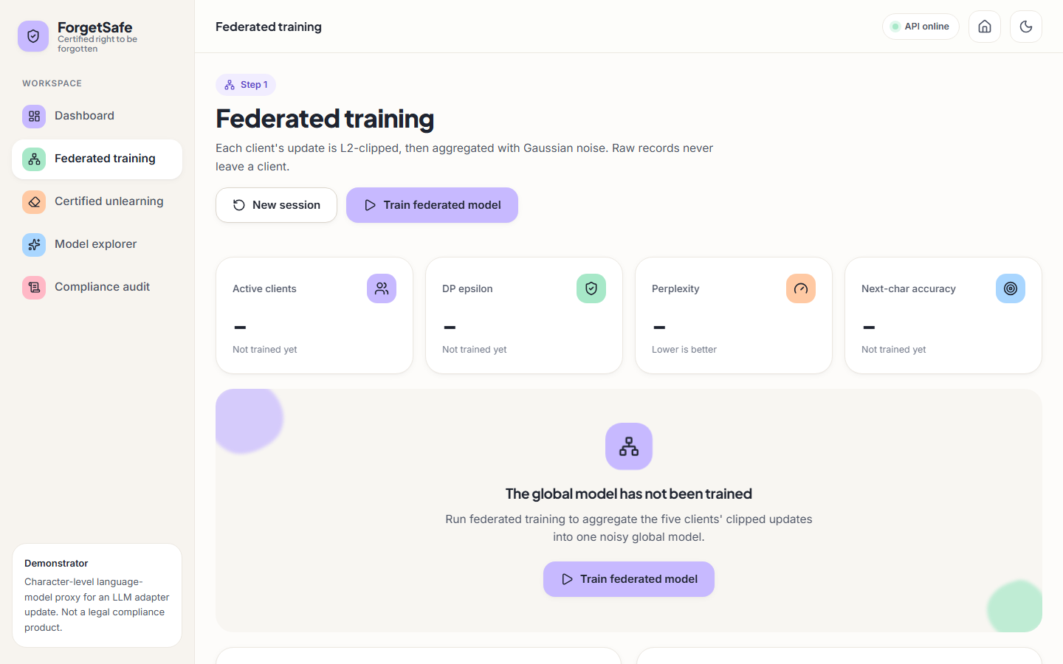  Fig. C.1: Federated training screen before the first training run | 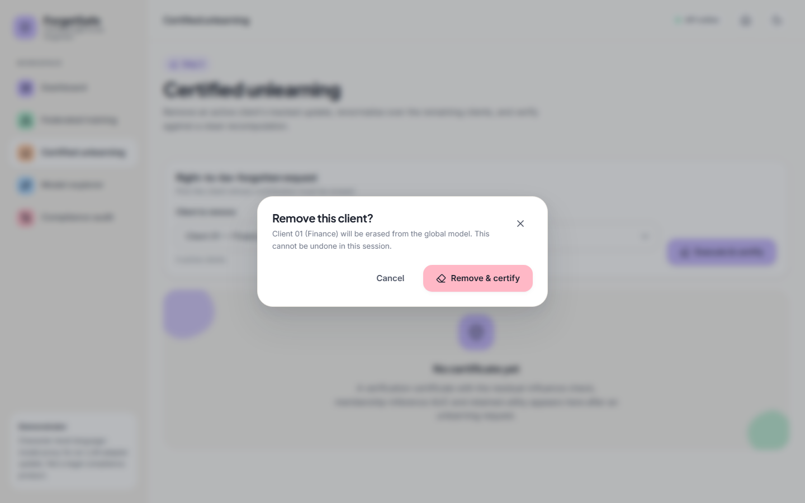  Fig. C.2: Confirmation dialog before a removal

In the untrained state all four tiles show a dash with the foot-note "Not trained yet", and an empty-state card reads "The global model has not been trained. Run federated training to aggregate the five clients' clipped updates into one noisy global model" with a Train federated model button. The header buttons New session and Train federated model are available and the status chip reads API online.
Pressing Execute & certify opens a modal dialog titled "Remove this client?" with the text "Client 01 (Finance) will be erased from the global model. This cannot be undone in this session." and two buttons, Cancel and Remove & certify. The page behind it is blurred. The dialog guards against an accidental click on an action that changes the model.
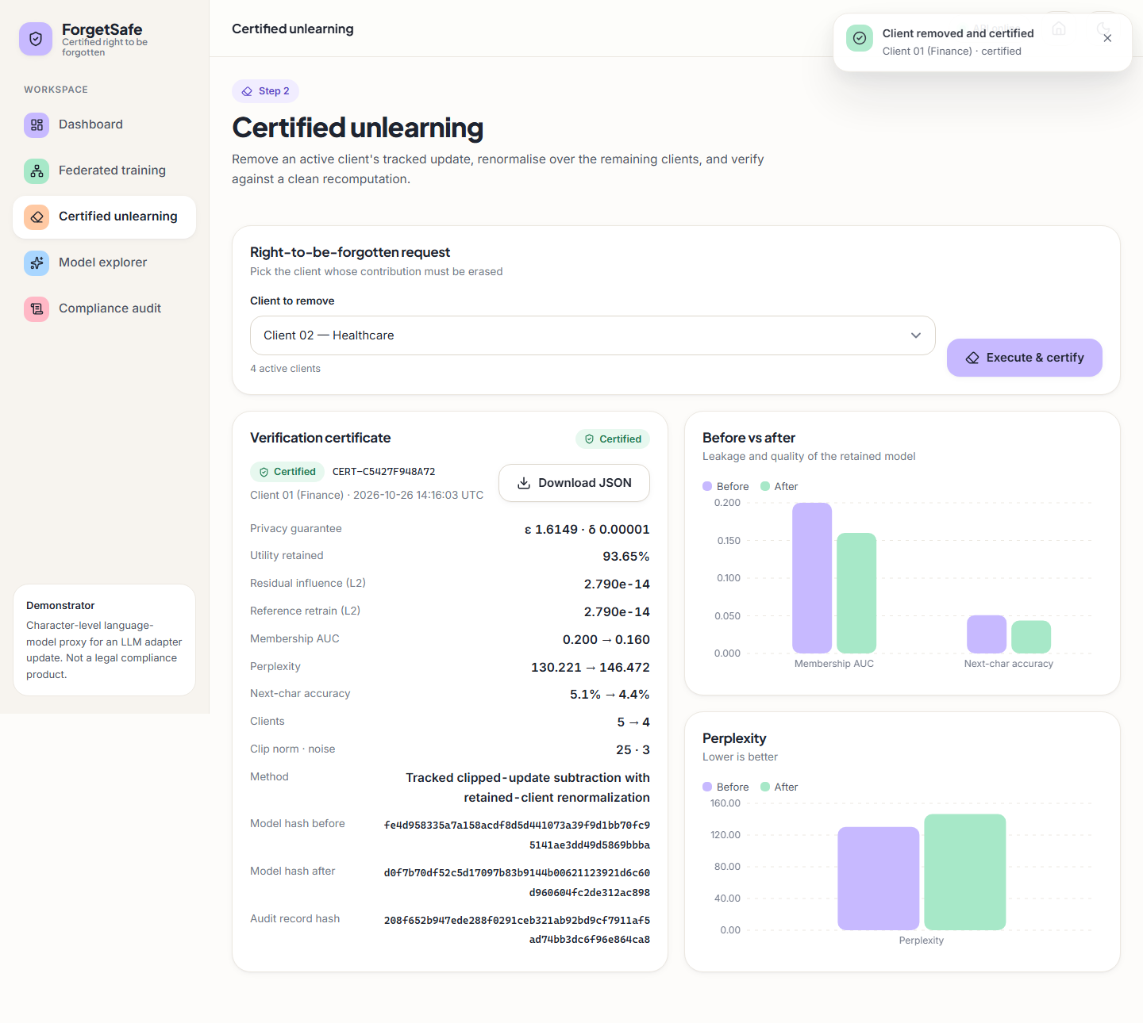
Fig. C.3: Verification certificate, full page
The full certificate adds the lower rows: Clients 5 → 4, clip norm · noise 25 · 3, the method "Tracked clipped-update subtraction with retained-client renormalization", the model hash before (fe4d958335a7a158…) and after (d0f7b70df52c5d17…) and the audit record hash 208f652b947ede288f0291ceb321ab92bd9cf7911af5ad74bb3dc6f96e864ca8, which is the value that links the certificate to ledger record 3. A second chart, Perplexity, shows the before bar (130.221) lower than the after bar (146.472).
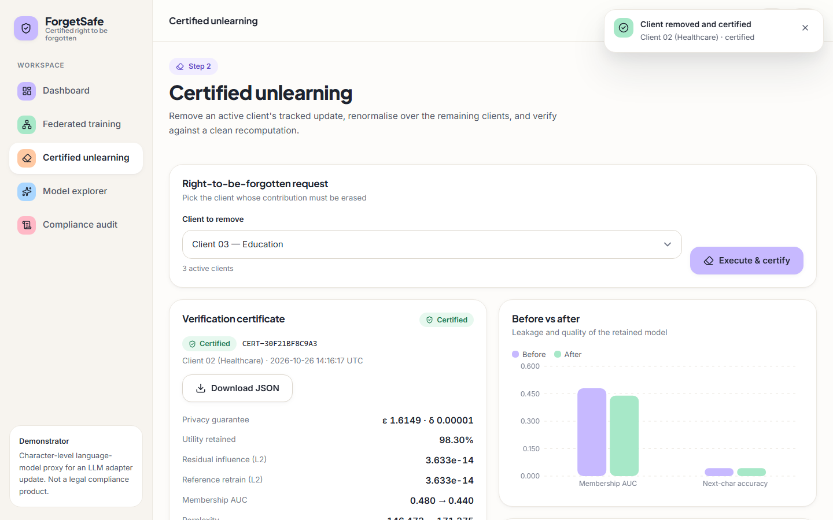  Fig. C.4: Certificate for the second removal (Client 02) | 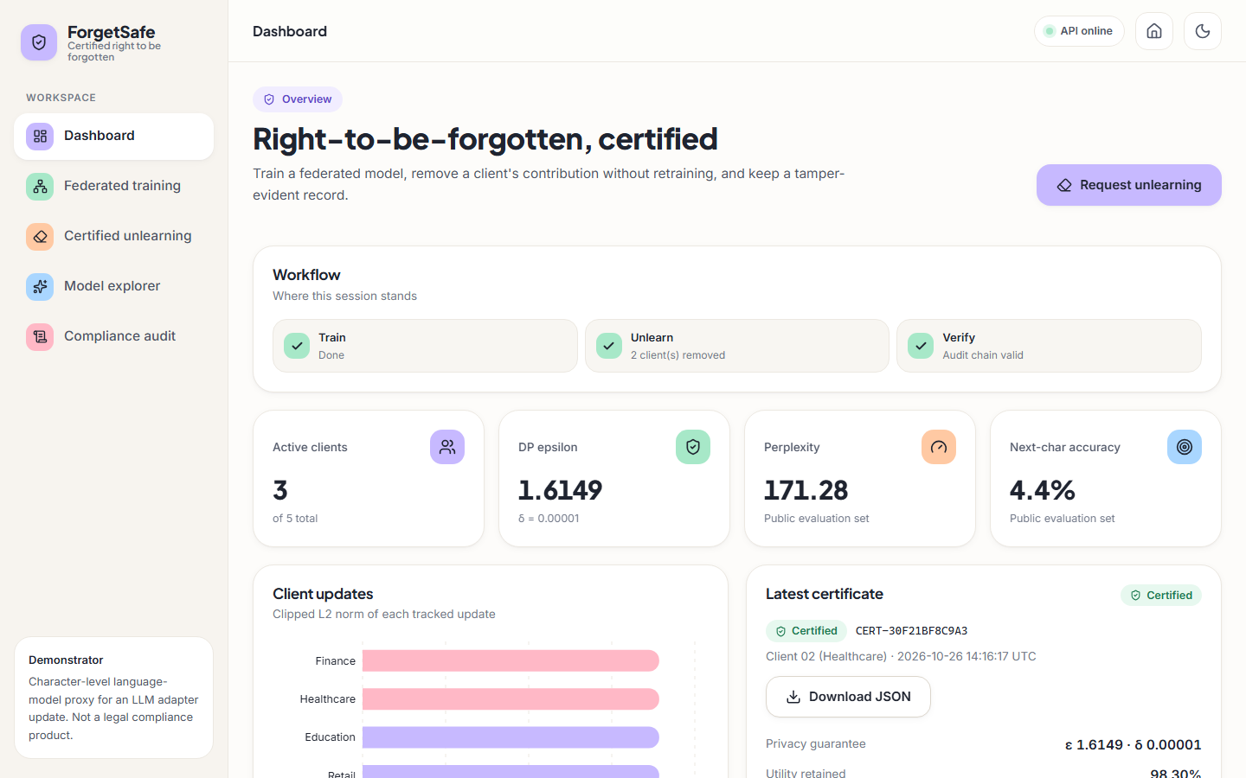  Fig. C.5: Dashboard after two removals

After the second request the certificate is CERT-30F21BF8C9A3 for Client 02 (Healthcare), issued 2026-10-26 14:16:17 UTC: ε 1.6149 · δ 0.00001, utility retained 98.30 %, residual influence and reference retrain both 3.633e-14, membership AUC 0.480 → 0.440, and perplexity 146.472 → 171.275 (the bottom row is partly cut off in the capture). The drop-down now offers Client 03 — Education with "3 active clients".
All three workflow steps are ticked; Unlearn reads "2 client(s) removed" and Verify "Audit chain valid". The tiles show 3 of 5 active clients, ε 1.6149 (unchanged), perplexity 171.28 and accuracy 4.4 %. The Client updates bars for Finance and Healthcare are drawn in a different colour from the others, and Latest certificate now shows CERT-30F21BF8C9A3 for Client 02 (Healthcare) with ε 1.6149 · δ 0.00001 and utility retained 98.30 %.
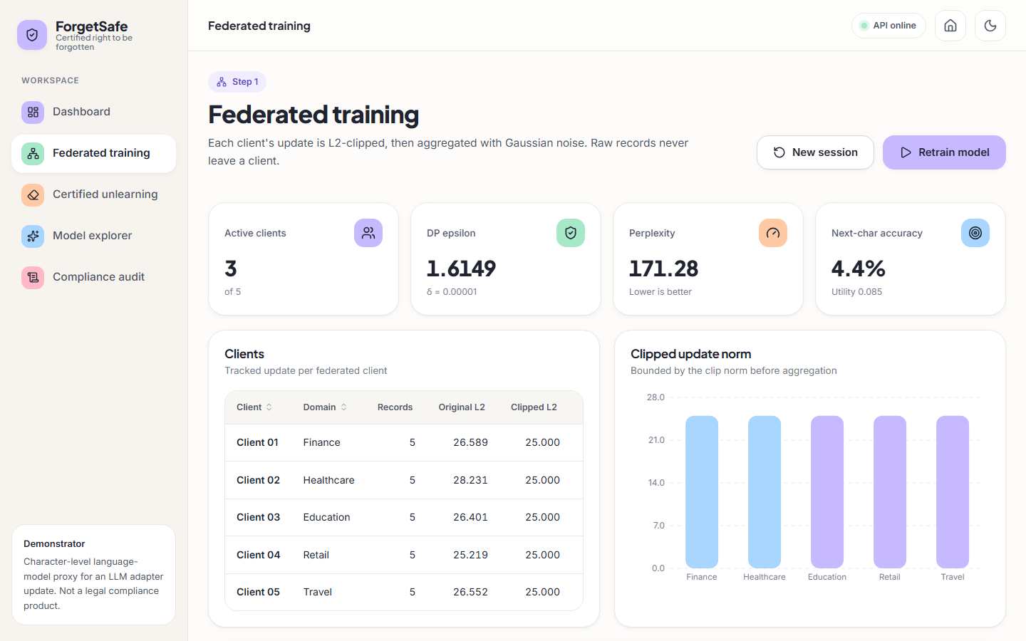  Fig. C.6: Training screen after two removals | 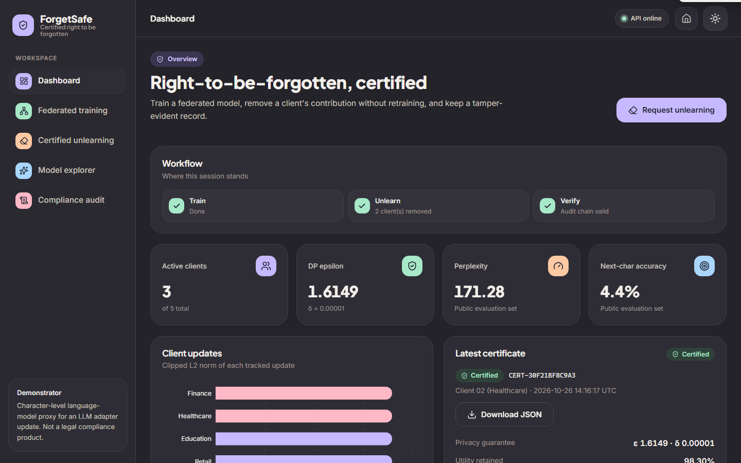  Fig. C.7: Dashboard in dark mode

The training screen keeps the per-client table (original and clipped norms are unchanged, because the stored updates are not modified by unlearning) while the tiles show 3 of 5 active clients, perplexity 171.28, accuracy 4.4 % and utility 0.085. The button now reads Retrain model and the bars of the two removed clients are drawn in a different (light blue) colour.
The same dashboard in the dark theme: the page, cards and tiles switch to dark surfaces with light text, the toggle in the top bar now shows a sun icon, and the accent colours remain legible. The numbers are the same as in the light theme (3 of 5 clients, 171.28, 4.4 %, certificate CERT-30F21BF8C9A3).
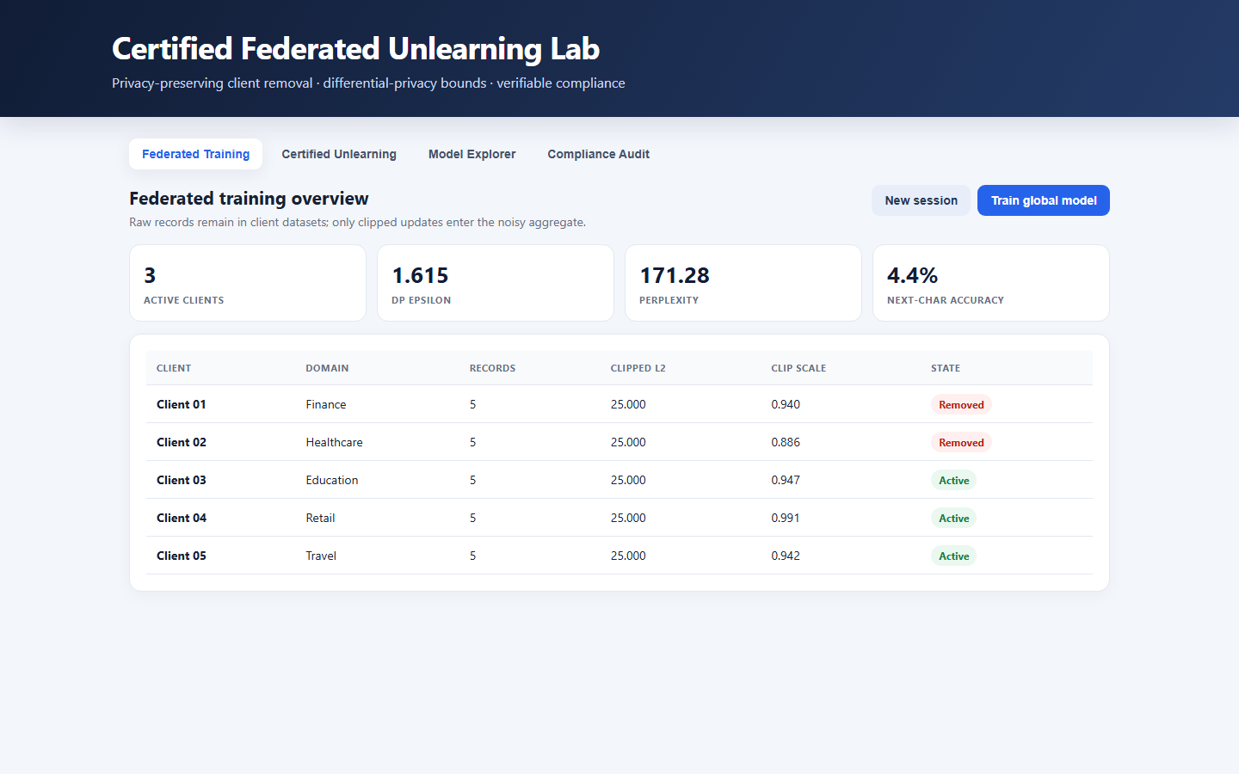  Fig. C.8: Original single-page interface served by the API |   Fig. C.9: Certified unlearning screen on a 390-pixel-wide viewport

The original interface, served at / by the Python server, shows the title "Certified Federated Unlearning Lab", four tabs (Federated Training, Certified Unlearning, Model Explorer, Compliance Audit) and the same session state as the React interface: 3 active clients, ε 1.615, perplexity 171.28, accuracy 4.4 %. The client table lists clipped L2 25.000 and clip scales 0.940, 0.886, 0.947, 0.991 and 0.942, with Client 01 and Client 02 marked Removed and the other three Active.
On a phone-width viewport the sidebar is replaced by a top bar (menu button, logo, status dot, theme toggle) and a bottom navigation with Home, Train, Forget, Explore and Audit, with Forget highlighted. The request card stacks vertically (Client 03 — Education, "3 active clients", Execute & certify) and the certificate card for CERT-30F21BF8C9A3 begins below it.
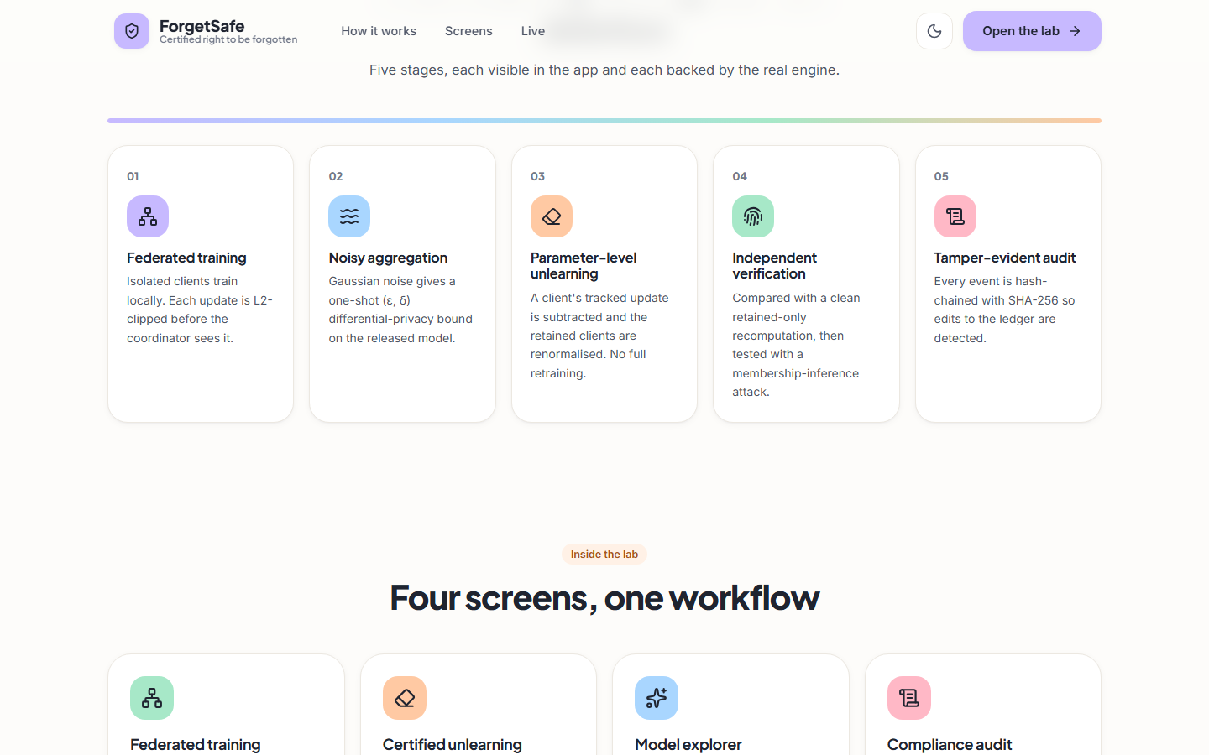
Fig. C.10: Landing page, how-it-works section
Scrolled down, the landing page lists five numbered stages: 01 Federated training (isolated clients, each update L2-clipped before the coordinator sees it), 02 Noisy aggregation (a Gaussian noise gives a one-shot (ε, δ) bound), 03 Parameter-level unlearning (a client's tracked update is subtracted, retained clients renormalised, no full retraining), 04 Independent verification (comparison with a clean retained-only recomputation, then a membership-inference attack) and 05 Tamper-evident audit (every event hash-chained with SHA-256). A heading "Four screens, one workflow" starts the next section.

